

# Team 24 – Sprint 1 Testing Document

Sakshi Choudhary, Giorgi Khmaladze, Nick Litman, Mihir Somani, Conley Utz

# User Story #01

**Test 1: Testing that a user can only register if they provide all the required details.**

Purpose: To meet the acceptance criteria, the user is created only if the user provides all the details: username, purdue email id, password, password confirmation.

Steps:

**Test 1.1 If the user does not put any input and press sign up button** 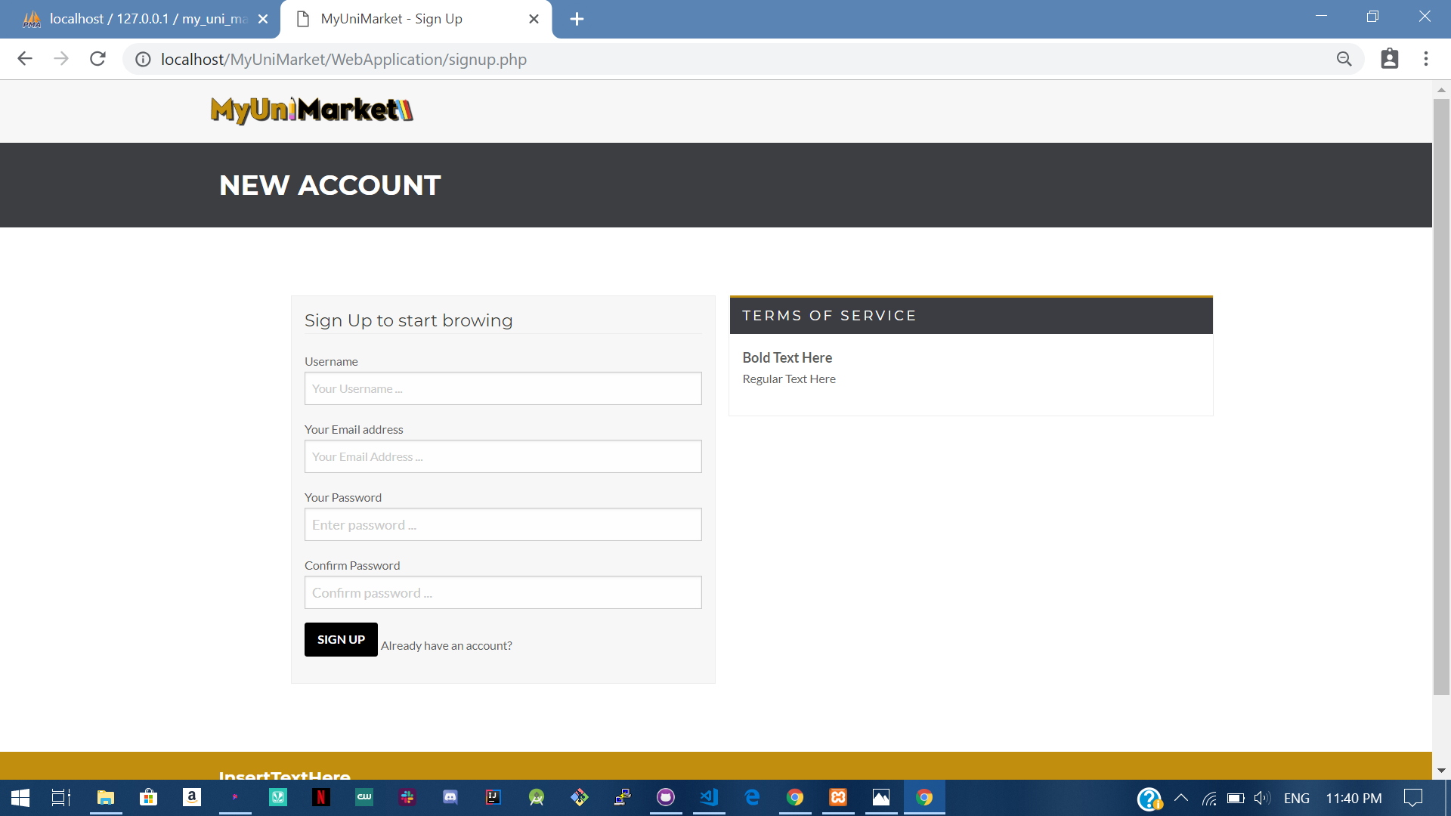

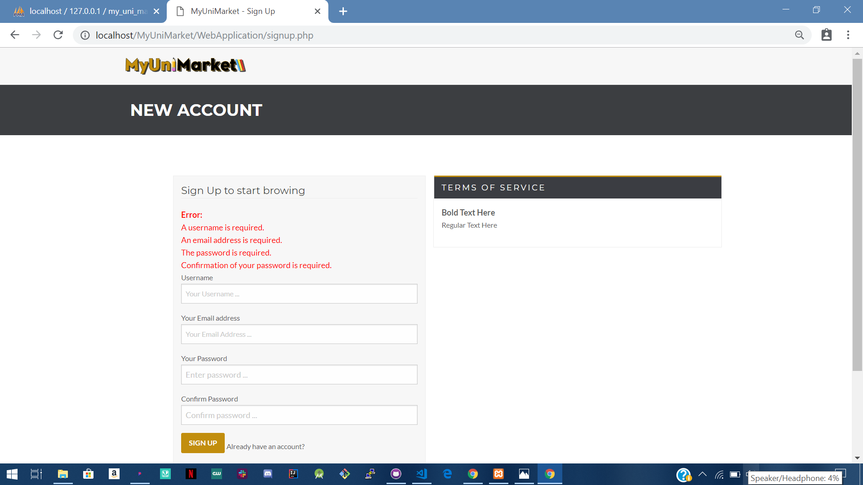

**Test 1.2 If the user just puts “Username”** 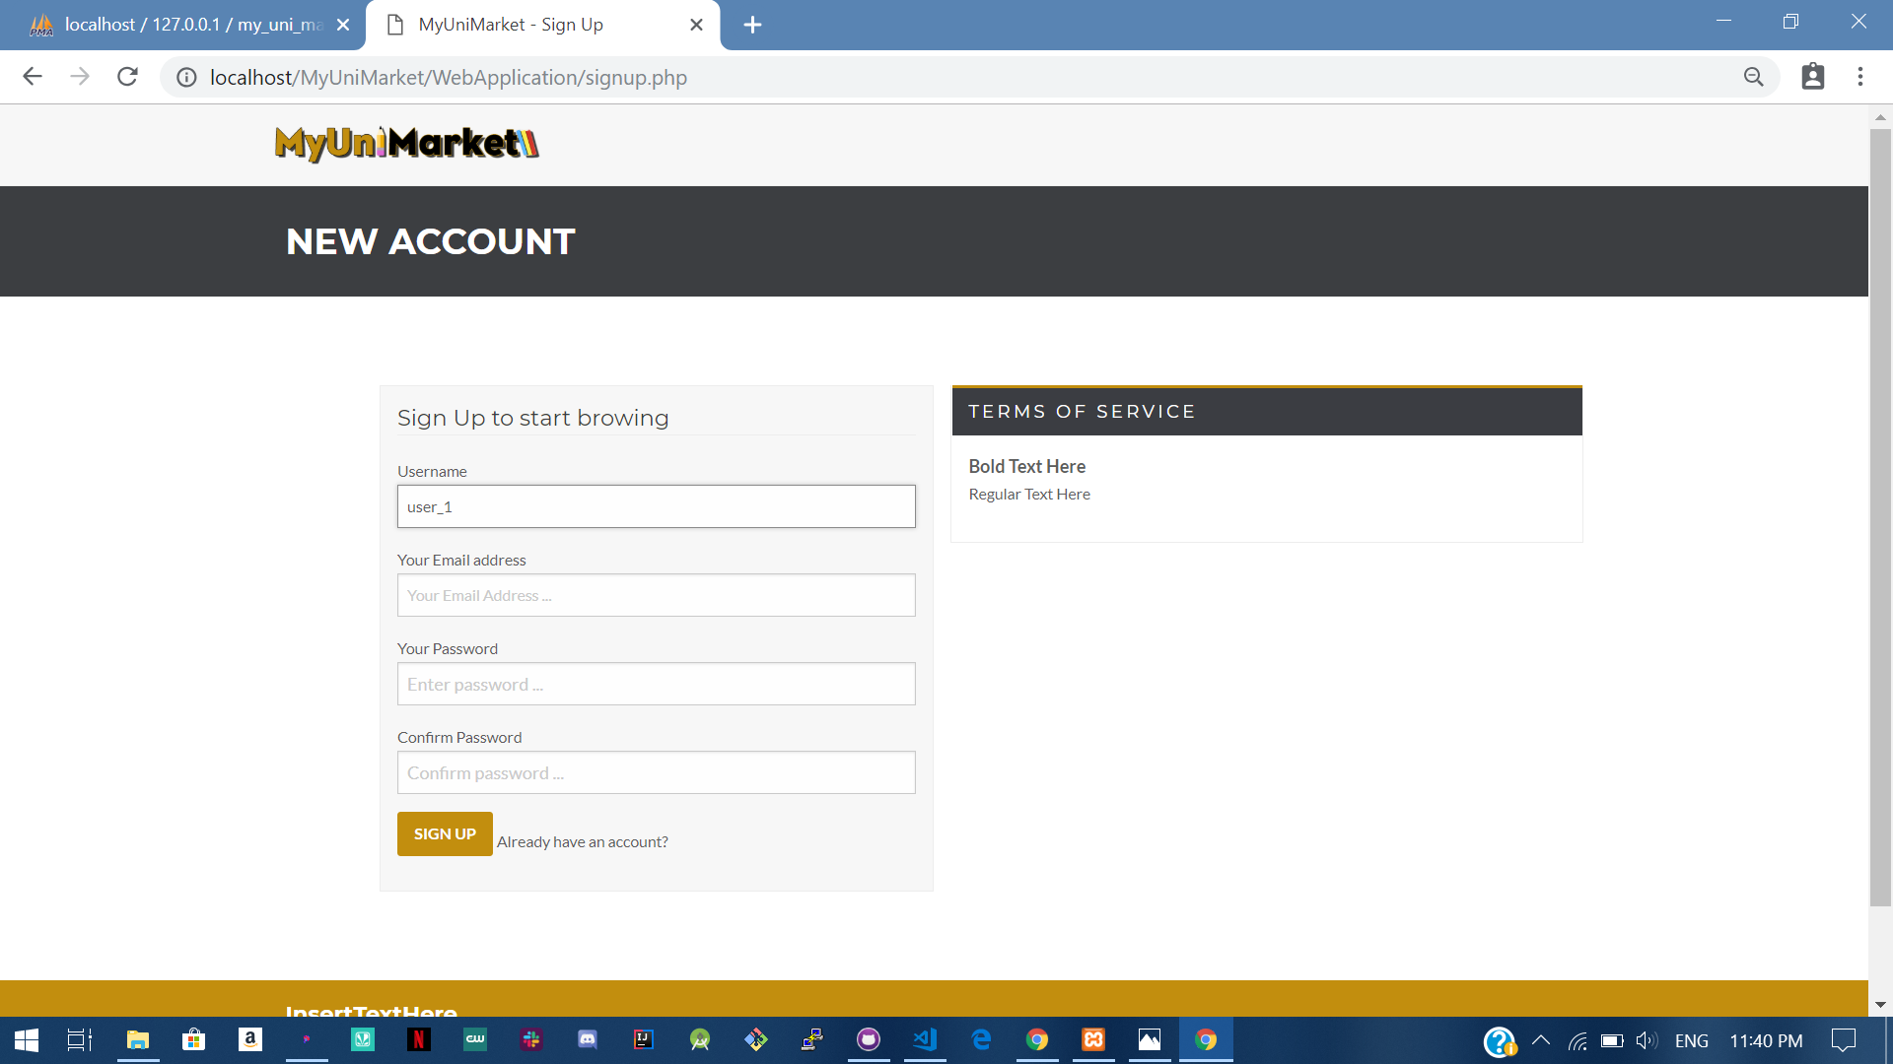

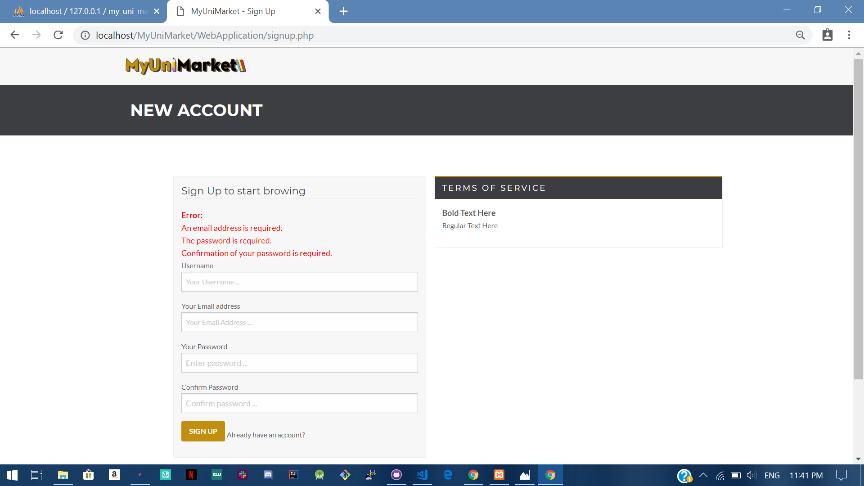

**Test 1.3 If the user just puts “Username” and “Email address”** 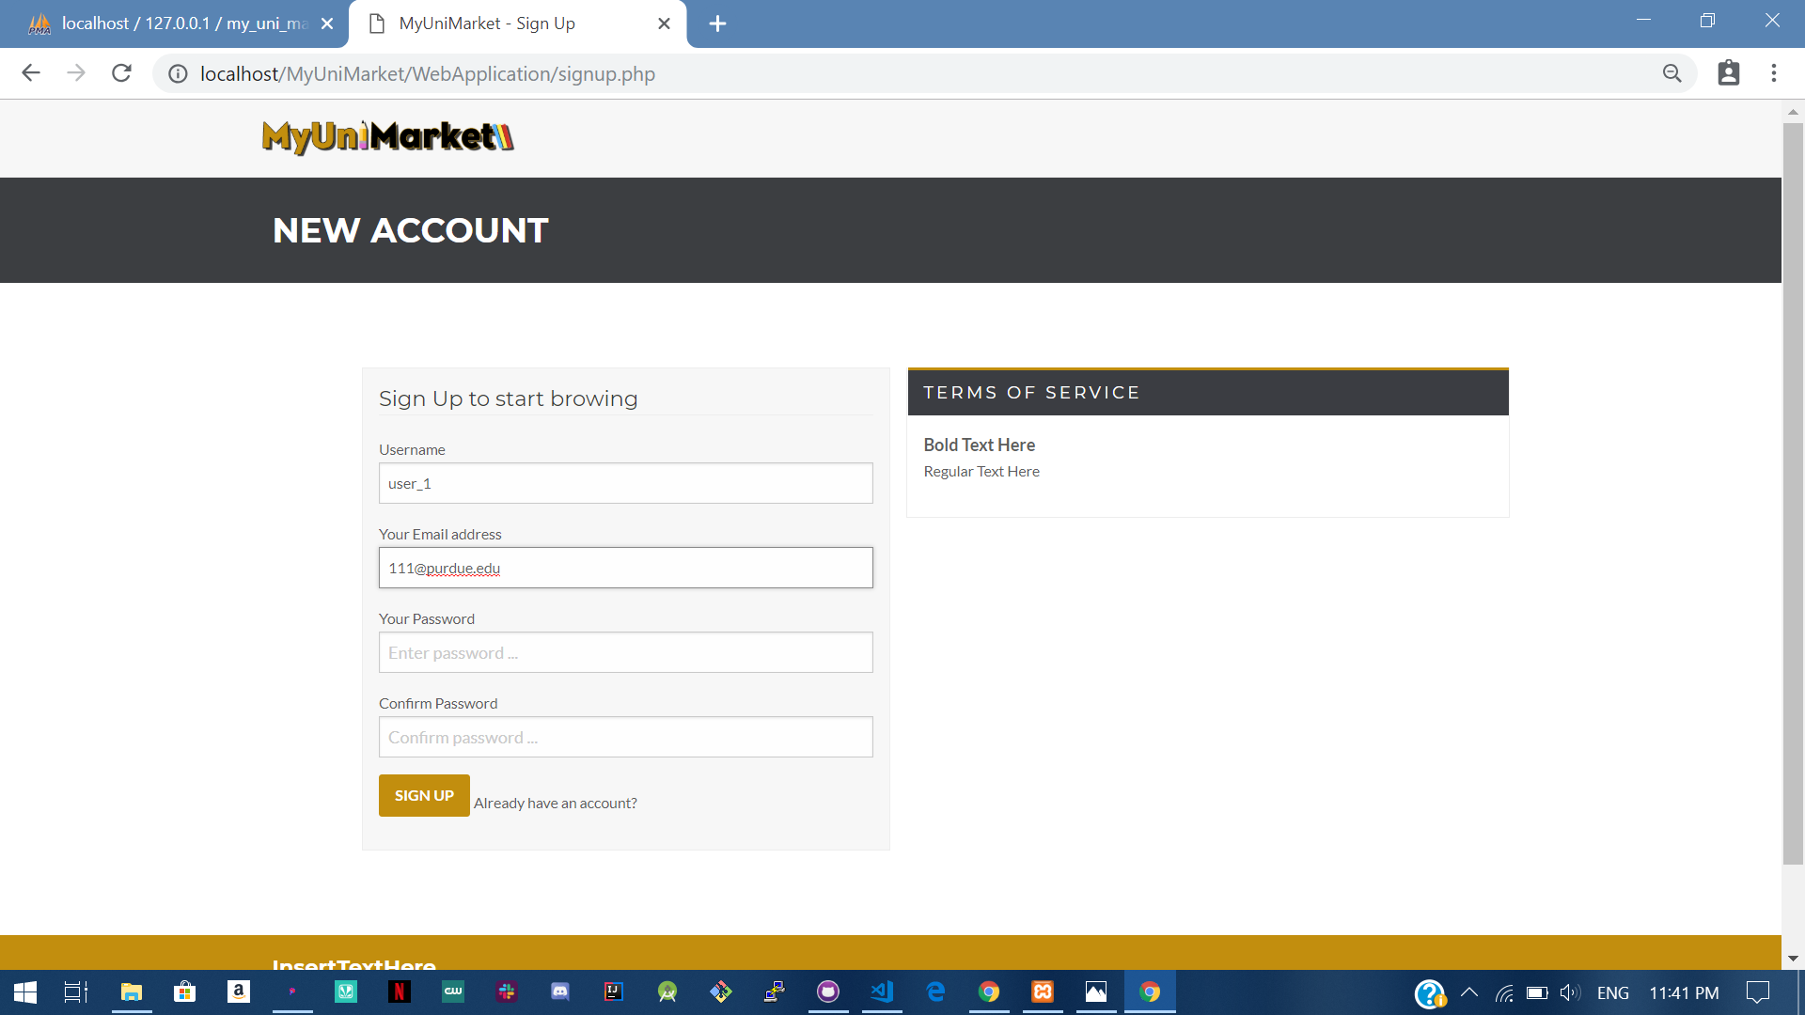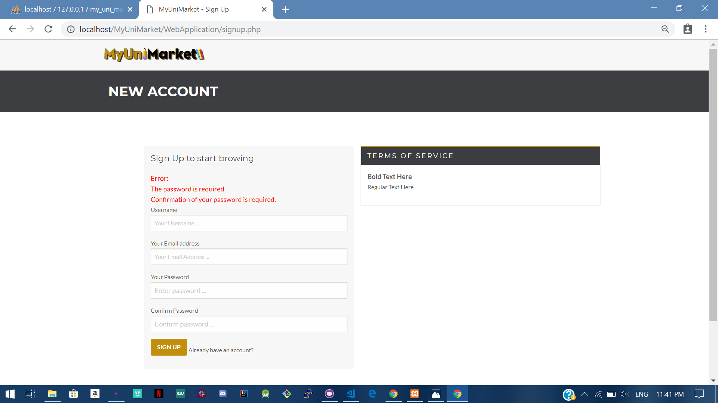

**Test 1.4 If the user just puts “Username” , “Email address” and “Password”** 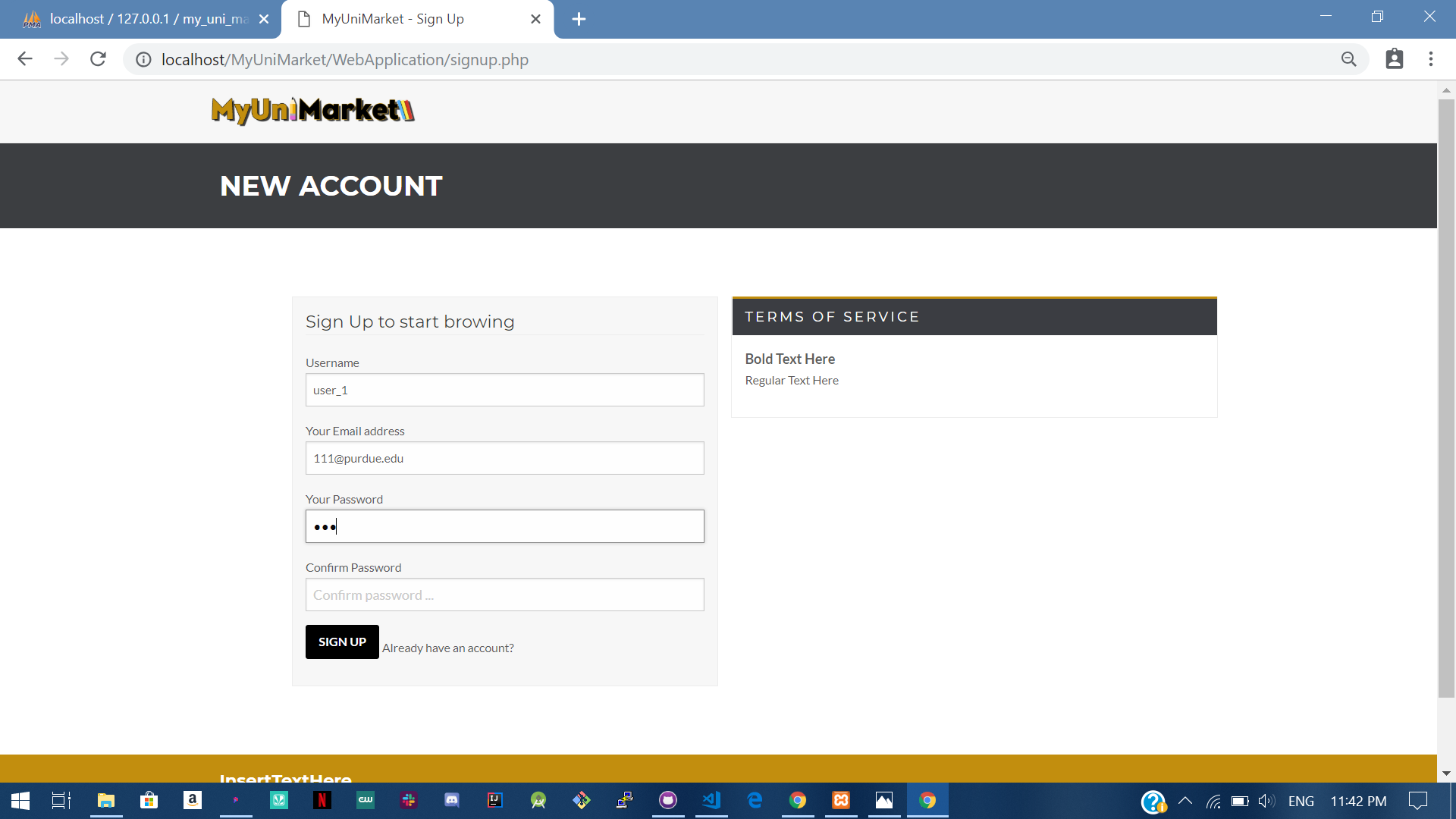

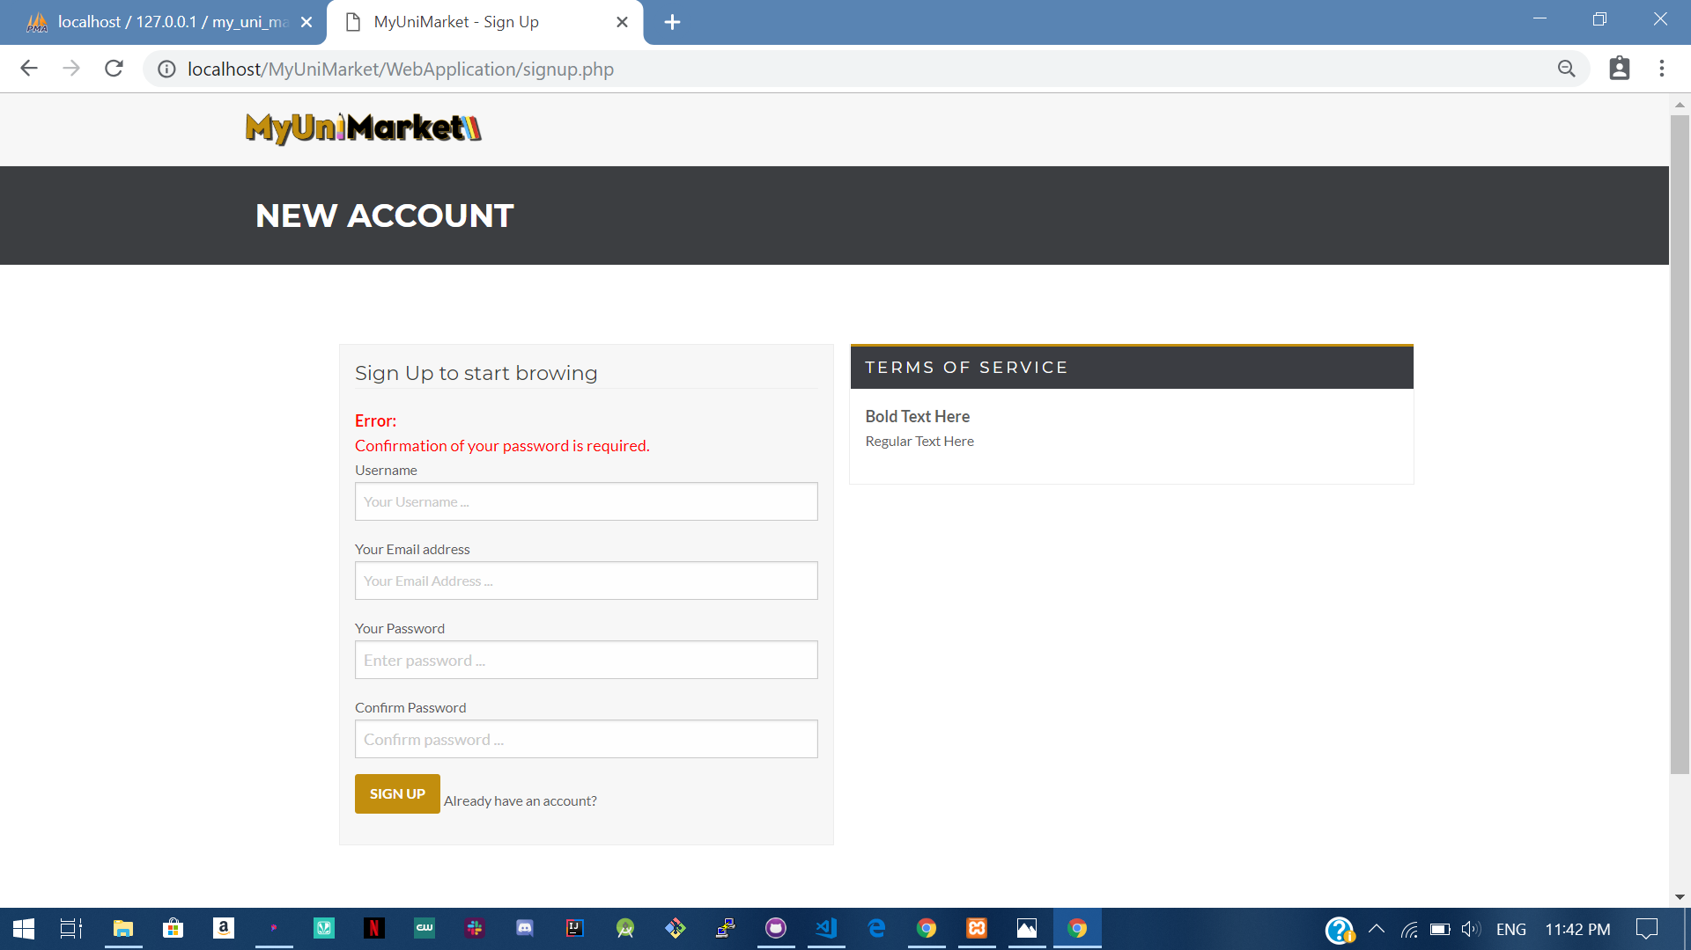

**Test 1.5 If the user puts all the required fields.**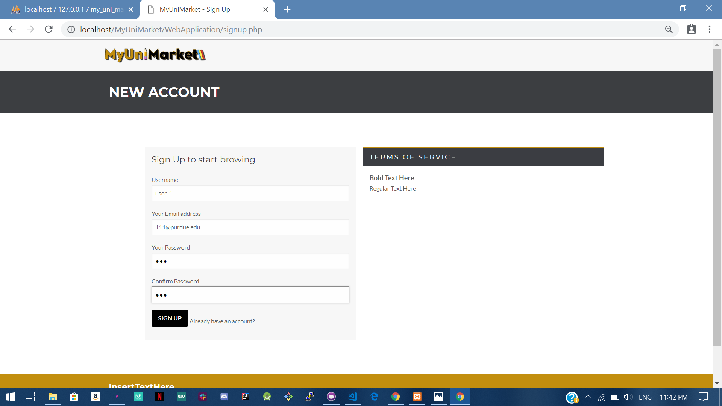

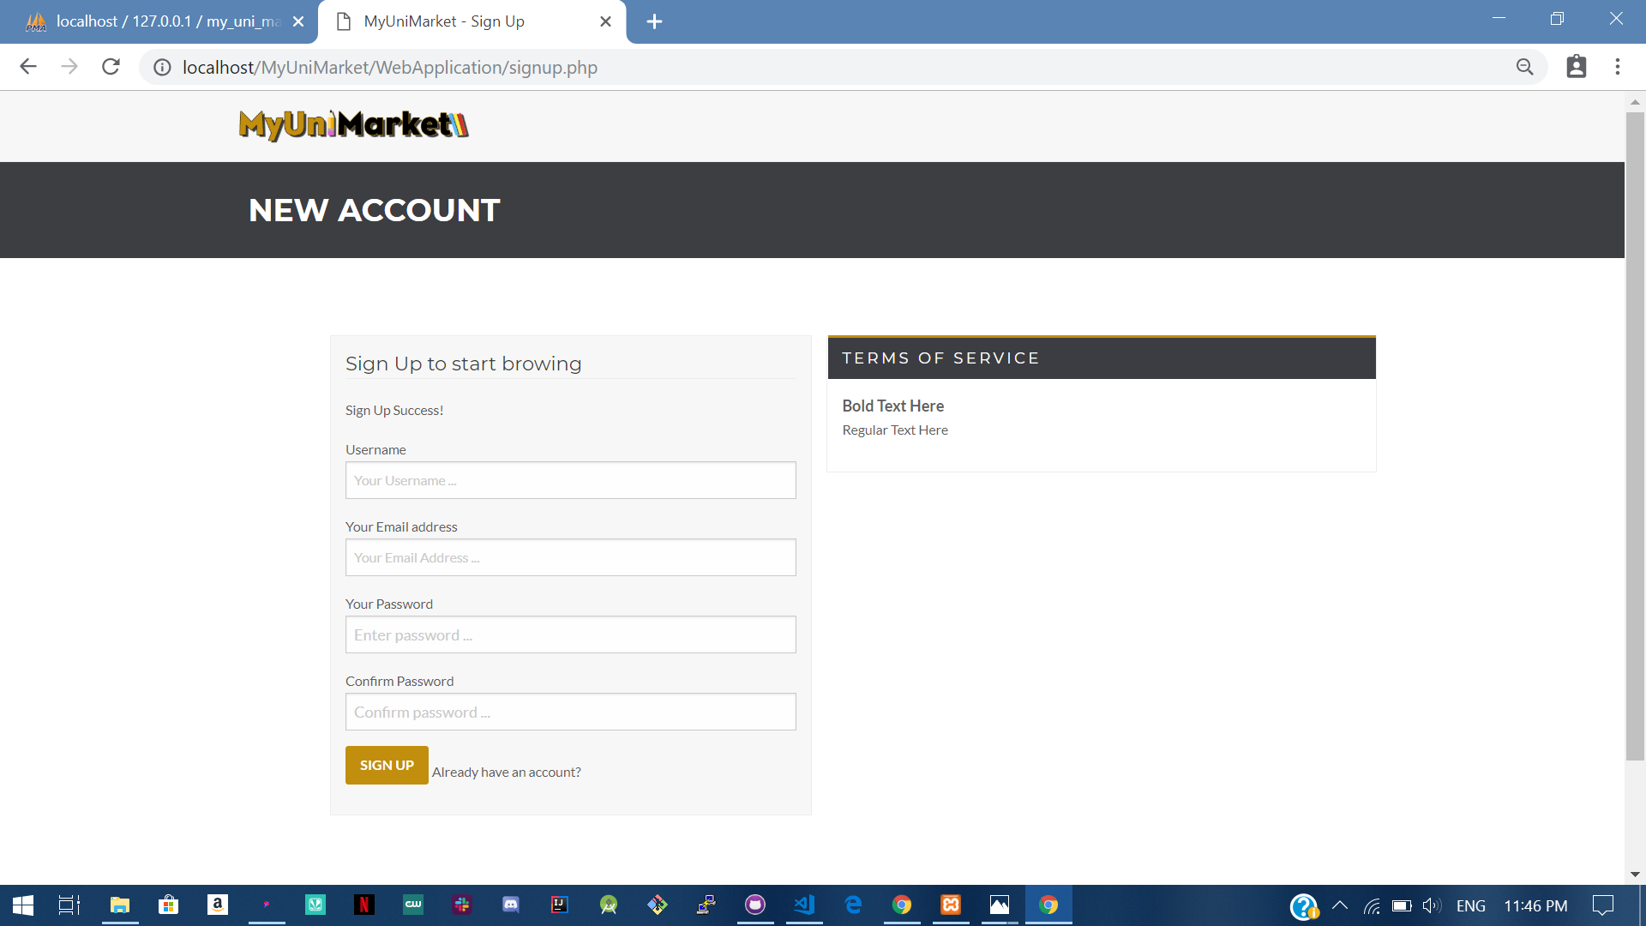

Expected: User is only created if the user provides all the user details .

Test Result: **PASSED**

**Test 2 Testing that a user can only register if the user provides an purdue.edu Email address** 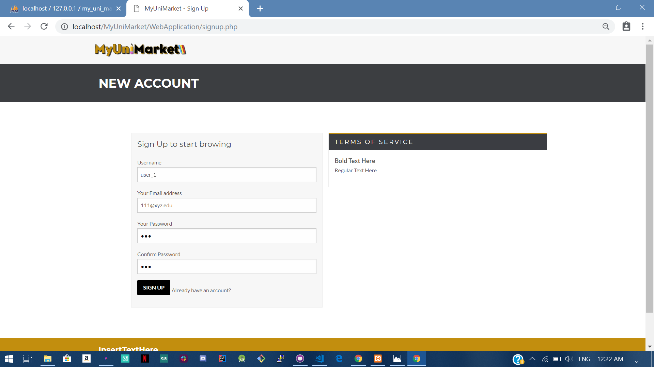

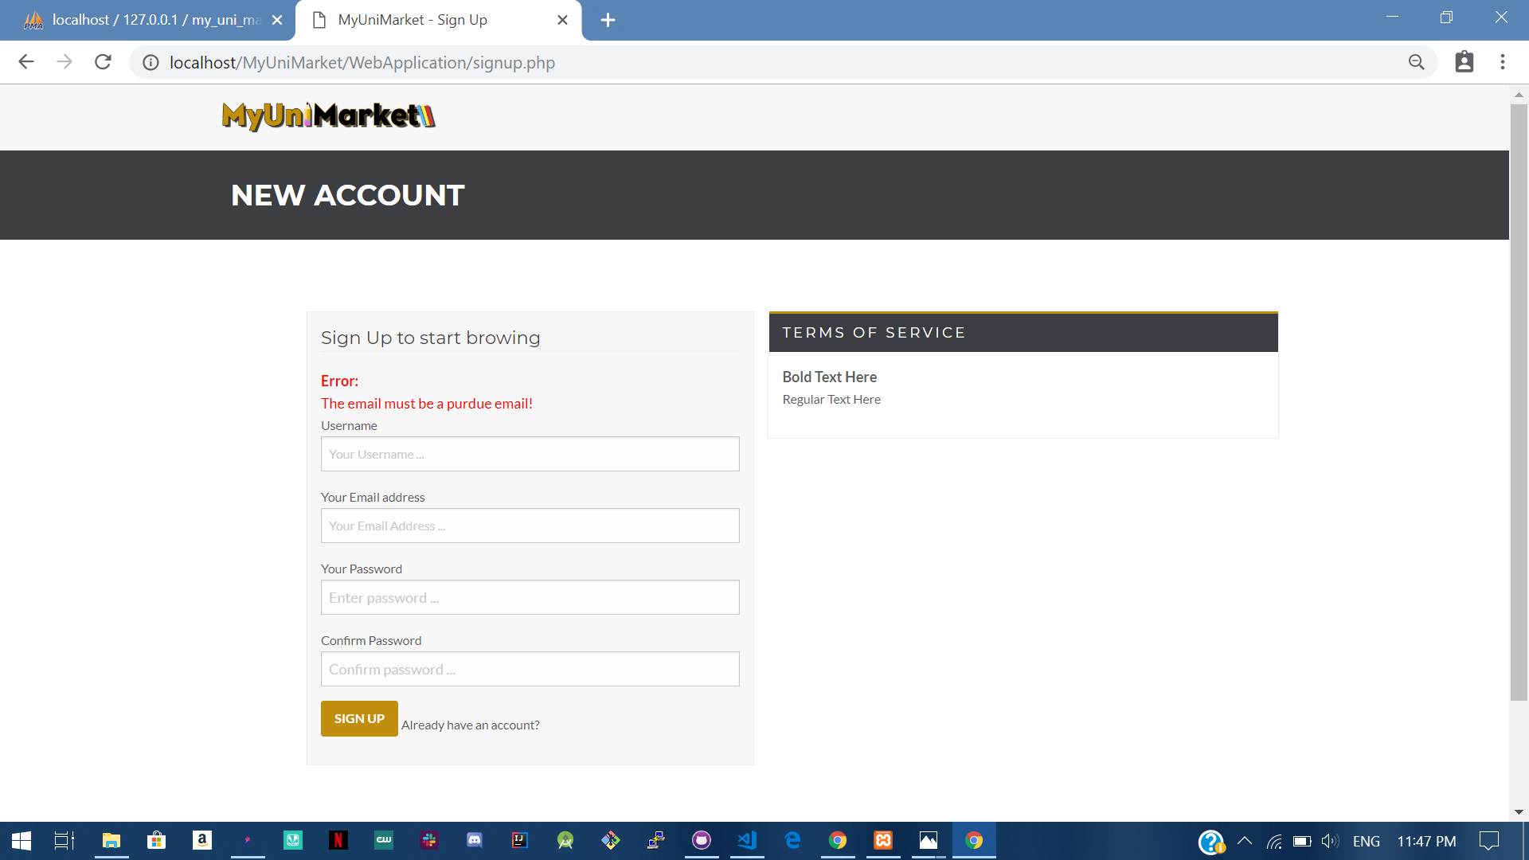

Expected: User cannot register without purdue email address.

Test Result: **PASSED**

**Test 3 Testing that a user is registered only after the user verifies their account.**

Step 1: Verification email is send to the user.

Step 2: If the user doesn’t verifies email and tries to sign in.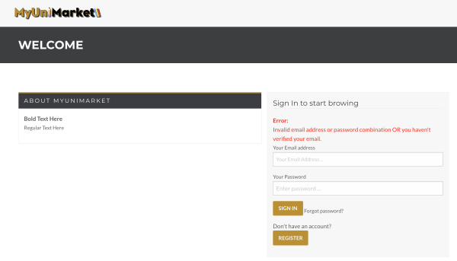

Step 3: If the user verifies email, confirmation is reflected in database and the user is registered.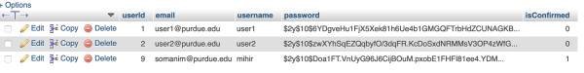

Expected: User can only sign in if they have verified their account.

Test Result: **PASSED**

# User Story #02

**Test 1: Given that they have already registered, a user is trying to log in.**

Purpose: To meet the acceptance criteria the user must provide correct email and password for logging in.

Steps:

1. Given that a session has not been started yet, the user chooses to enter the index/login page of the website. 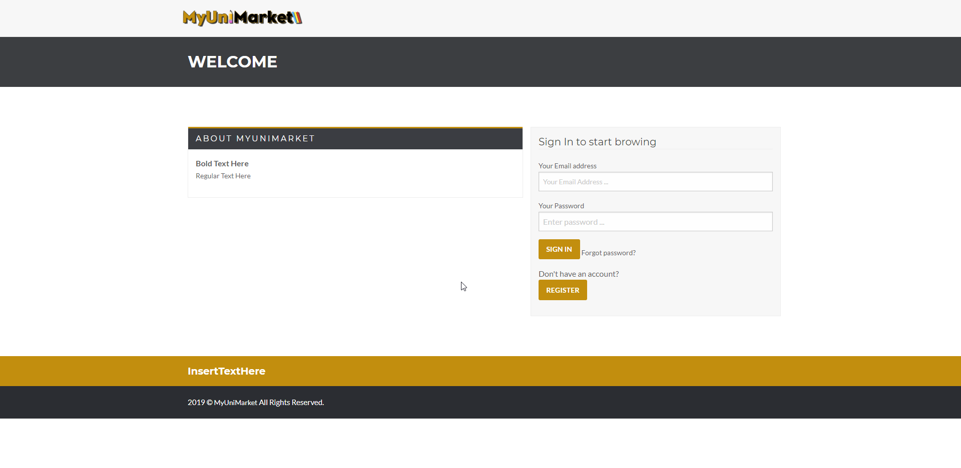
2. The user enters their login information. 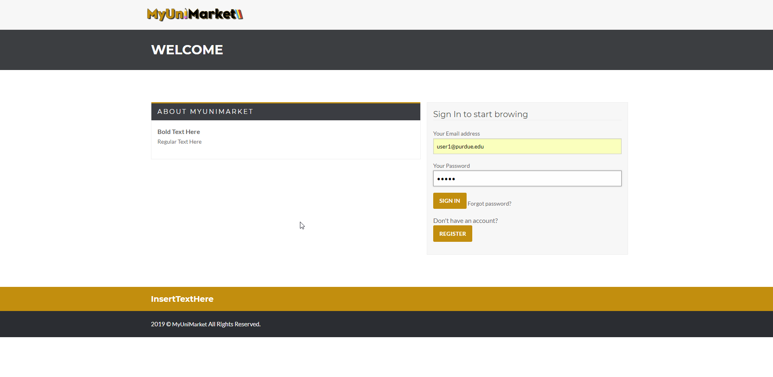
3. The user clicks log “SIGN IN” 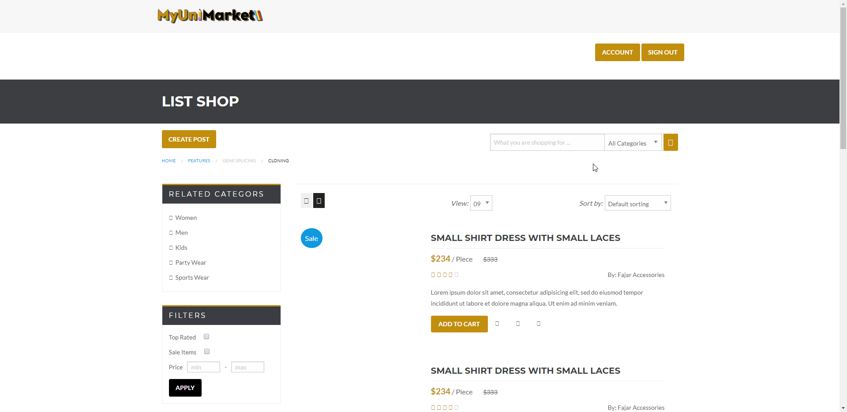

Expected result: The user is redirected to the main market page.

Test Result: **PASSED**

**Test 2: A user is trying to sign in without entering any information.**

Purpose: To meet the acceptance criteria, the user must complete all required fields (email and password in this case.)

Steps:

1. The user enters the sign in page. 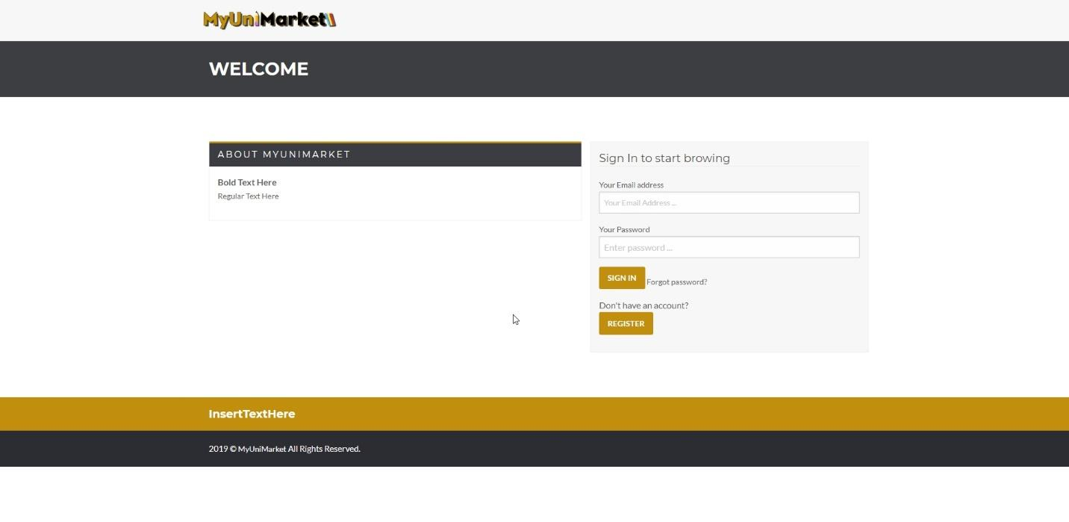
2. The user clicks “SIGN IN” without entering any information. 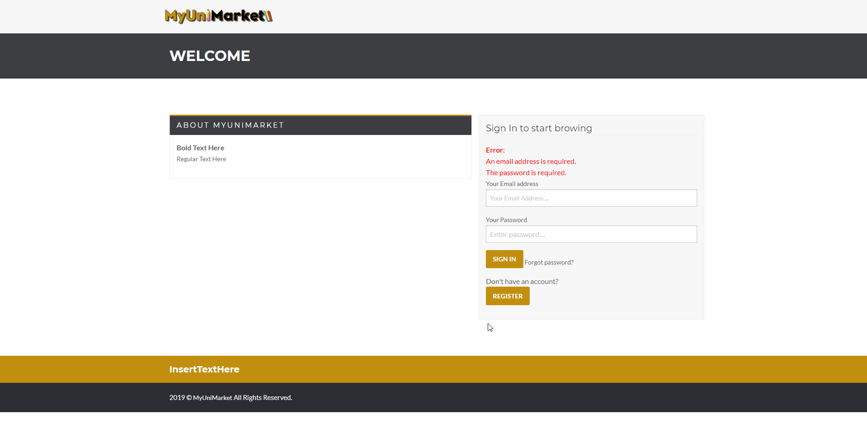

Expected Result: The browser must notify the user that they have not completed certain required fields.

Test Result: **PASSED**

**Test 3: A user is trying to sign in without entering a password.**

Purpose: To meet the acceptance criteria, the user must complete all required fields (email and password in this case.)

Steps:

1. The user enters the sign in page. 
2. The user provides only the email address. 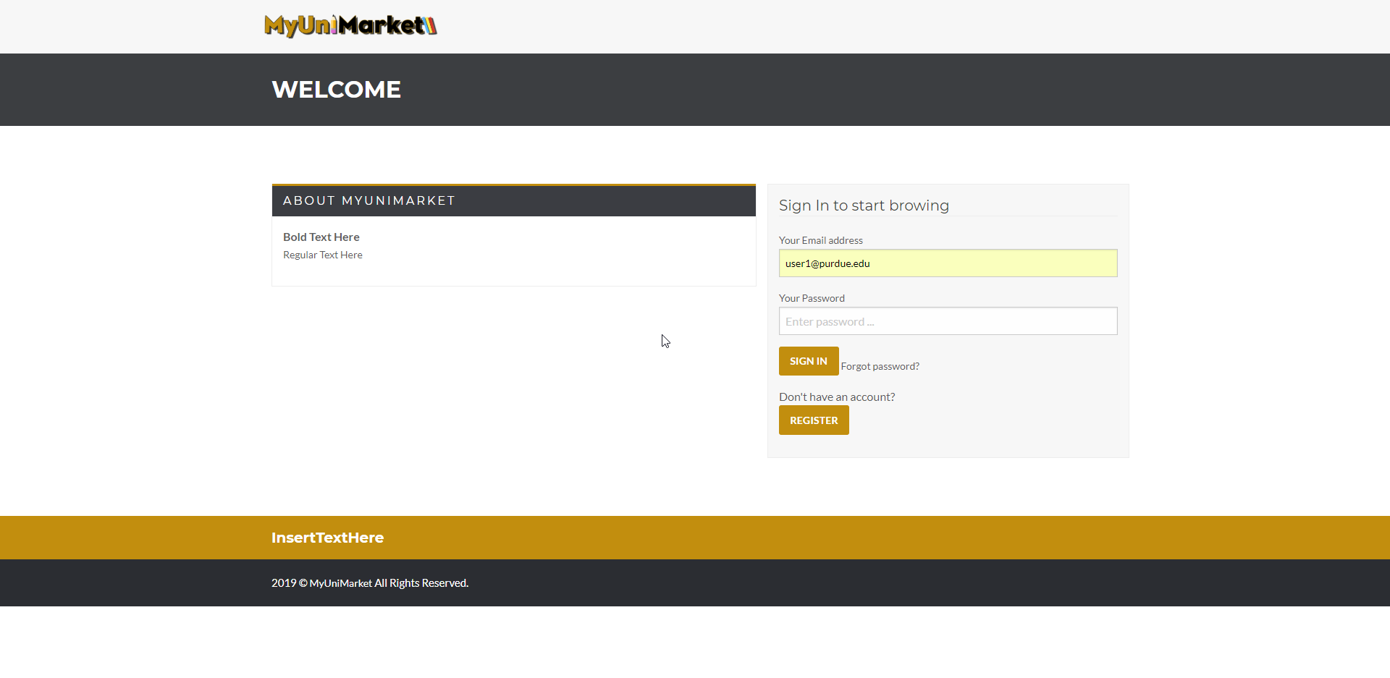
3. The user clicks “SIGN IN”. 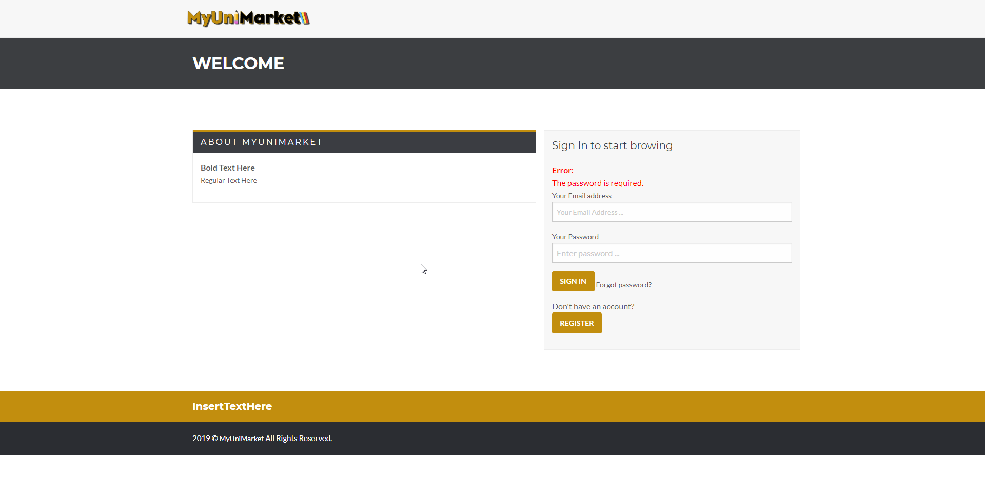

Expected Result: The page notifies the user that they have not enter their password.

Test Result: **PASSED**

**Test 4: A user is trying to sign in with an invalid email format.**

Purpose: To meet the acceptance criteria the page must notify the user that their email format is invalid.

Steps:

1. The user enters the sign in page. 
2. The user provides mistyped/invalid format email. 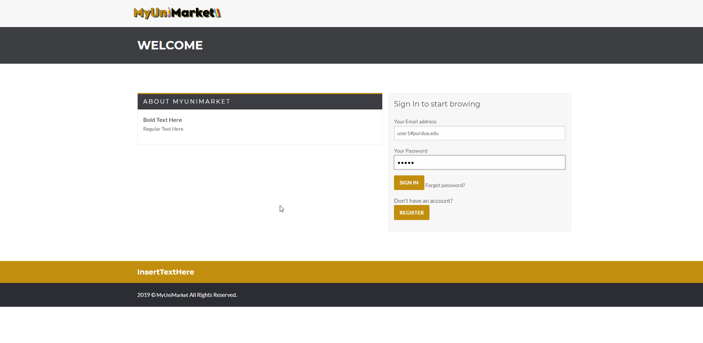
3. The user clicks “SIGN IN”. 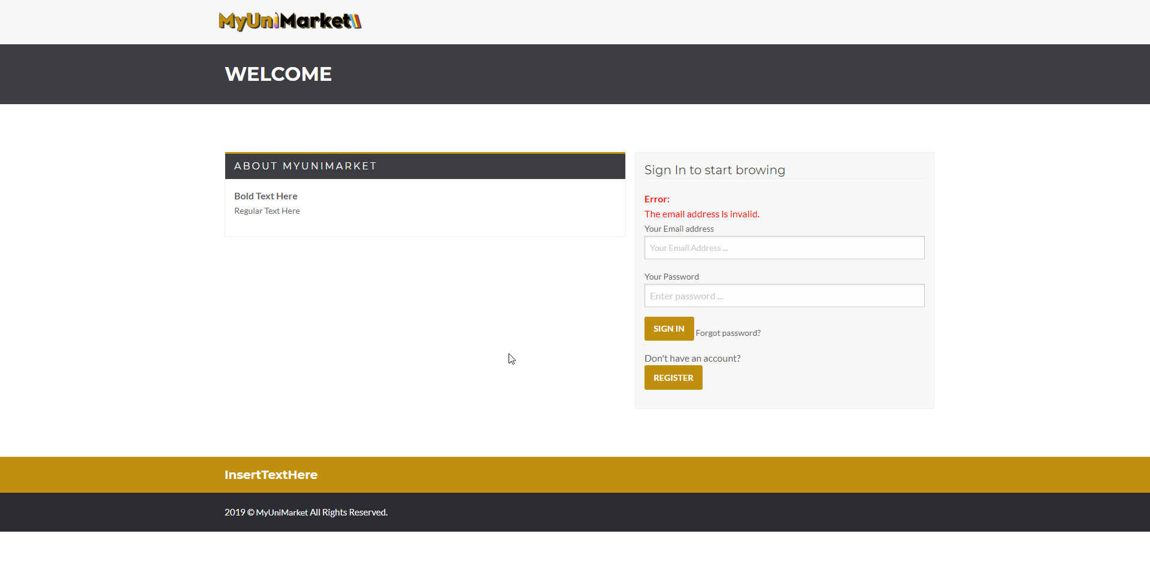

Expected Result: The user must be notified that they have mistyped or used an invalid syntax for their email address.

Test Result: **PASSED**

# User Story #03

**Test 1: Testing if a user can sign out.**

Purpose: To meet the acceptance criteria, user should be able to sign out from their account from any page and once they press logout it should display a logout success message and redirect the user to sign in page. Also, user can’t access any other page once they are signed out.

Steps:

1. The user is able to sign out from all the pages.

account.php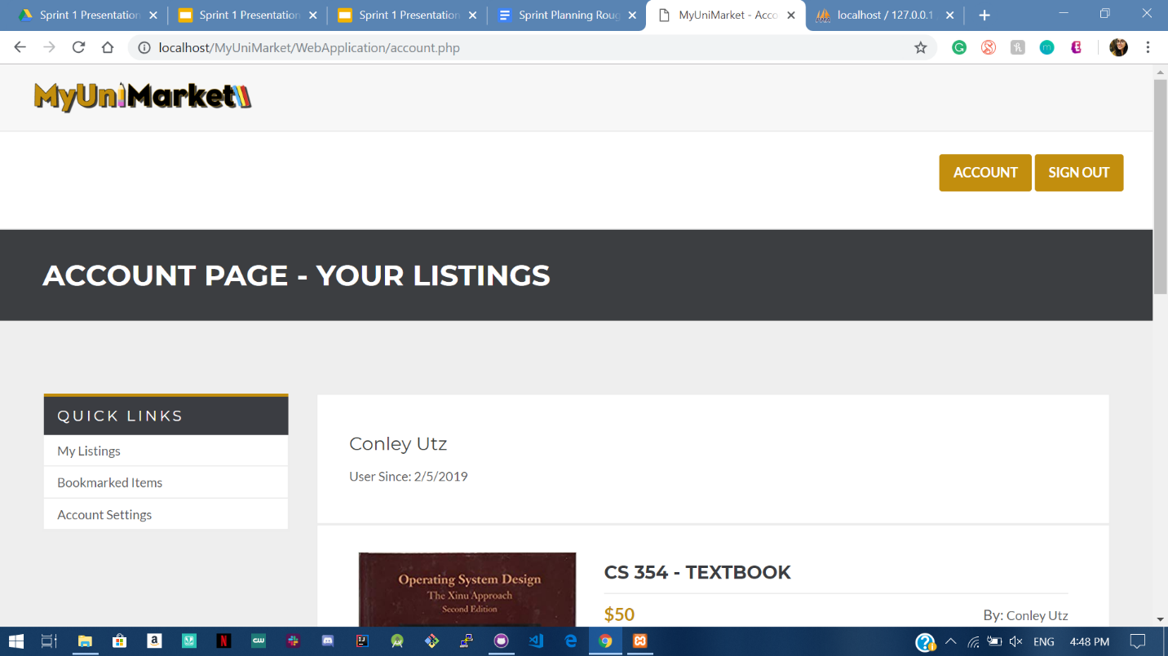

account2.php

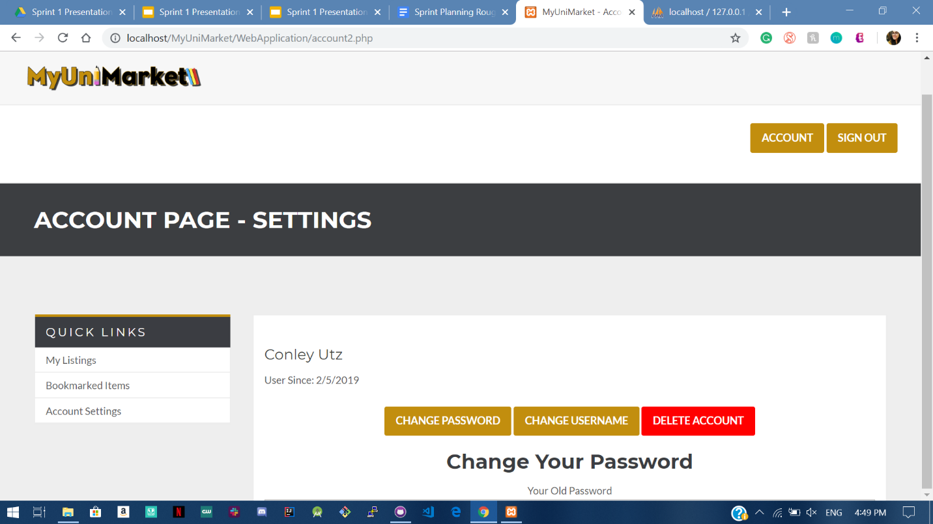

create.php 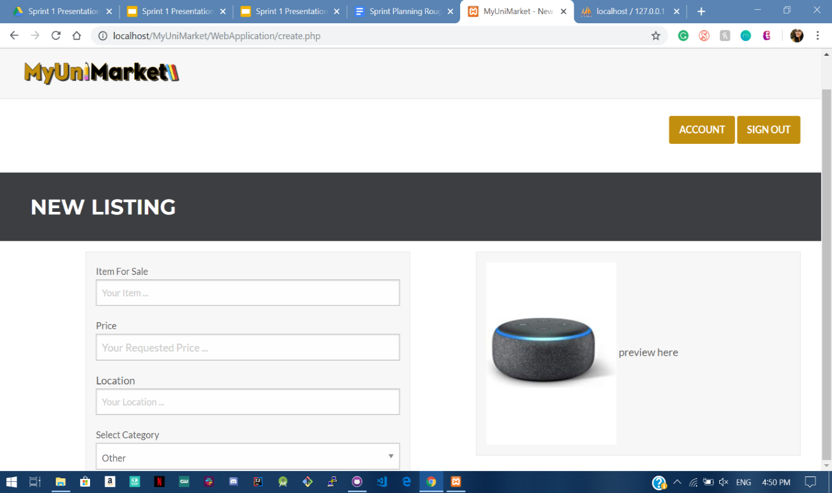

market.php

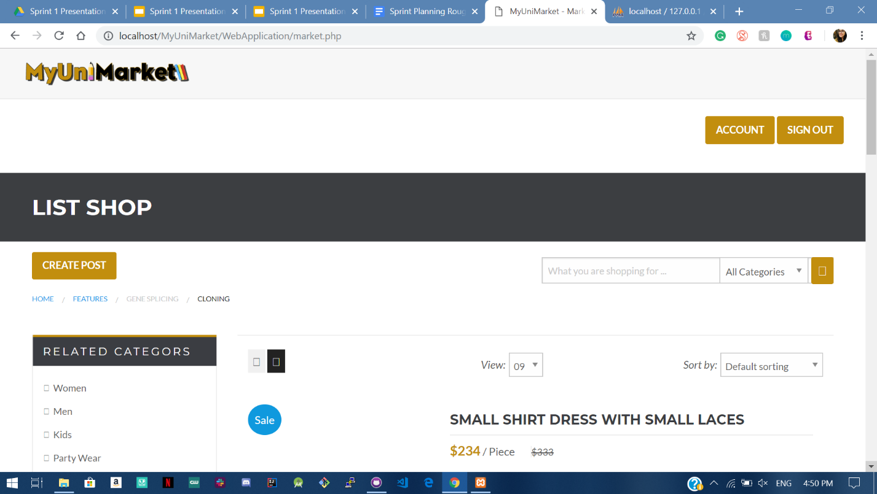

1. The user clicks sign out and SUCCESS message pops up

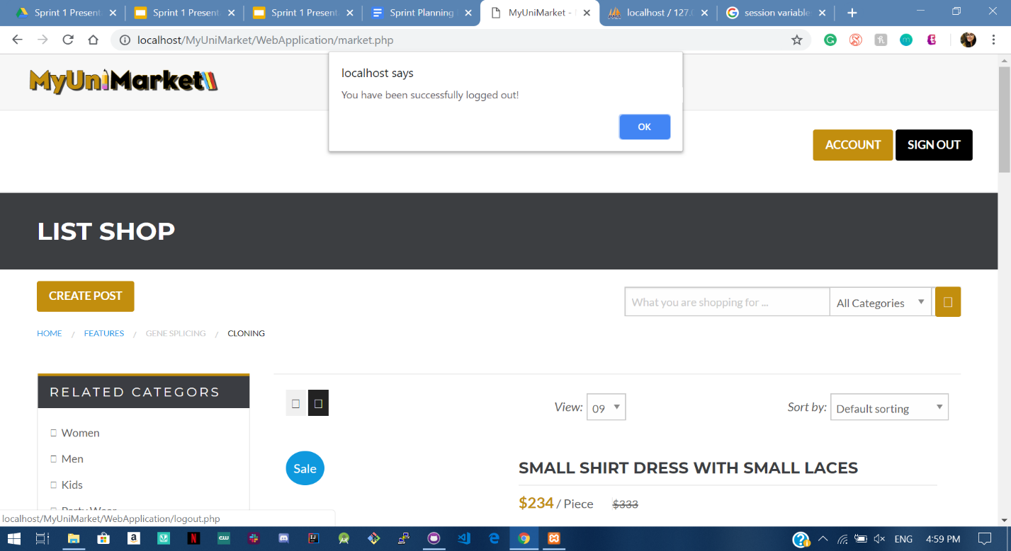

1. The User is redirected to sign in when they press OK.

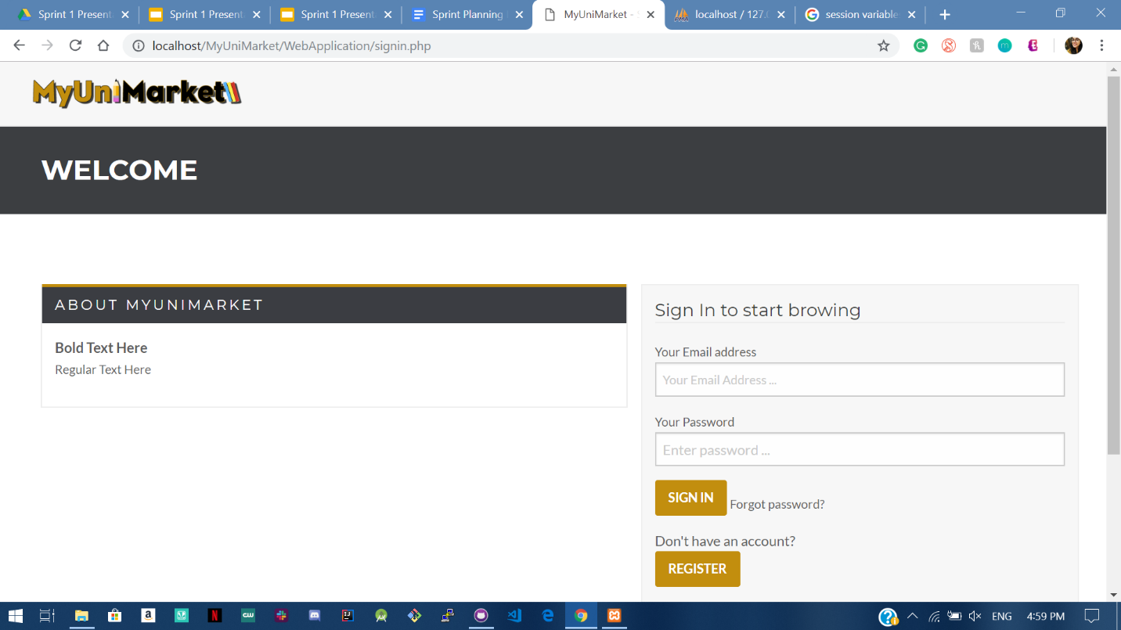

1. The session variables are modified once the user signs out, so that they can’t access any page without signing in (they are redirected to signin.php).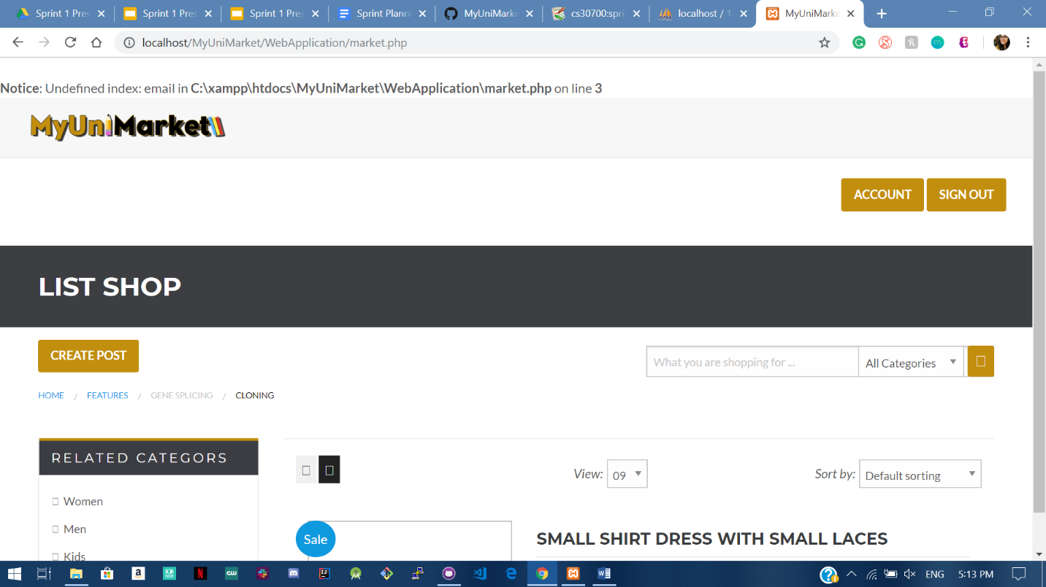

Expected Result: User is successfully able to sign out.

Test Result: **PASSED**

# User Story #04

**Test 1: Given that the user is logged in and has navigated to the account settings page, the user should be able to change their username.**

Purpose: To meet the acceptance criteria the password that a user chooses must be stored as a hash.

Steps:

1. The user clicks “CHANGE USERNAME” button. 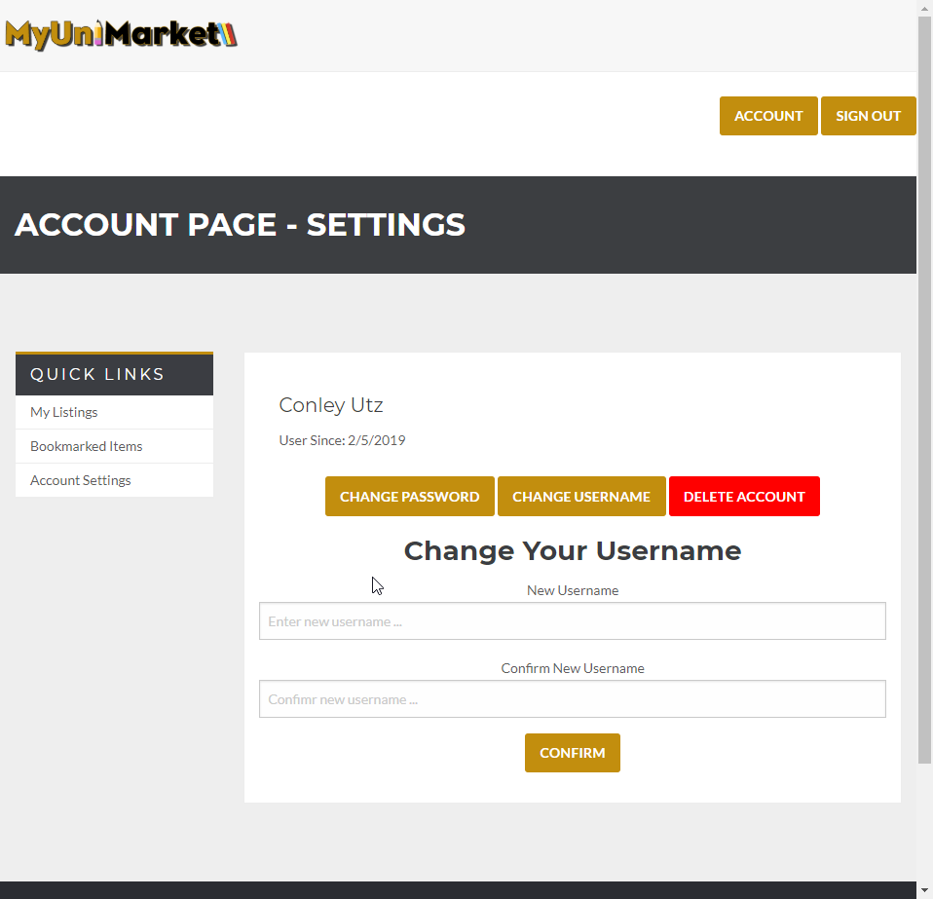
2. The user completes the required fields. 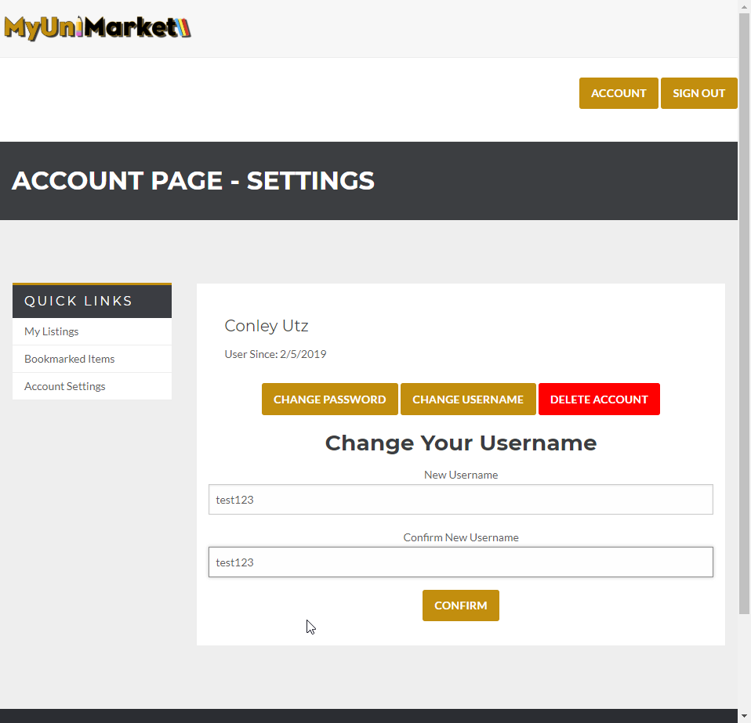
3. The database lists the username as “user1” 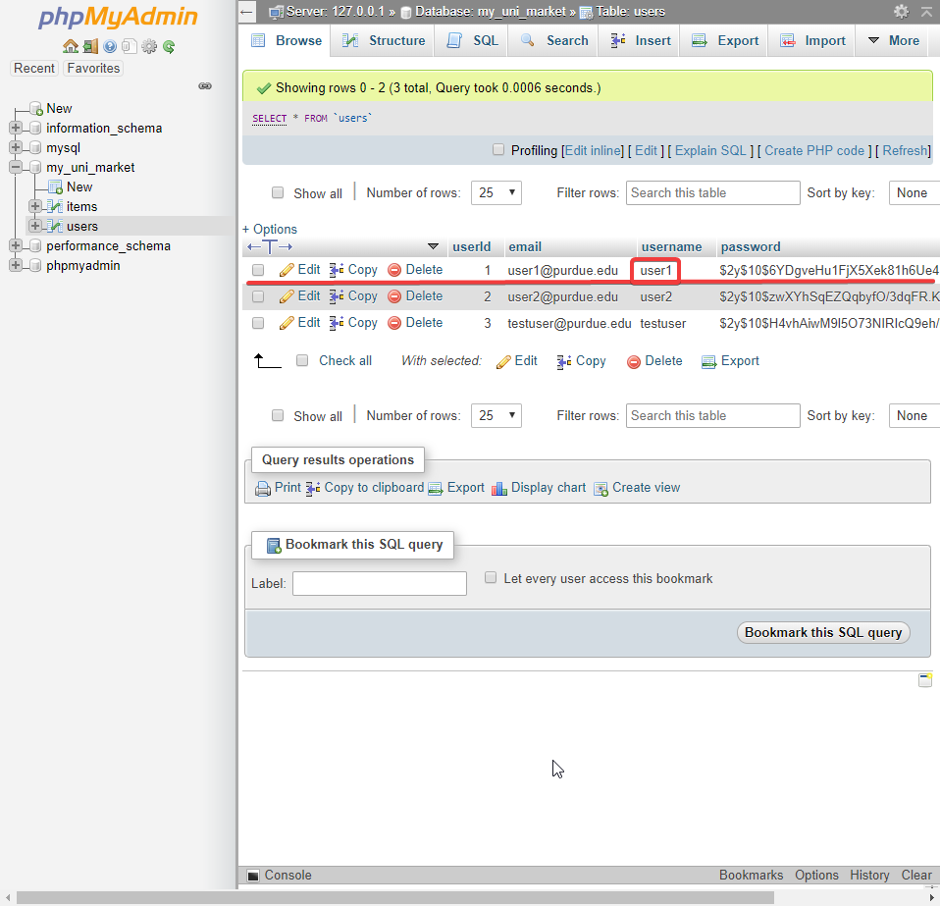
4. The user clicks “CONFIRM” and the page is reset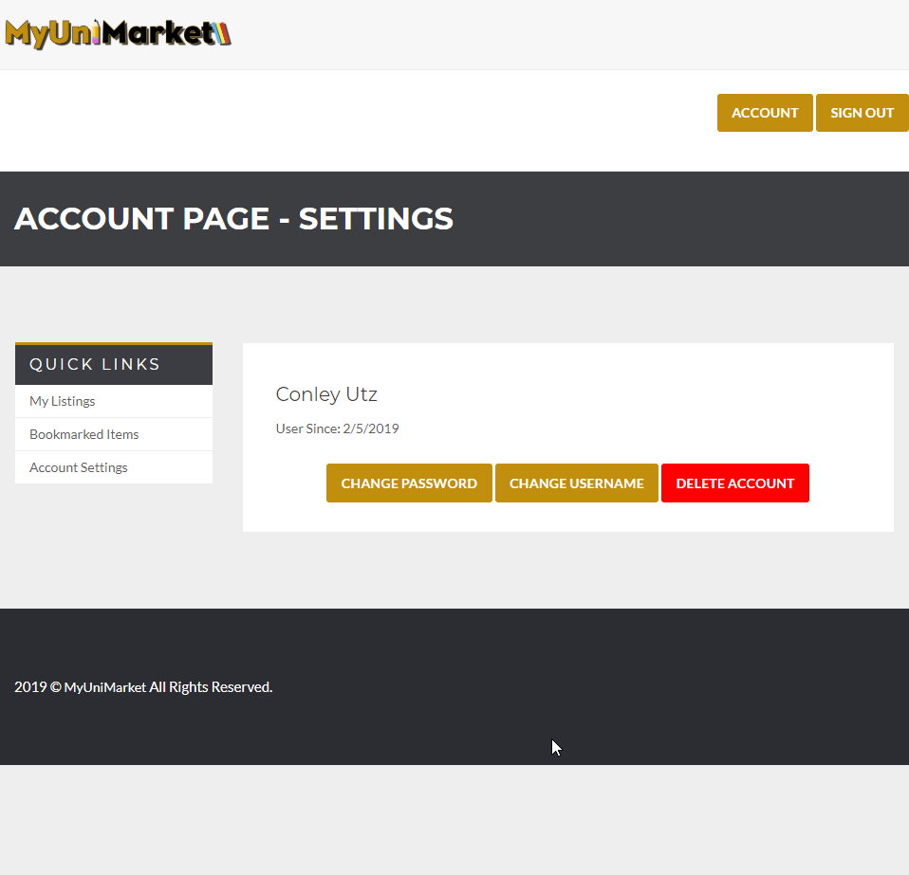
5. The username of the user is changed in the database. 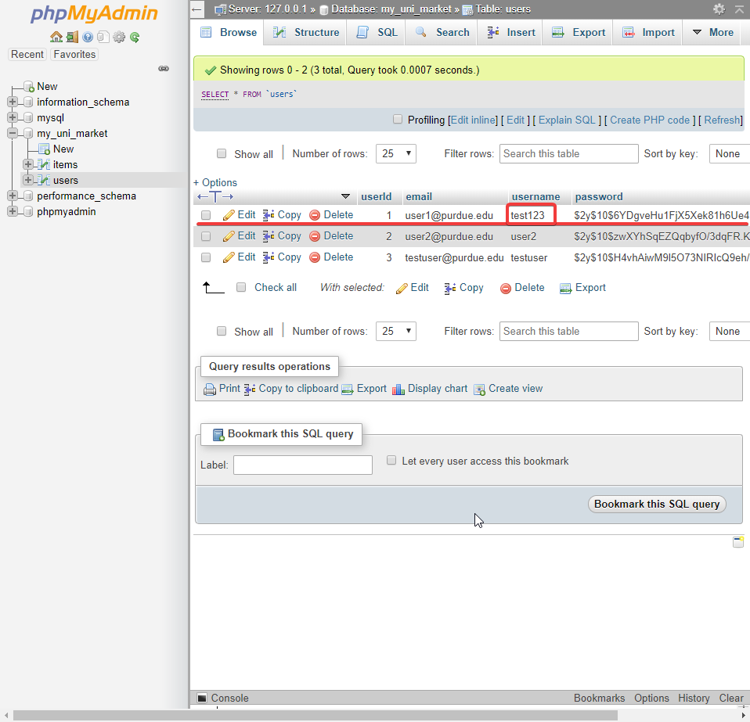

Expected Result: The username of the user should change in the database if all the fields are completed correctly.

Test Result: **PASSED**

**Test 2: Given that the user is logged in and has navigated to the account settings page, the user tries to change their password.**

Purpose: To meet the acceptance criteria the user should be able to change their password using their current details.

Steps:

1. The user clicks “CHANGE PASSWORD” button. 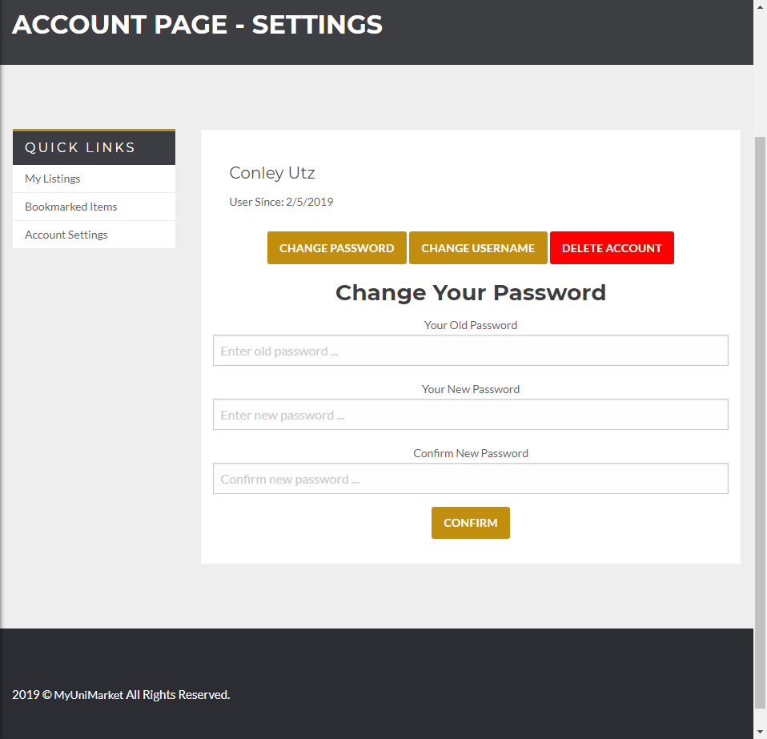
2. The user completes the fields. 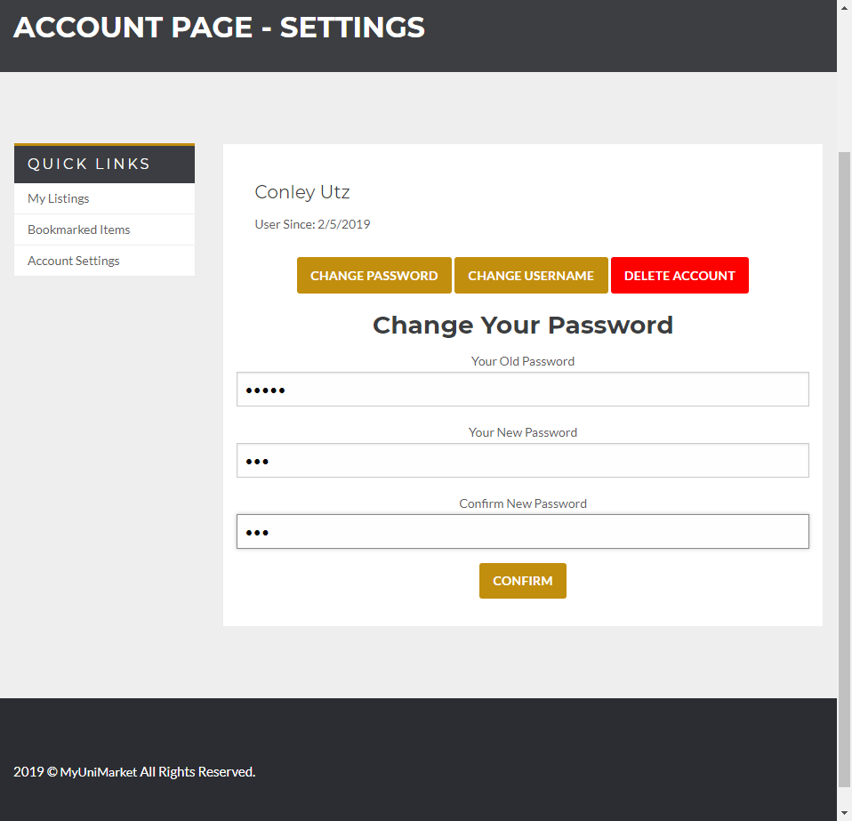
3. The database has the password stored as a hash. (the real password is ‘user1’ and the new password is ‘123’) 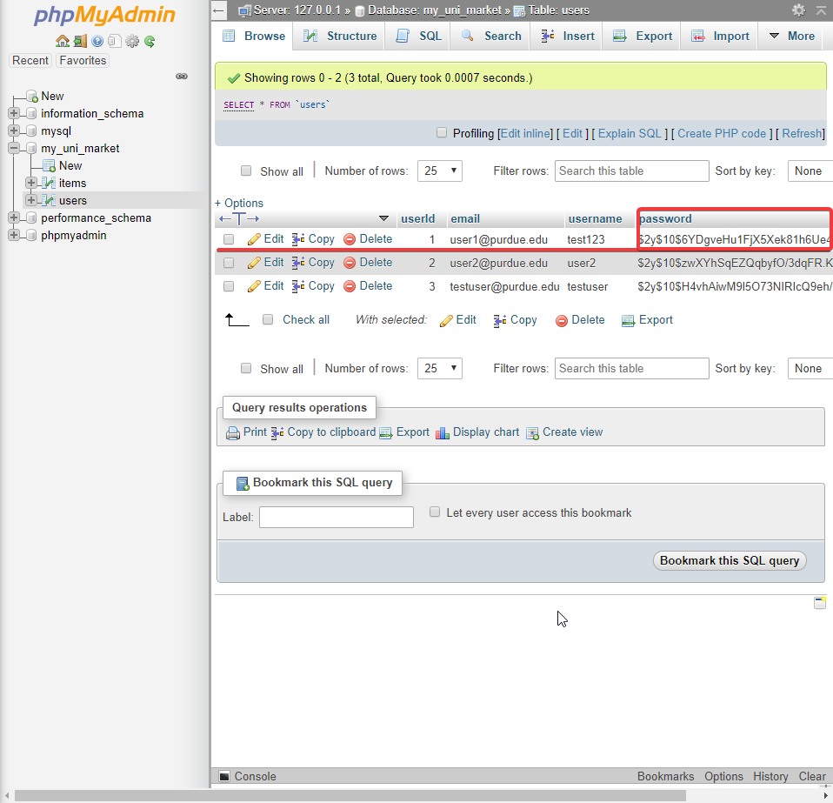
4. The user clicks “CONFIRM” and the page resets. 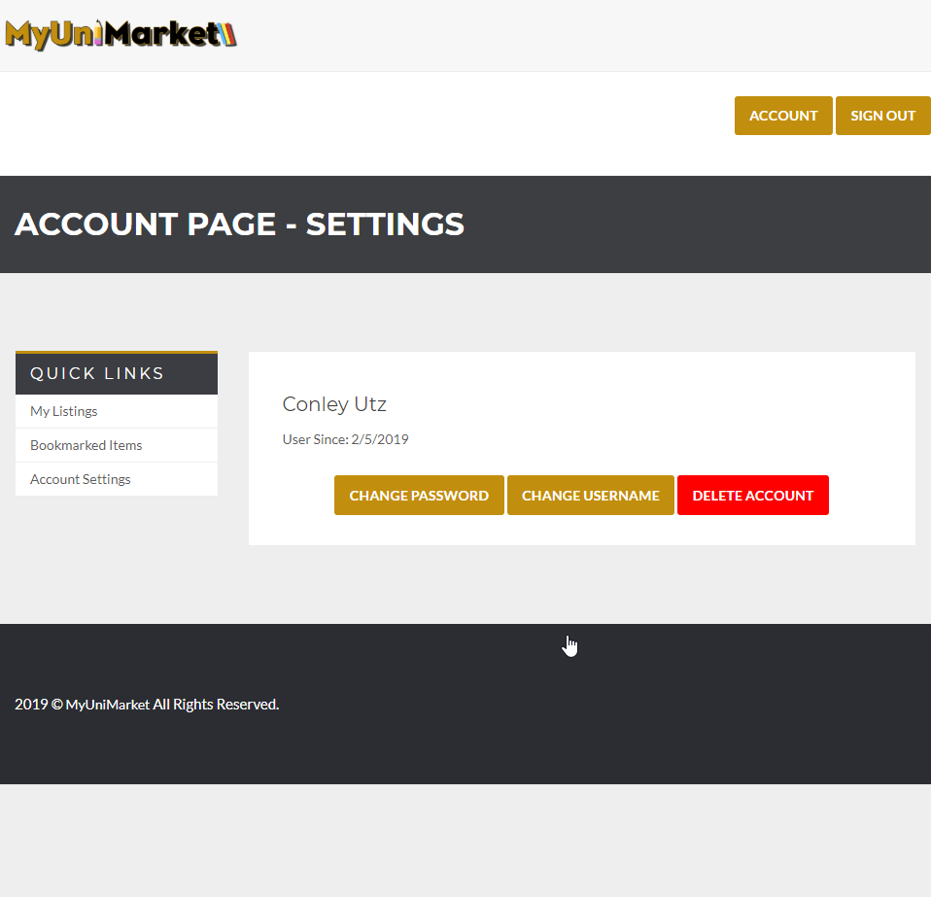
5. The hash of the password changes in the database. 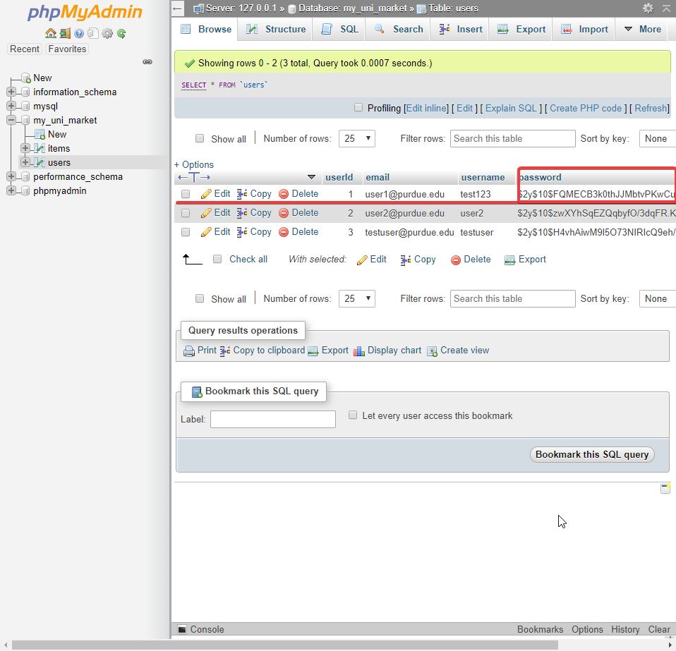

Expected Result: The password of the current user should change in the database.

Test Result: **PASSED**

**Test 3: Given that the user is logged in and has navigated to the account settings page, entering no information or incorrect information in any of the fields will give an error and reset the page.**

Purpose: To meet the acceptance criteria the user should be notified when they have not completed a field or have completed it incorrectly.

Steps:

1. The user clicks “CHANGE PASSWORD” 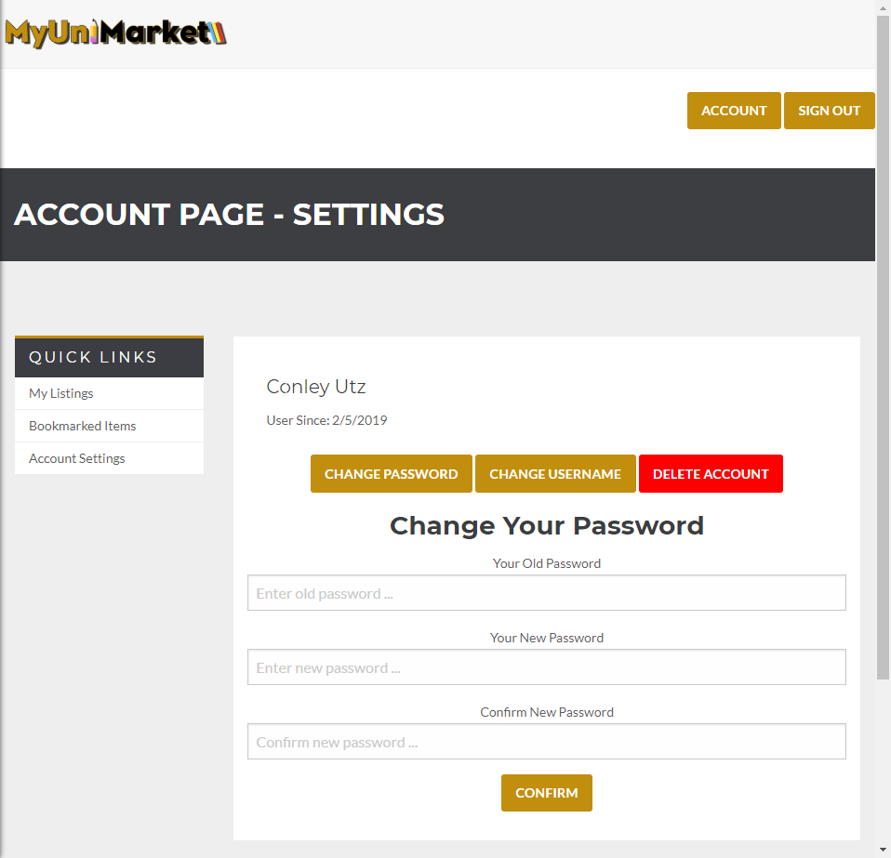
2. The user clicks confirm without entering any information 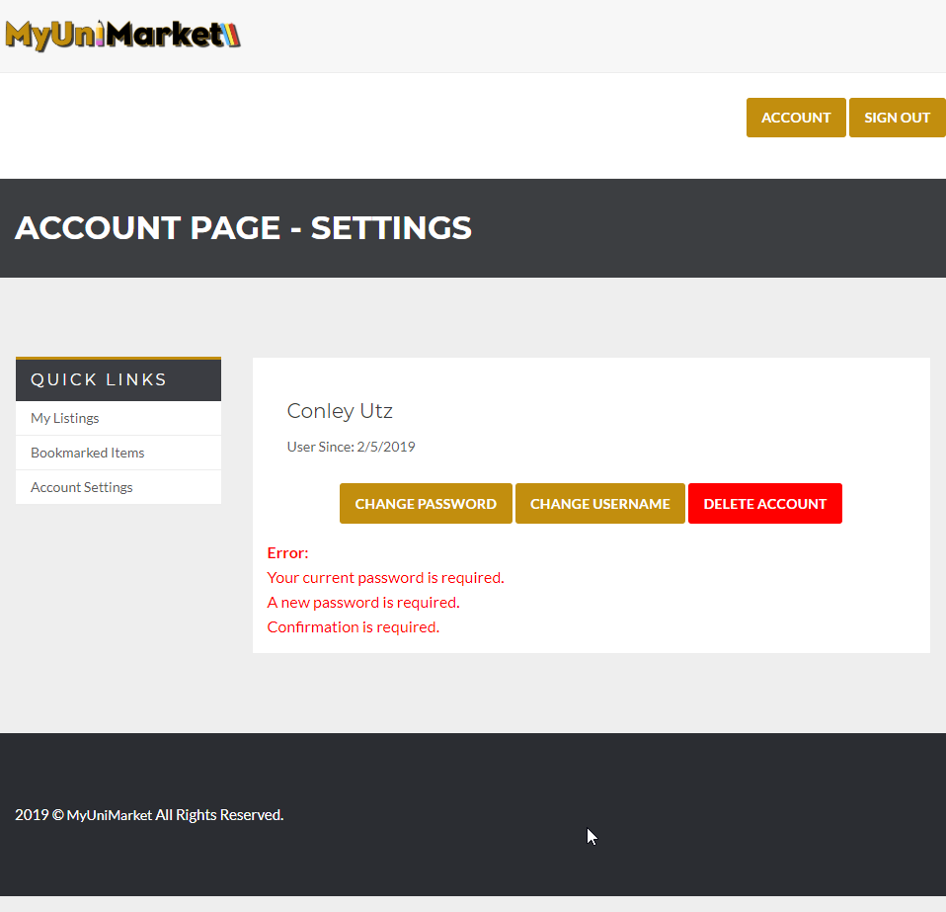
3. The user enters incorrect password and clicks confirm. 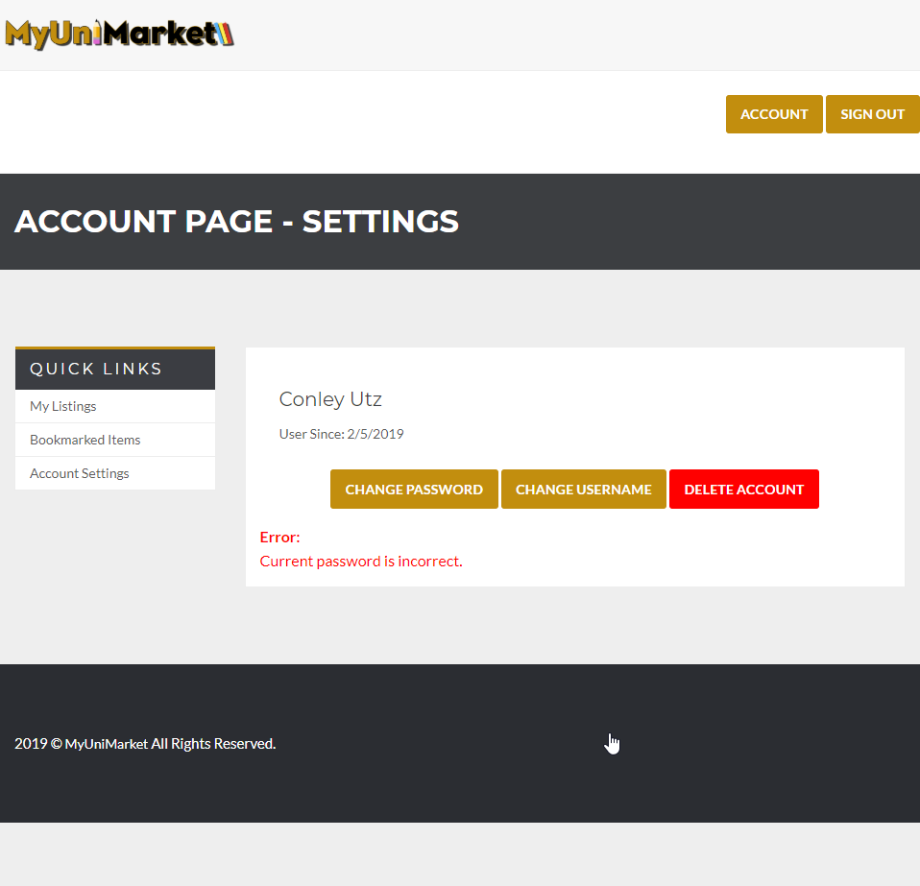
4. The user enters the current password correctly but enters the new password confirmation field wrong. 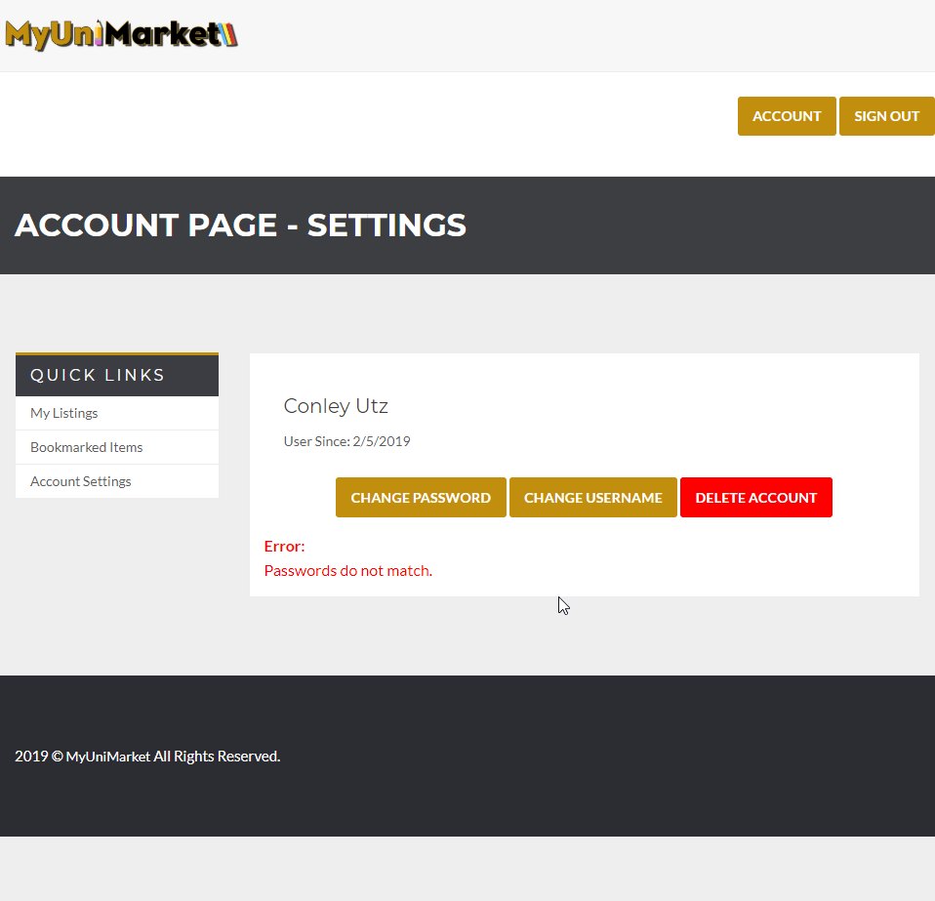
5. The user clicks “CHANGE USERNAME” 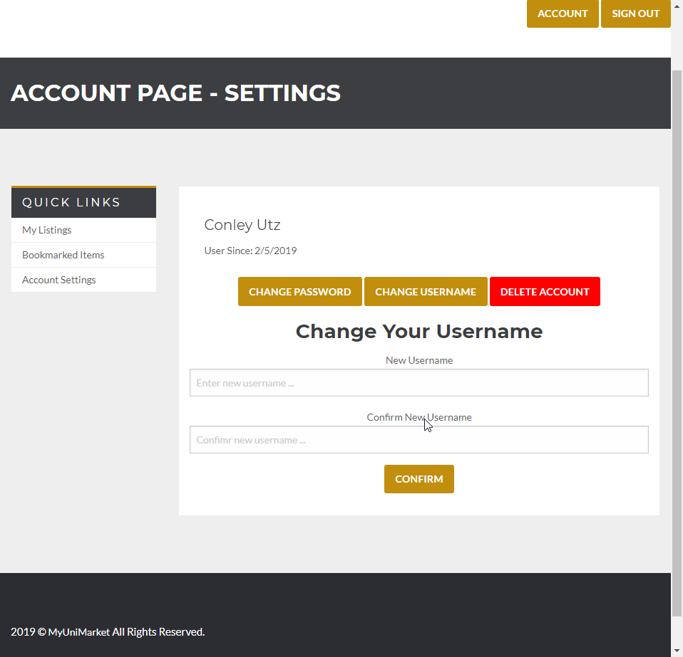
6. The user clicks confirm without entering any information 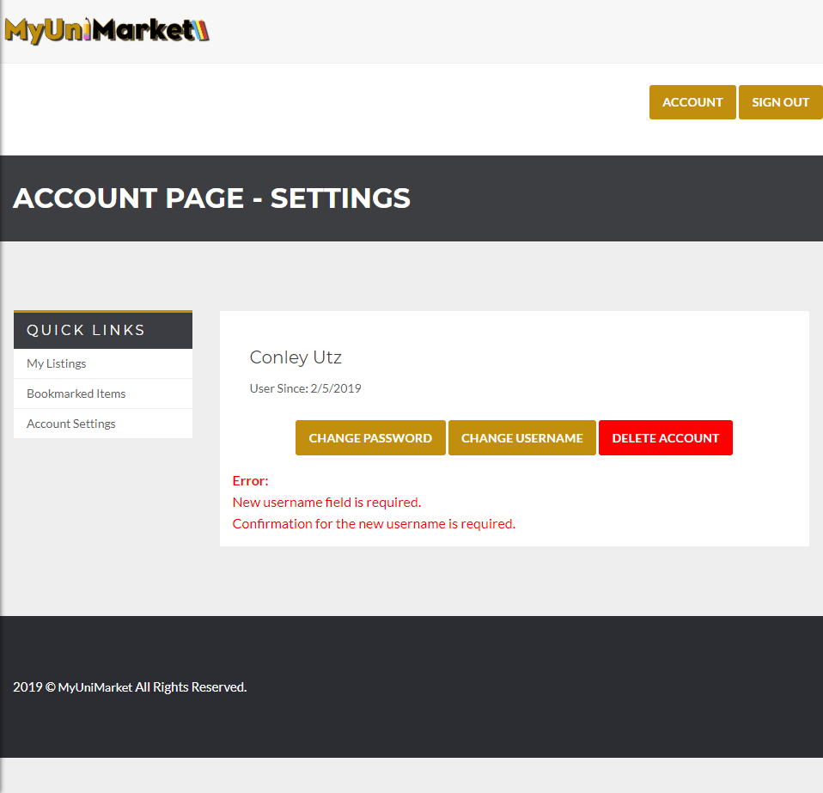
7. The user mistypes confirmation field 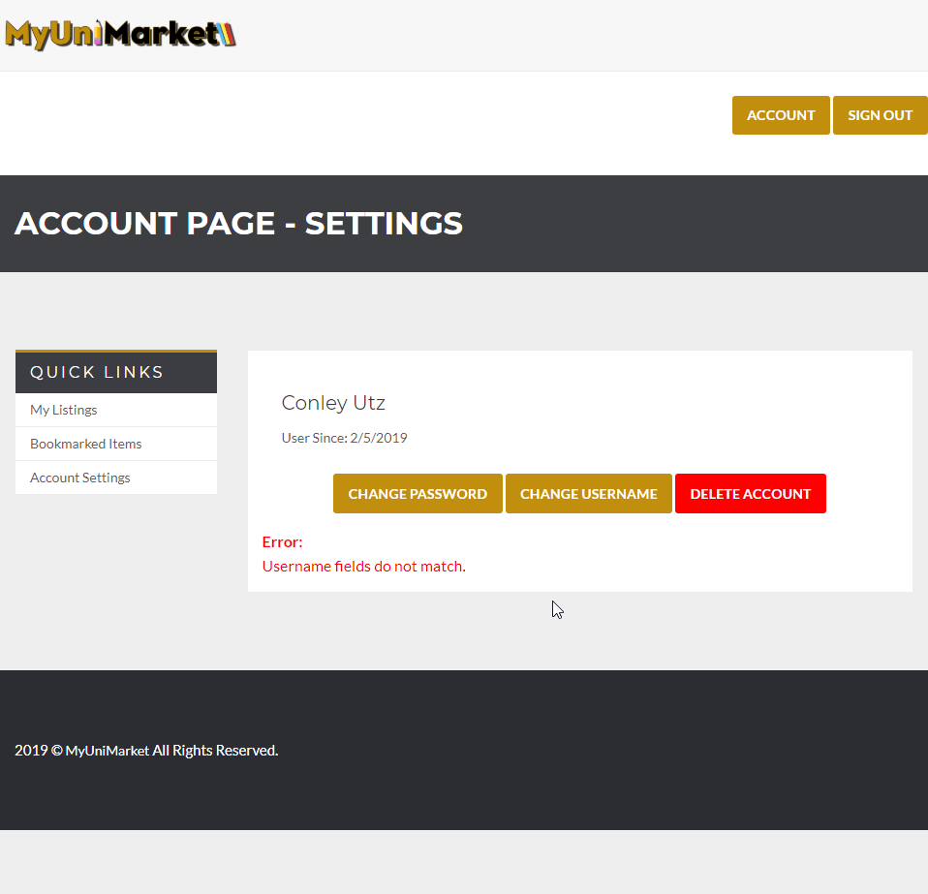

Expected Result: The website notifies the user when they have entered information incorrectly.

Test Result: **PASSED**

# User Story #05

**Test 1: Given that the user is logged in and has navigated to the account settings page, the user should be able to delete their account.**

Purpose: To meet the acceptance criteria a user has to be able to delete their account which is removed from the database as a consequence.

Steps:

1. The user clicks “DELETE ACCOUNT” 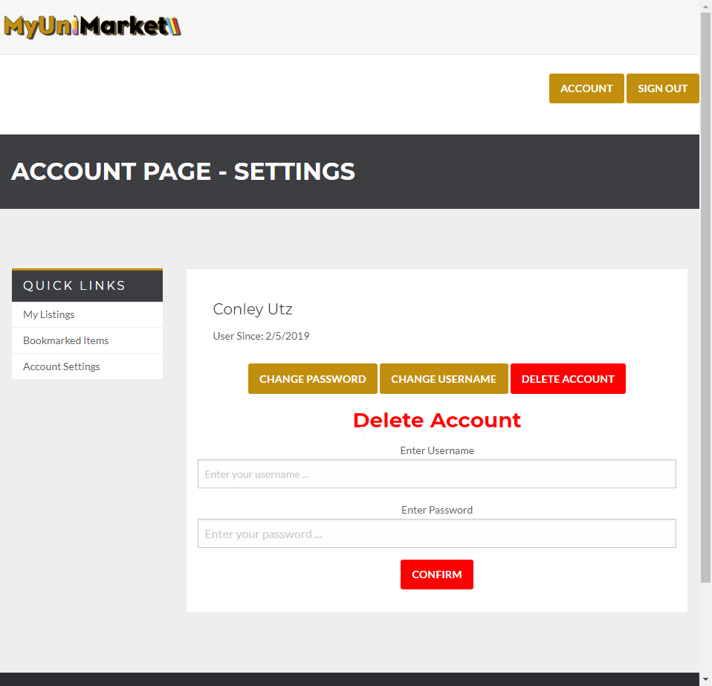
2. The user enters all fields correctly. 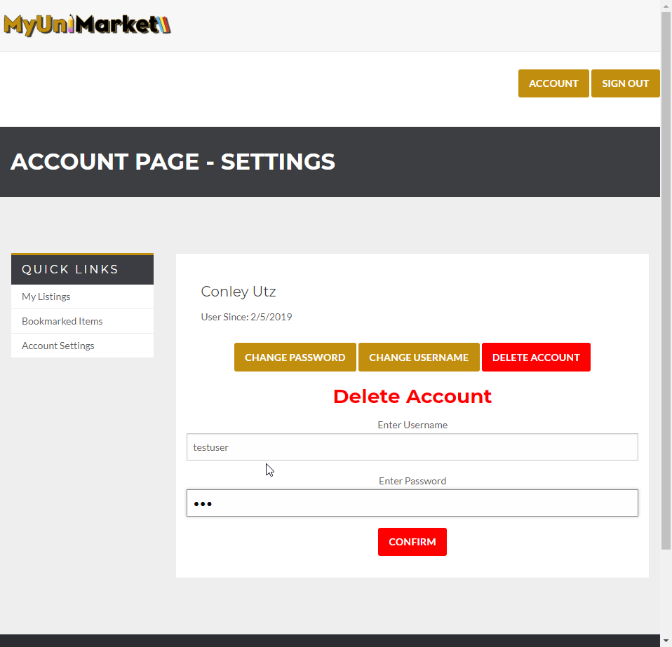
3. The user currently is in the database. 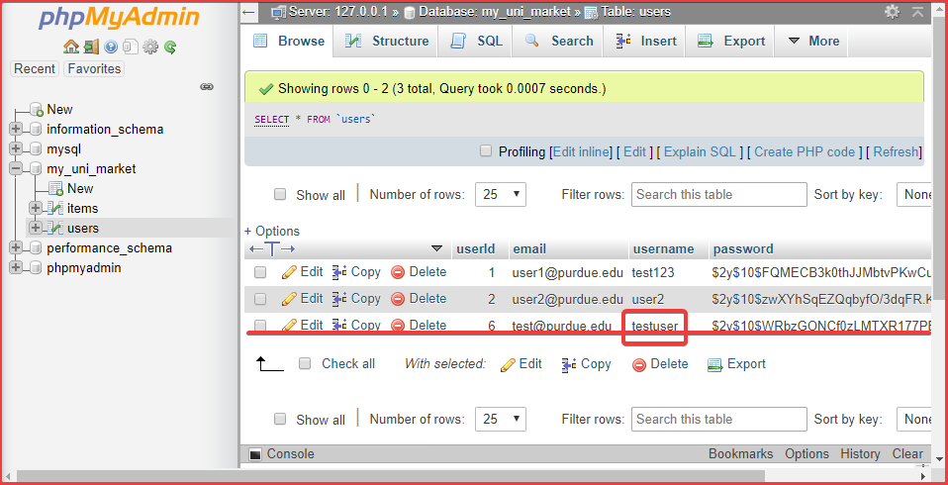
4. The user clicks “CONFIRM” and is logged out automatically. 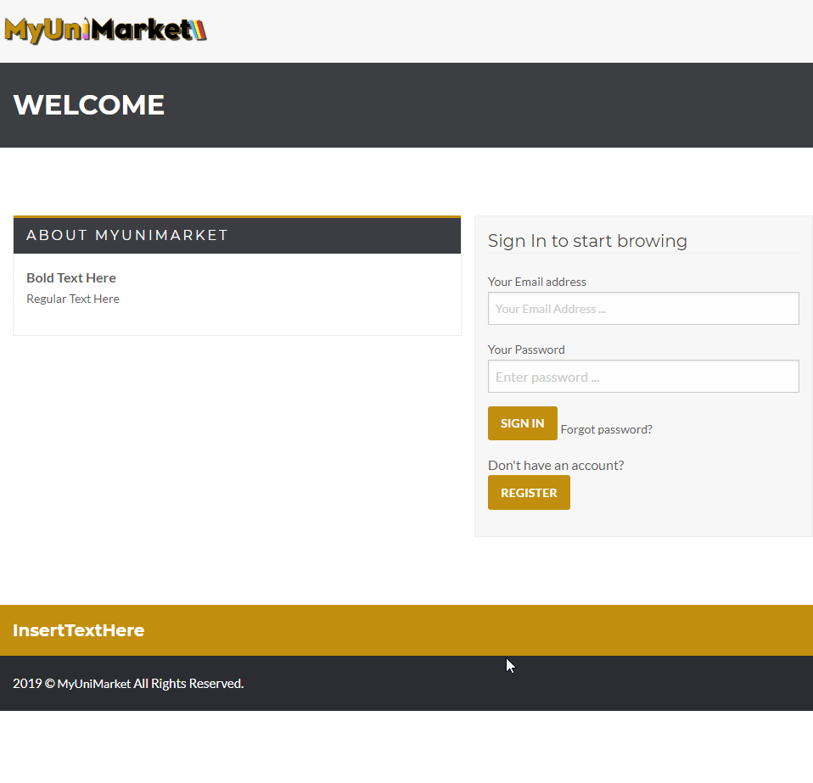
5. The user is deleted from the database. 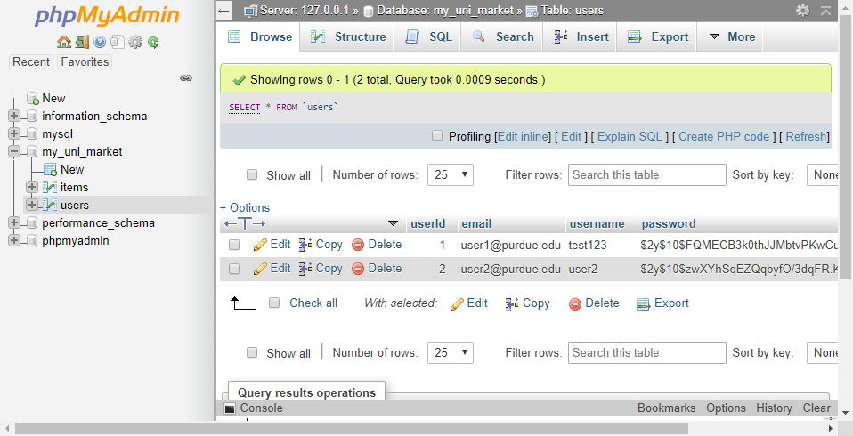

Expected Result: After deleting the account the user must be signed out automatically and their account details must be removed from the database.

Test Result: **PASSED**

# User Story #06

**Test 1.1: Given that the user have not filled out all required fields in the listing, if they attempt to post their listing, then the listing is not added to the database and they are prompted to fill the remaining required fields**

Purpose: To meet acceptance criteria that improperly formatted listings are not added to the database

Steps:

1. User does not enter any required information

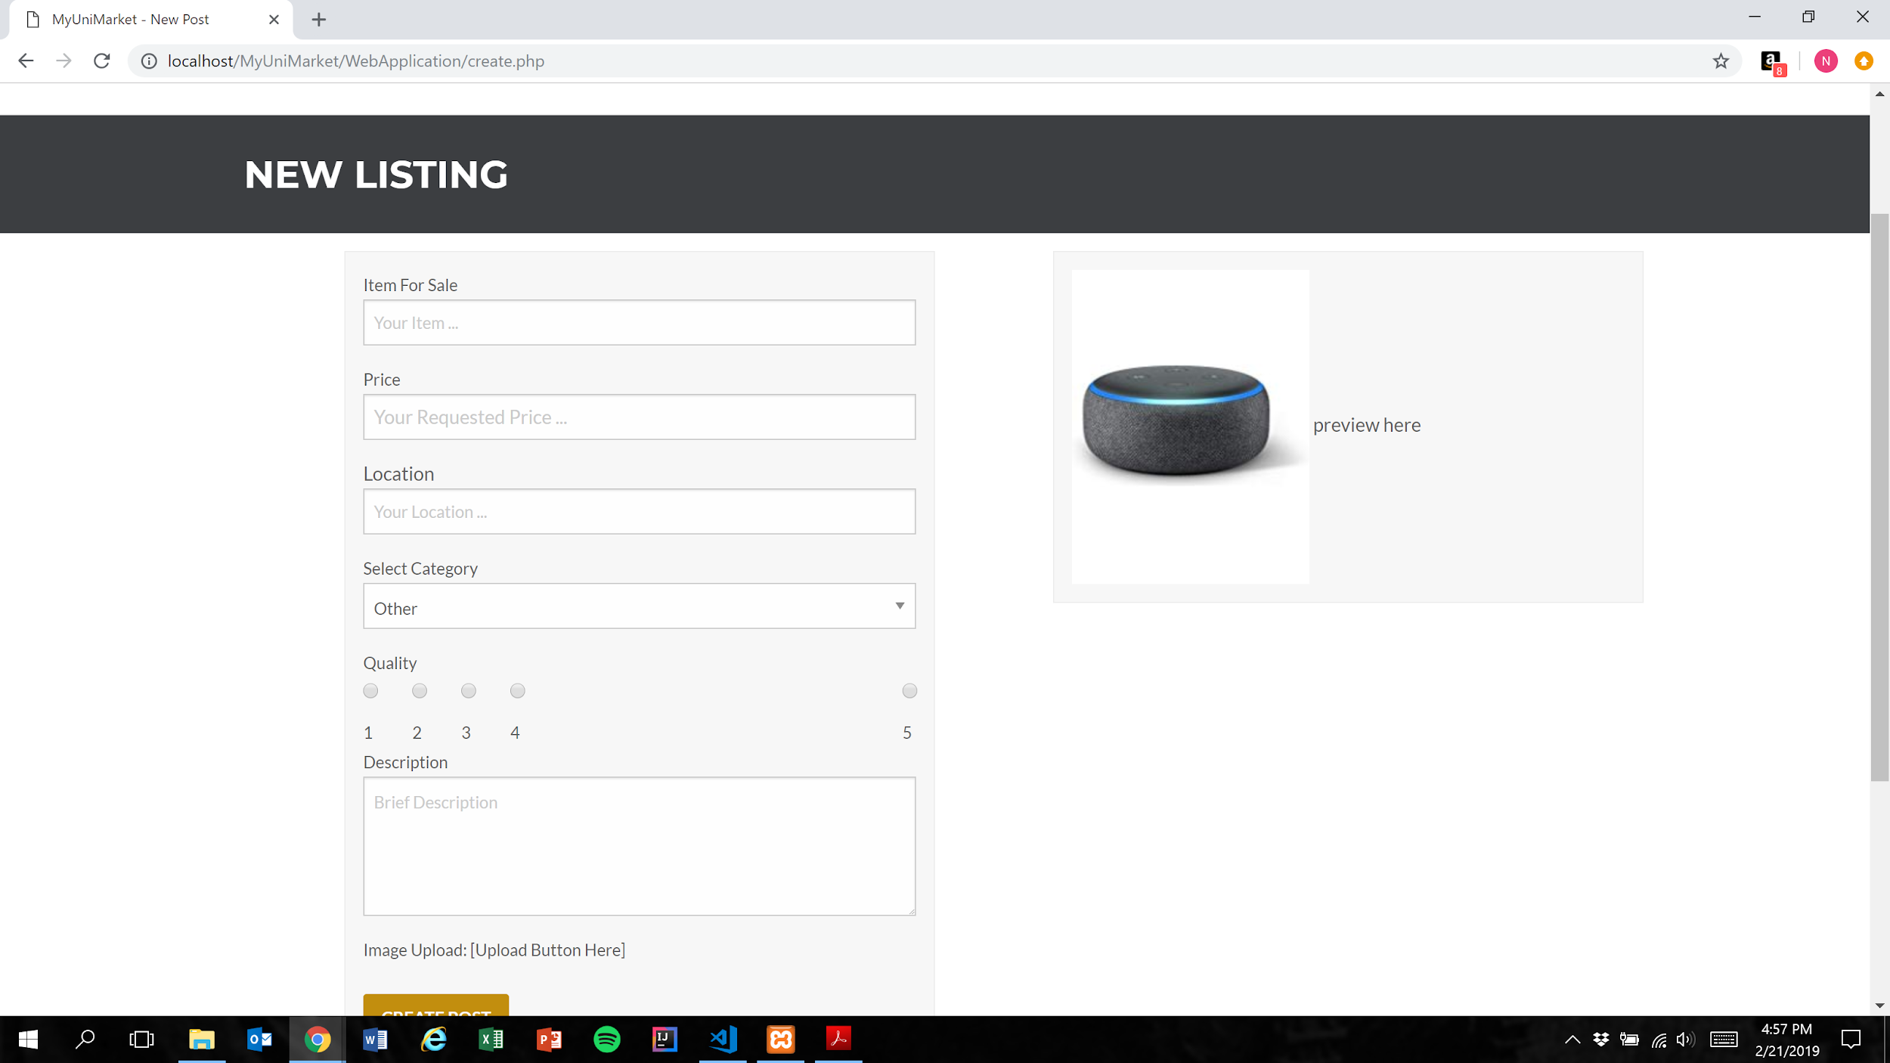

2. User presses the create post button

Figure 1

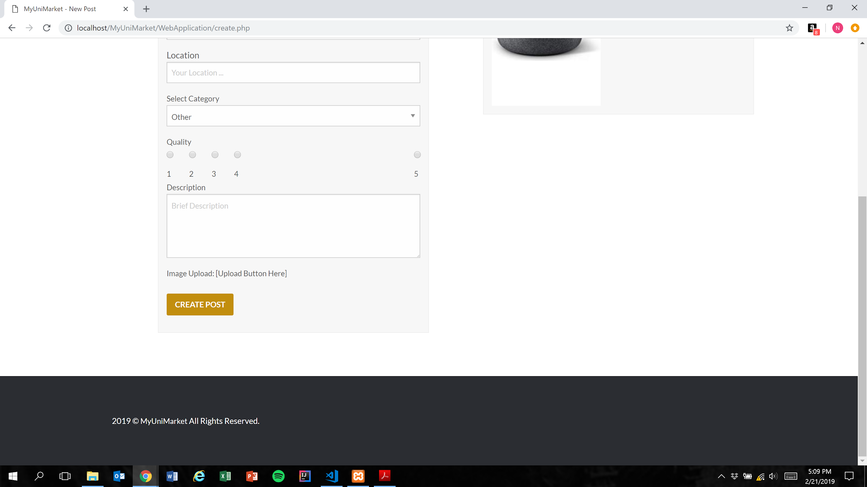

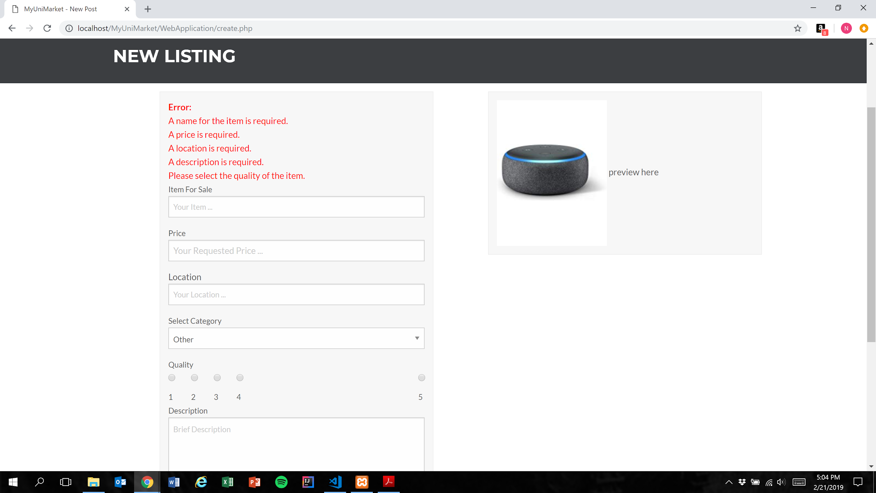

Expected Result: Listing is not added to the database and user is shown error messages for each missing category

Test Result: **PASSED**

**Test 2: Given that the user have not filled out all required fields in the listing, if they attempt to post their listing, then the listing is not added to the database and they are prompted to fill the remaining required fields**

Purpose: To meet acceptance criteria that improperly formatted listings are not added to the database

Steps:

1. User inputs text into the “Item For Sale” field only

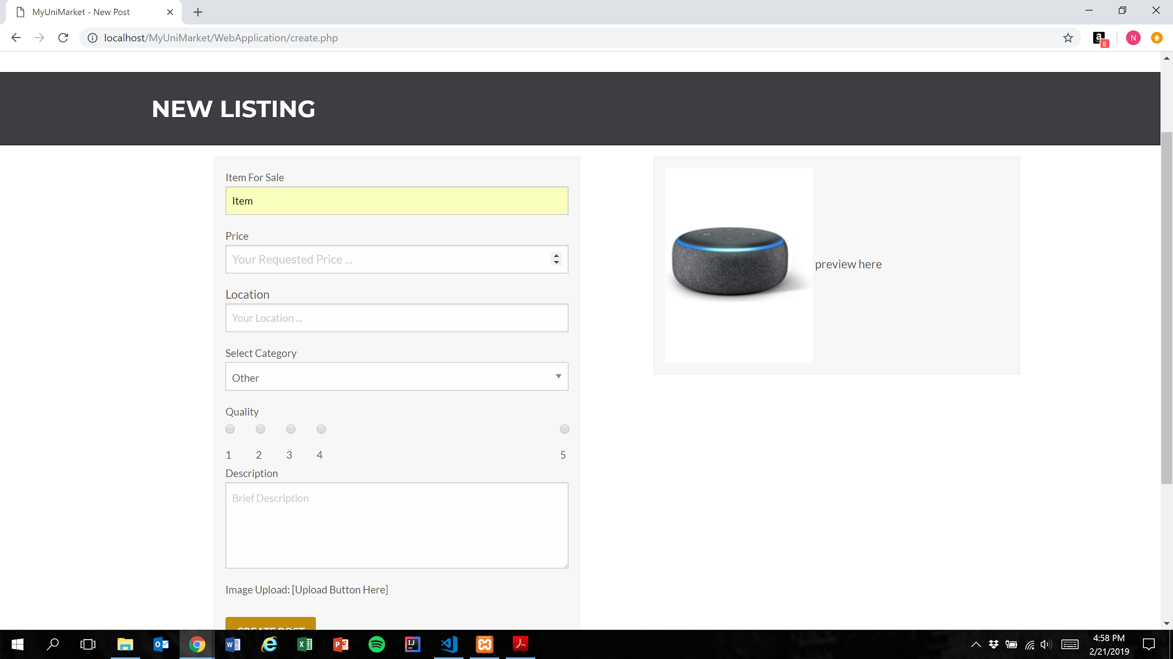

1. User presses the create post button (Figure 1)

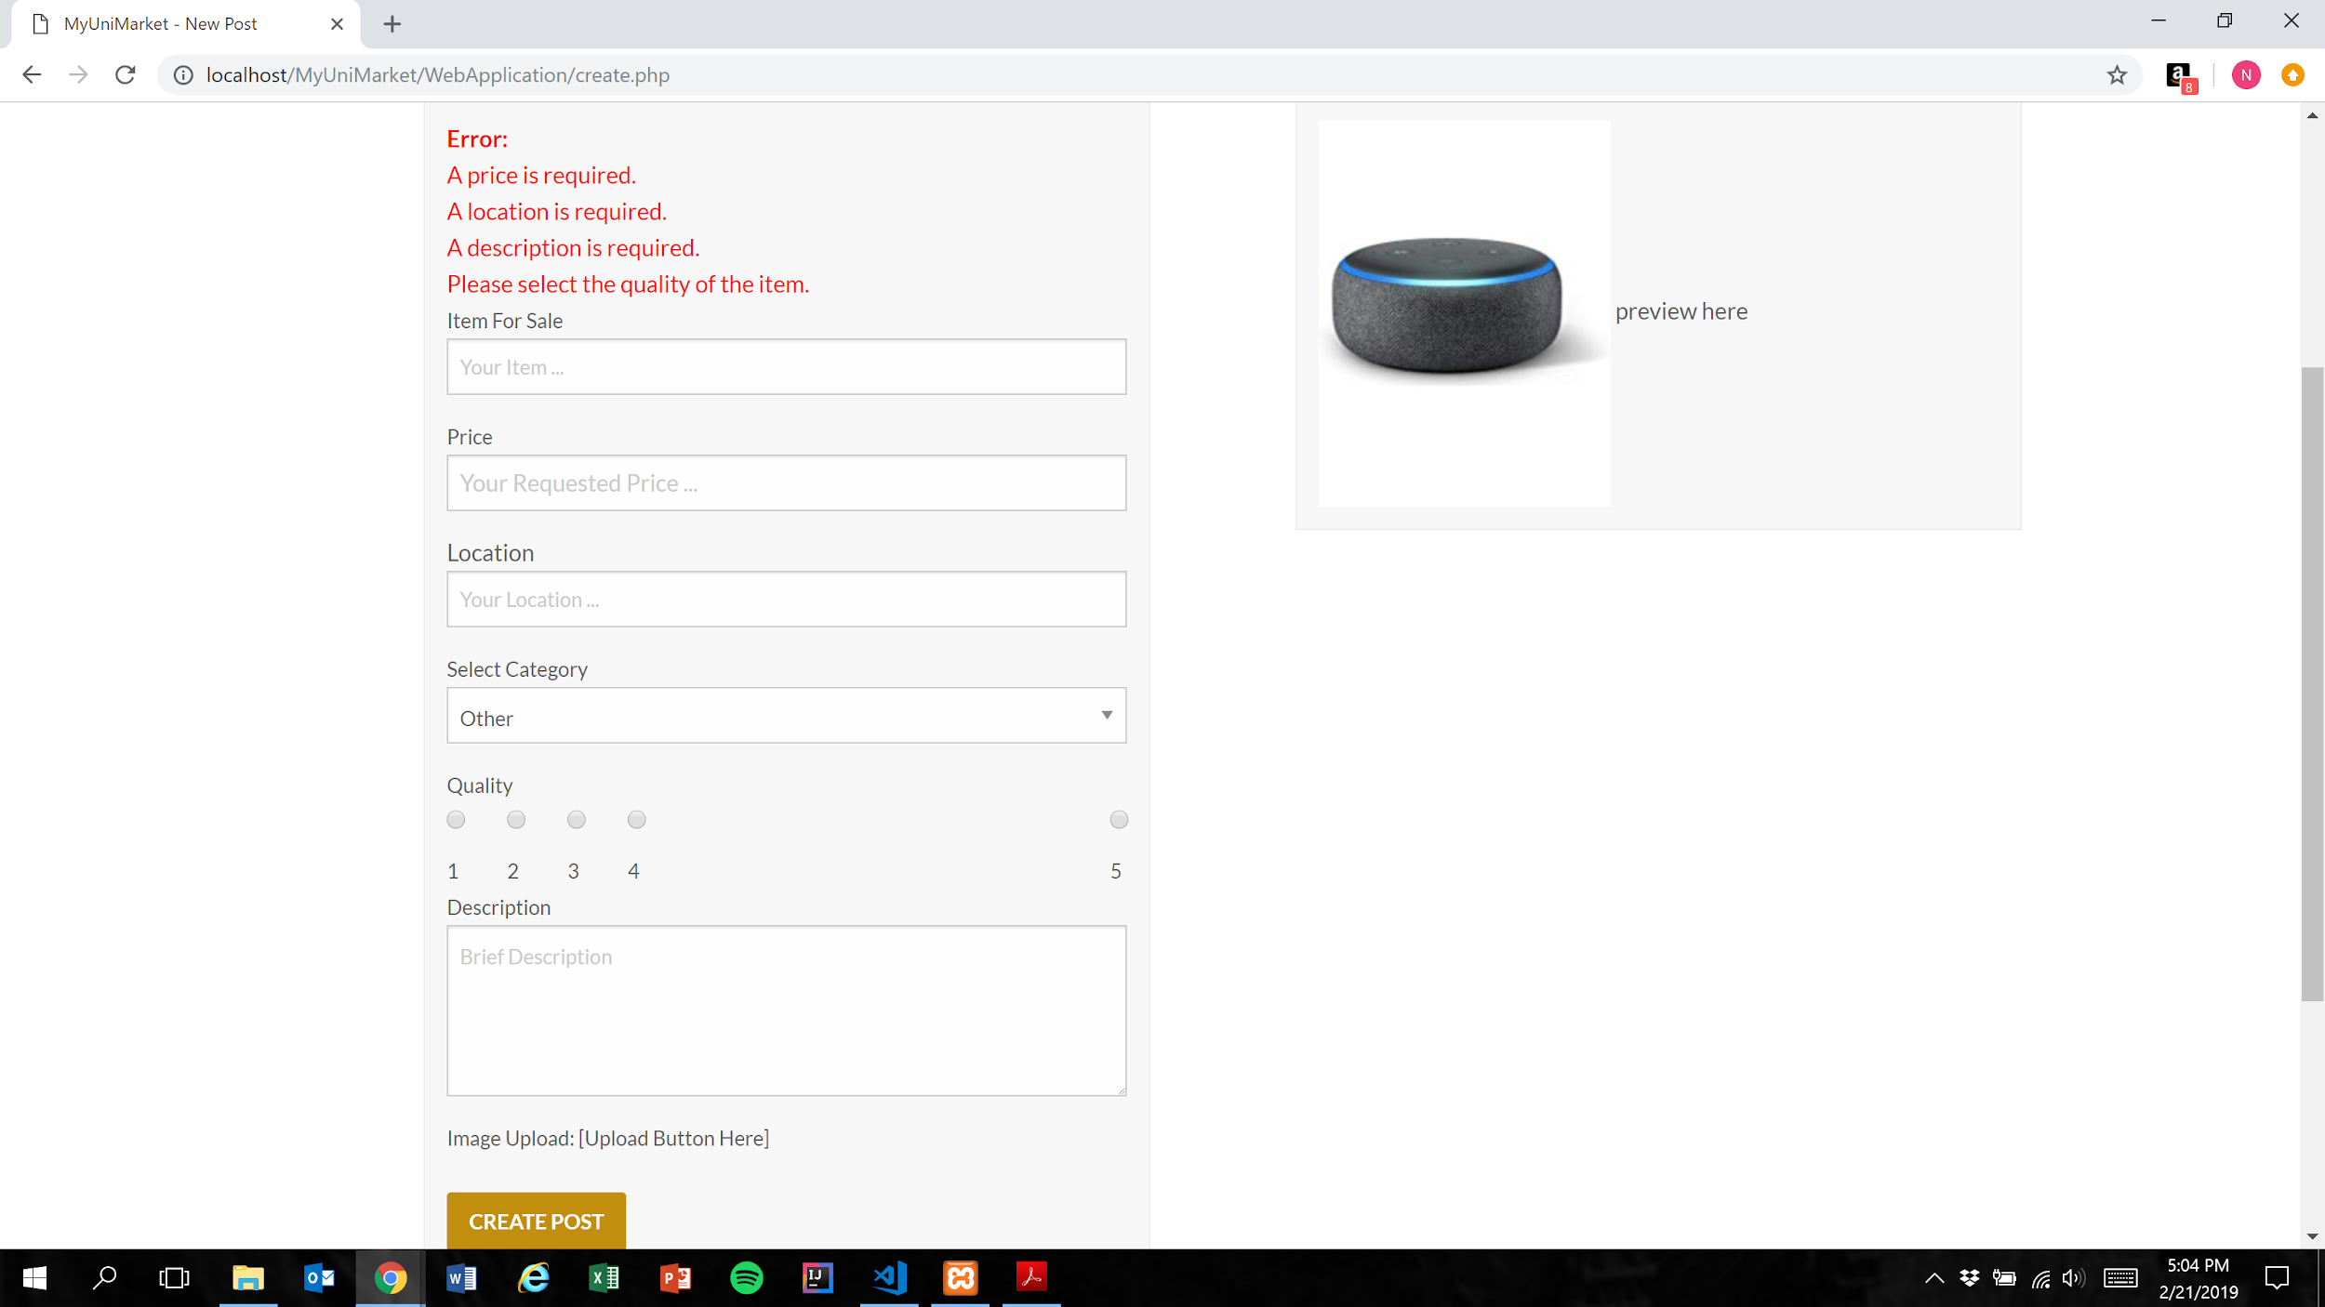

Expected Result: Listing is not added to the database and user is shown error messages for each remaining missing category

Test Result: **PASSED**

**Test 3: Given that the user have not filled out all required fields in the listing, if they attempt to post their listing, then the listing is not added to the database and they are prompted to fill the remaining required fields**

Purpose: To meet acceptance criteria that improperly formatted listings are not added to the database

Steps:

1. User inputs text into the “Item For Sale” and “Price” fields only

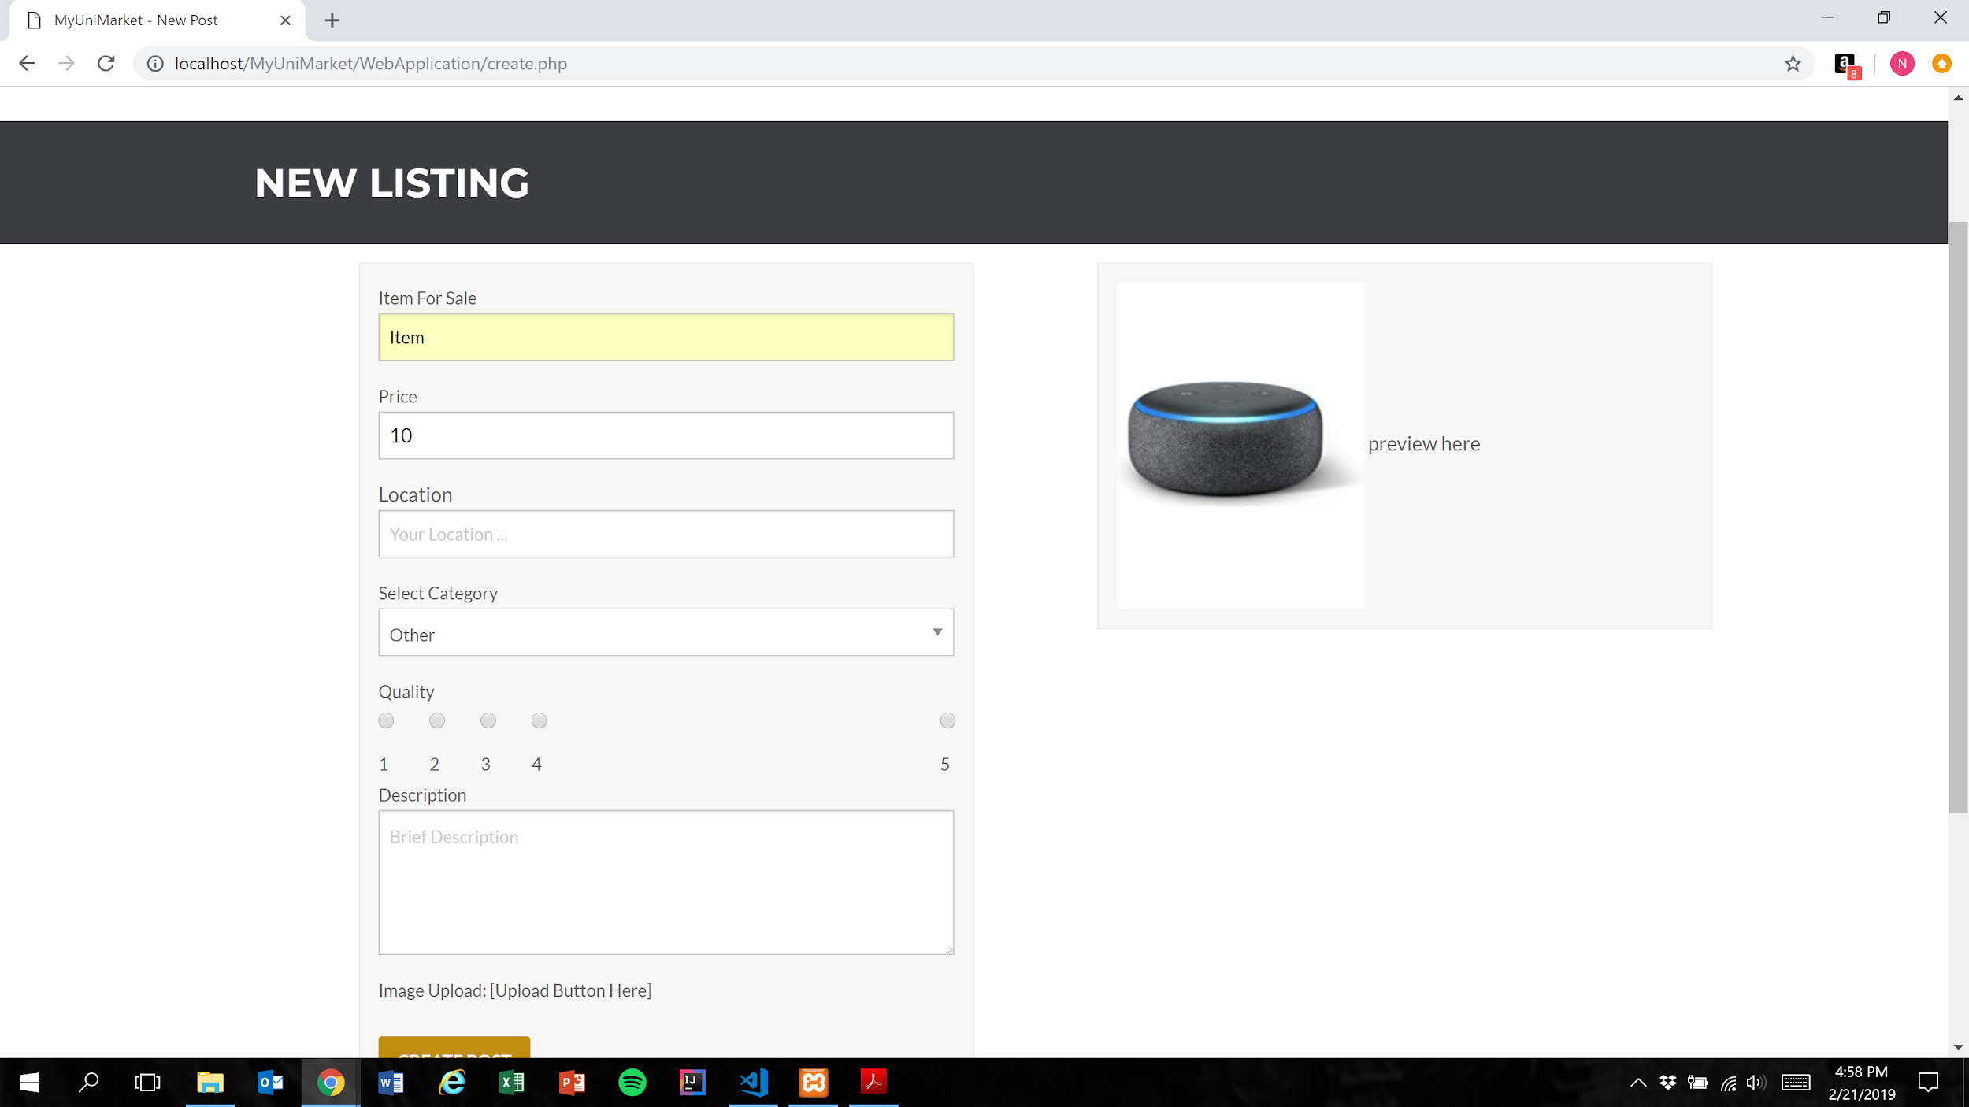

1. User presses the create post button (Figure 1)

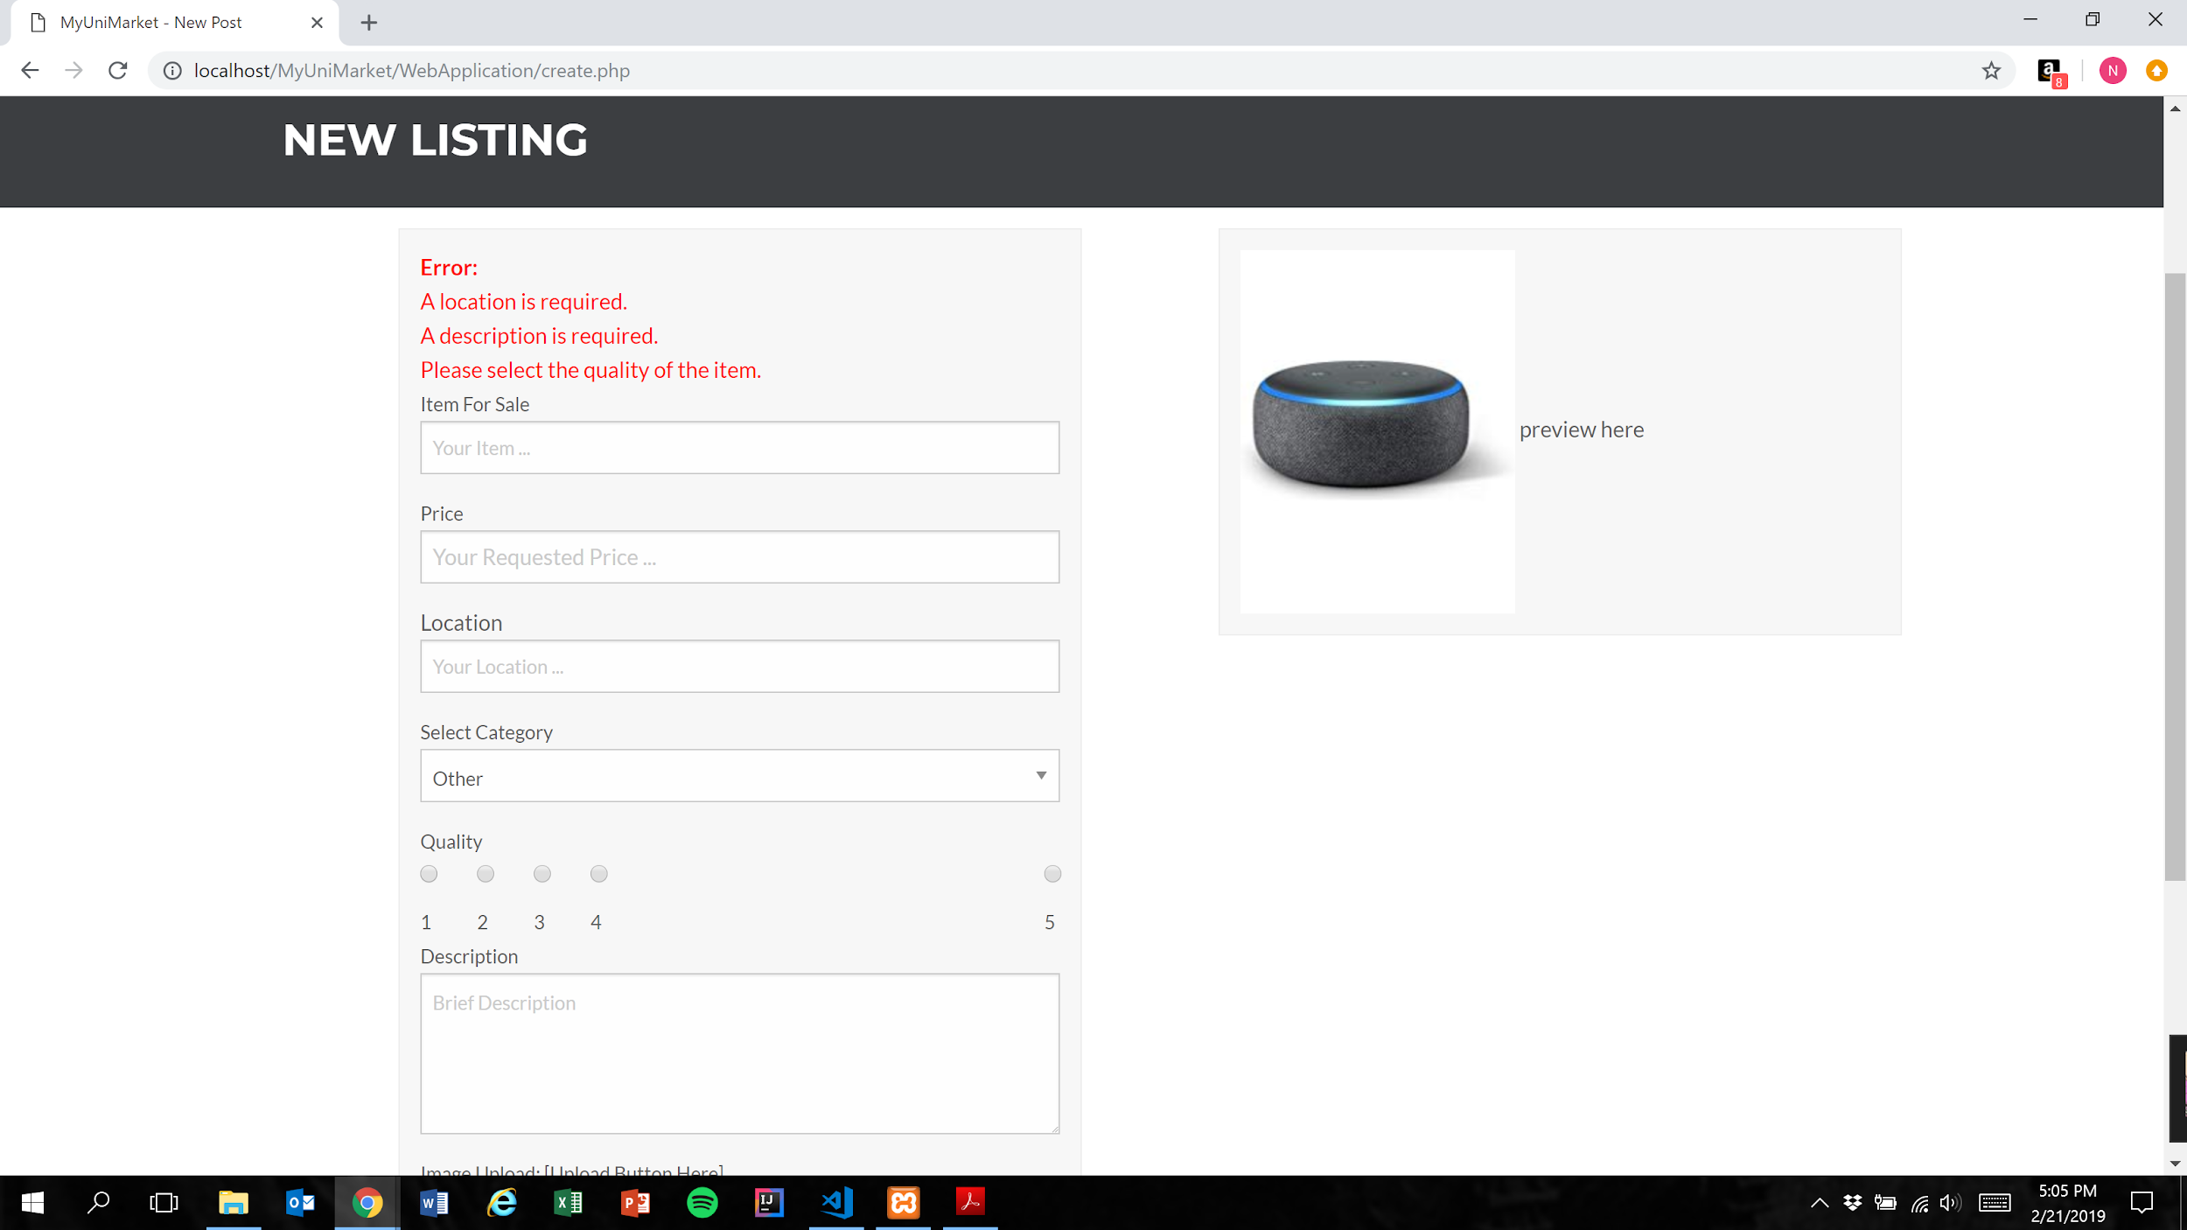

Expected Result: Listing is not added to the database and user is shown error messages for each remaining missing category

**NOTE:** In price field, user is only able to type number characters and the “.” character. This functionality cannot be shown via screenshots but is important to mention

Test Result: **PASSED**

**Test 4: Given that the user have not filled out all required fields in the listing, if they attempt to post their listing, then the listing is not added to the database and they are prompted to fill the remaining required fields**

Purpose: To meet acceptance criteria that improperly formatted listings are not added to the database

Steps:

1. User inputs text into the “Item For Sale”, “Price”, and “Location” fields only

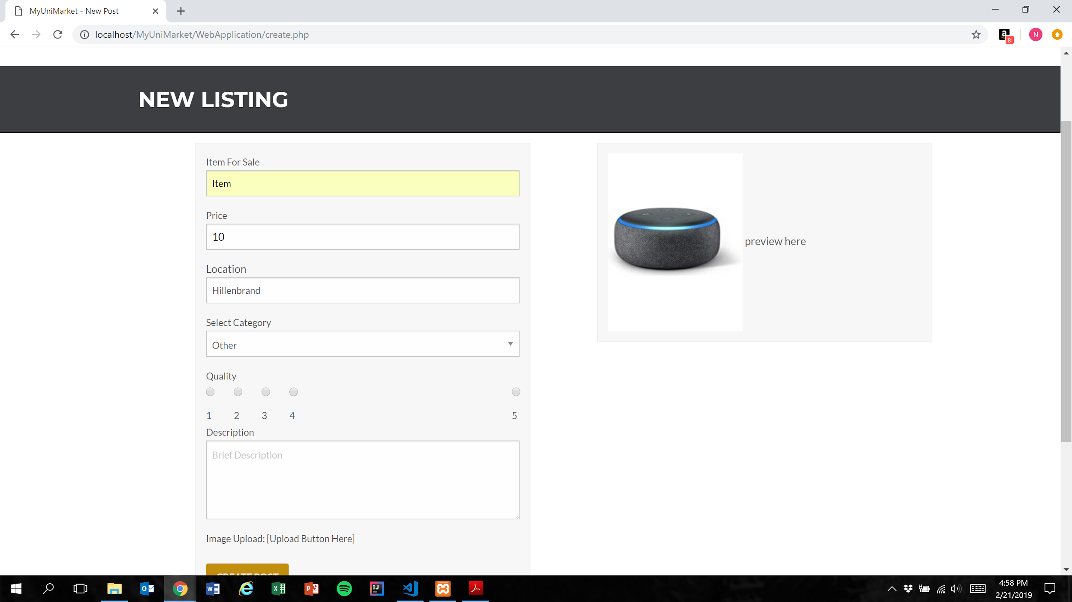

1. User presses the create post button (Figure 1)

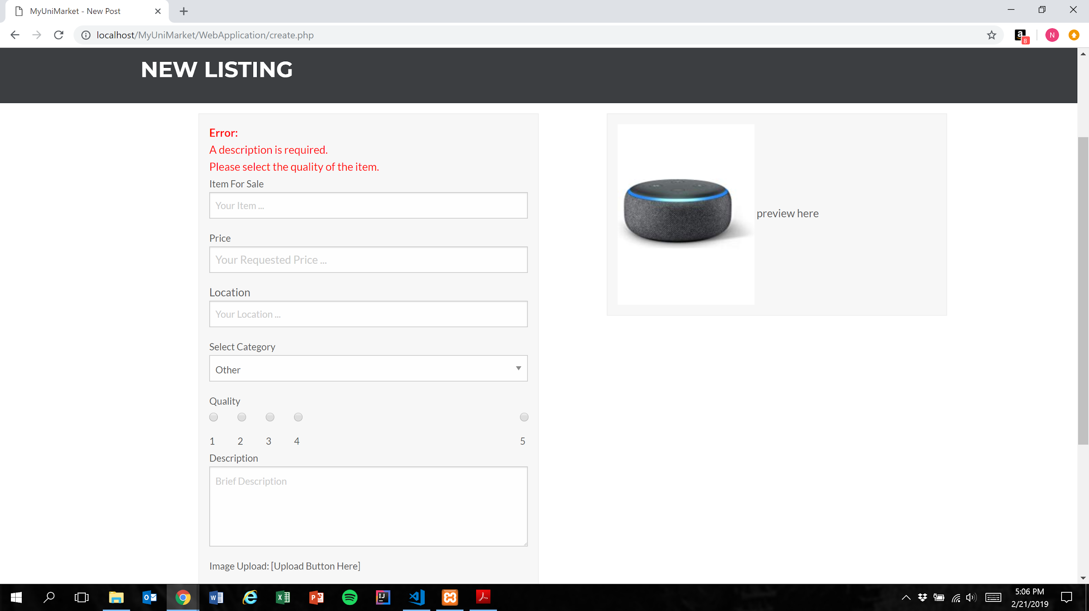

Expected Result: Listing is not added to the database and user is shown error messages for each remaining missing category

Test Result: **PASSED**

**Test 4: Given that the user have not filled out all required fields in the listing, if they attempt to post their listing, then the listing is not added to the database and they are prompted to fill the remaining required fields**

Purpose: To meet acceptance criteria that improperly formatted listings are not added to the database

Steps:

1. User inputs text into the “Item For Sale”, “Price”, and “Location” fields and selects an option for the “Quality” field only

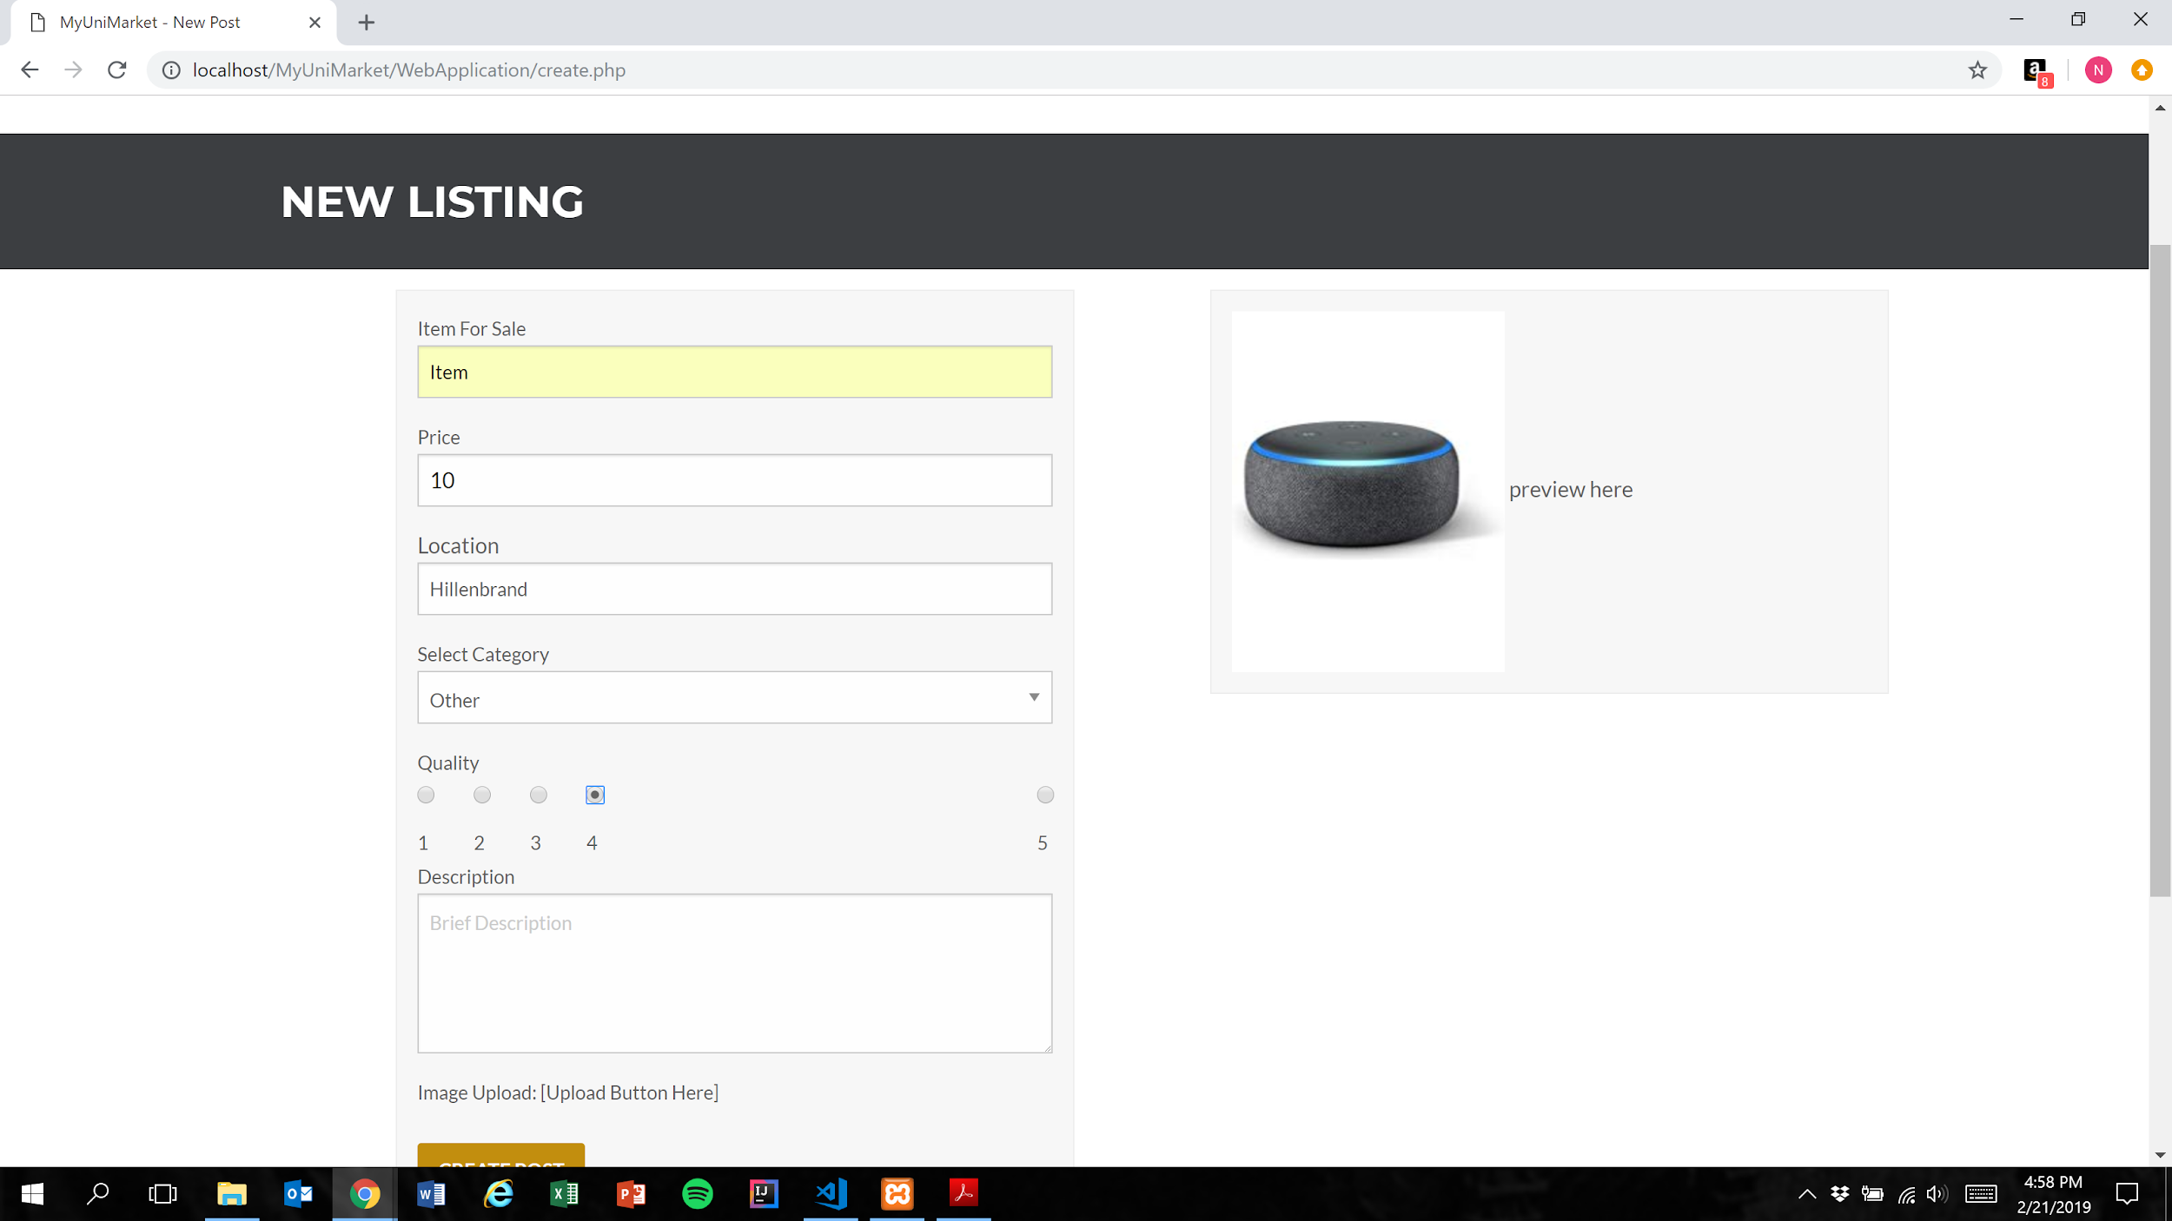

1. User presses the create post button (Figure 1)

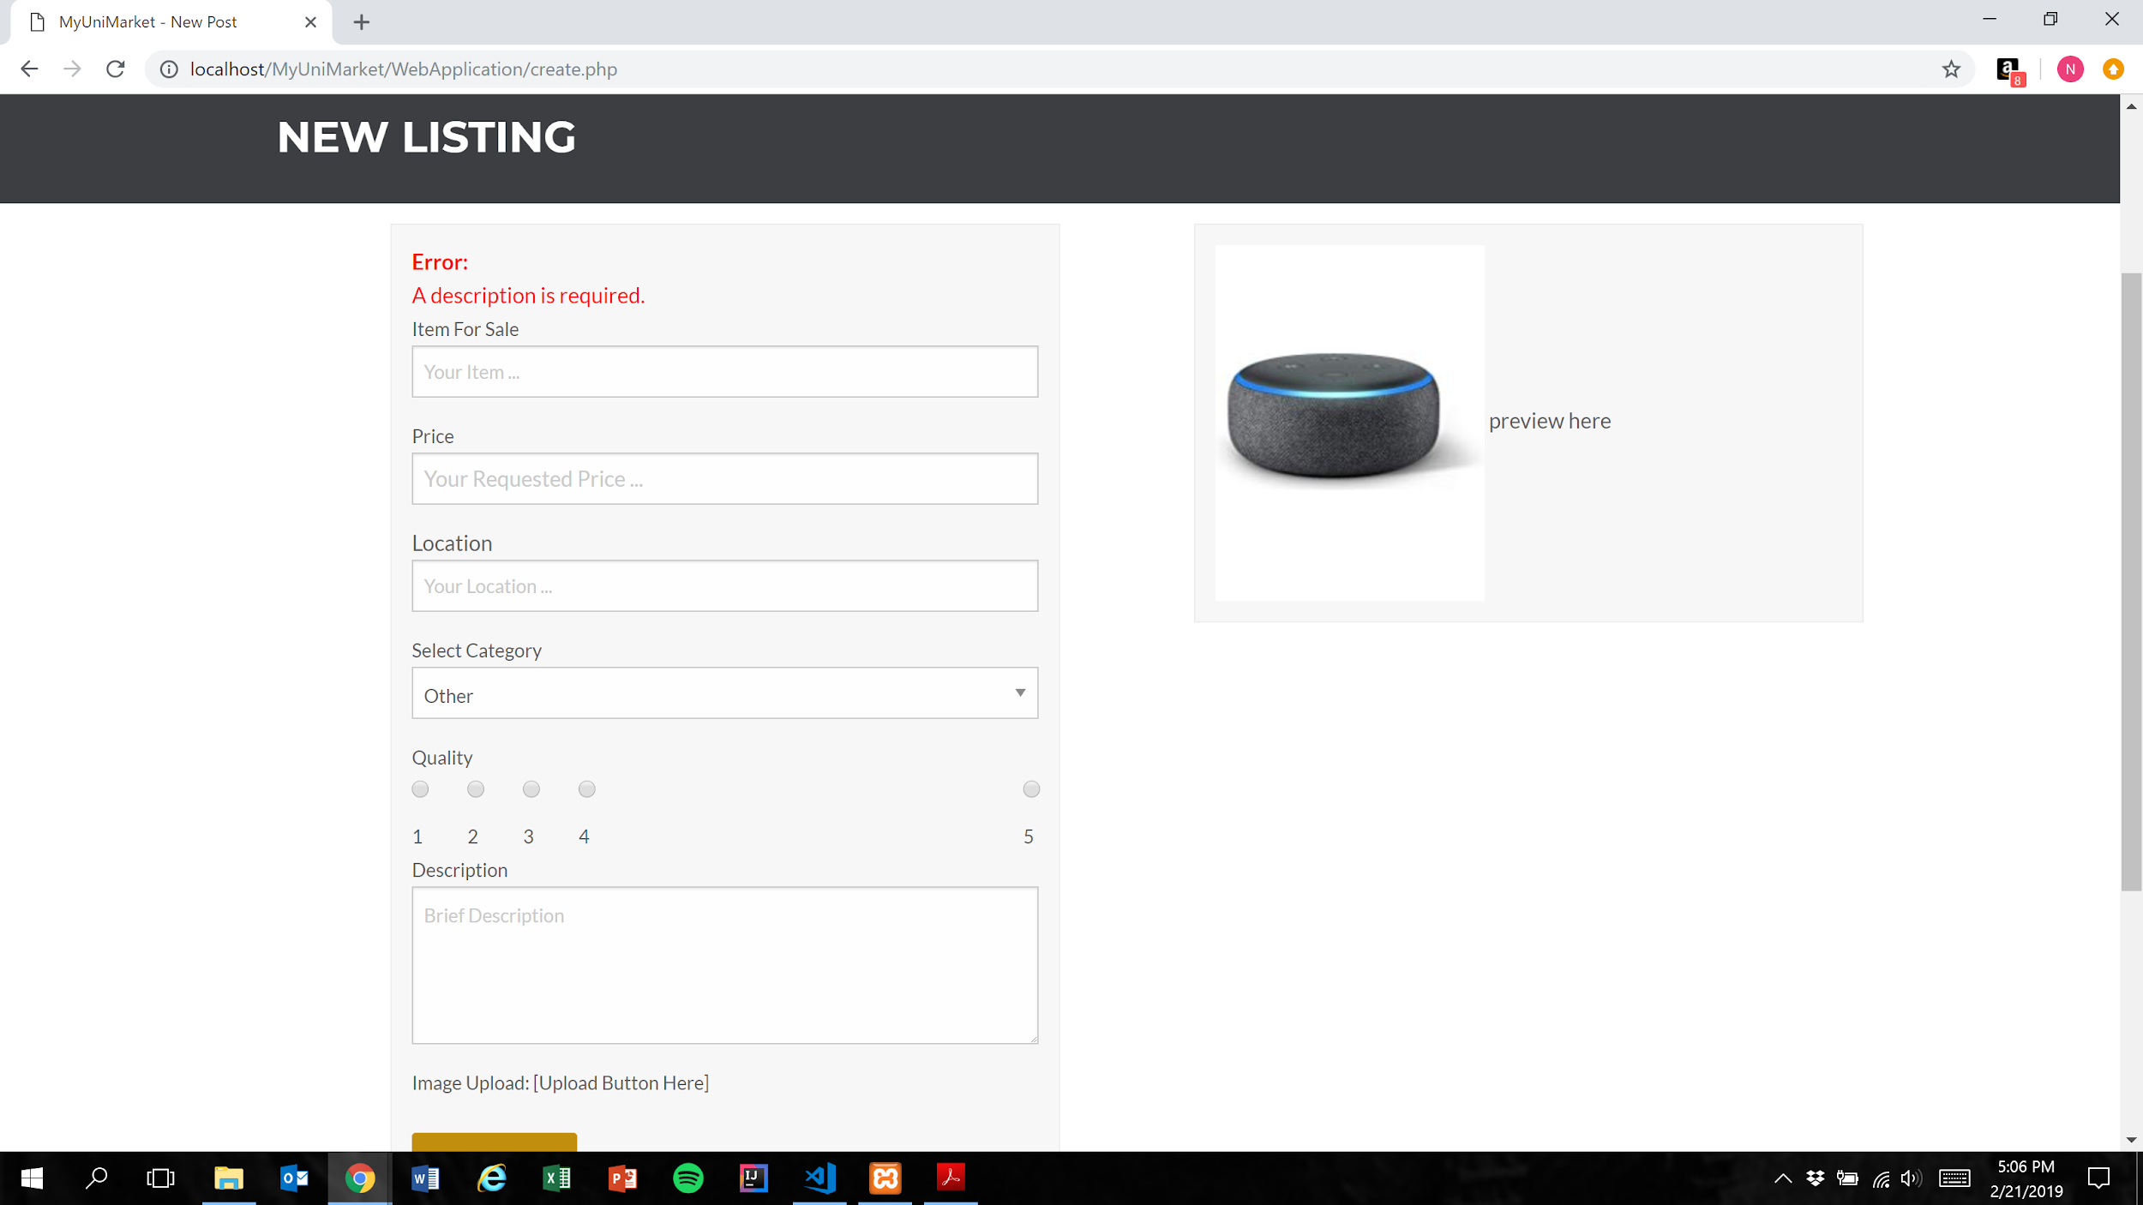

Expected Result: Listing is not added to the database and user is shown error messages for each remaining missing category

Test Result: **PASSED**

**Test 5: Given that the user has filled out all required fields in the listing, if they attempt to post their listing, then the listing is added to the database**

Purpose: To meet acceptance criteria that properly formatted listings are added to the database

Steps:

1. User inputs text into the “Item For Sale”, “Price”, “Location”, and “Description” fields and selects an option for the “Quality” field

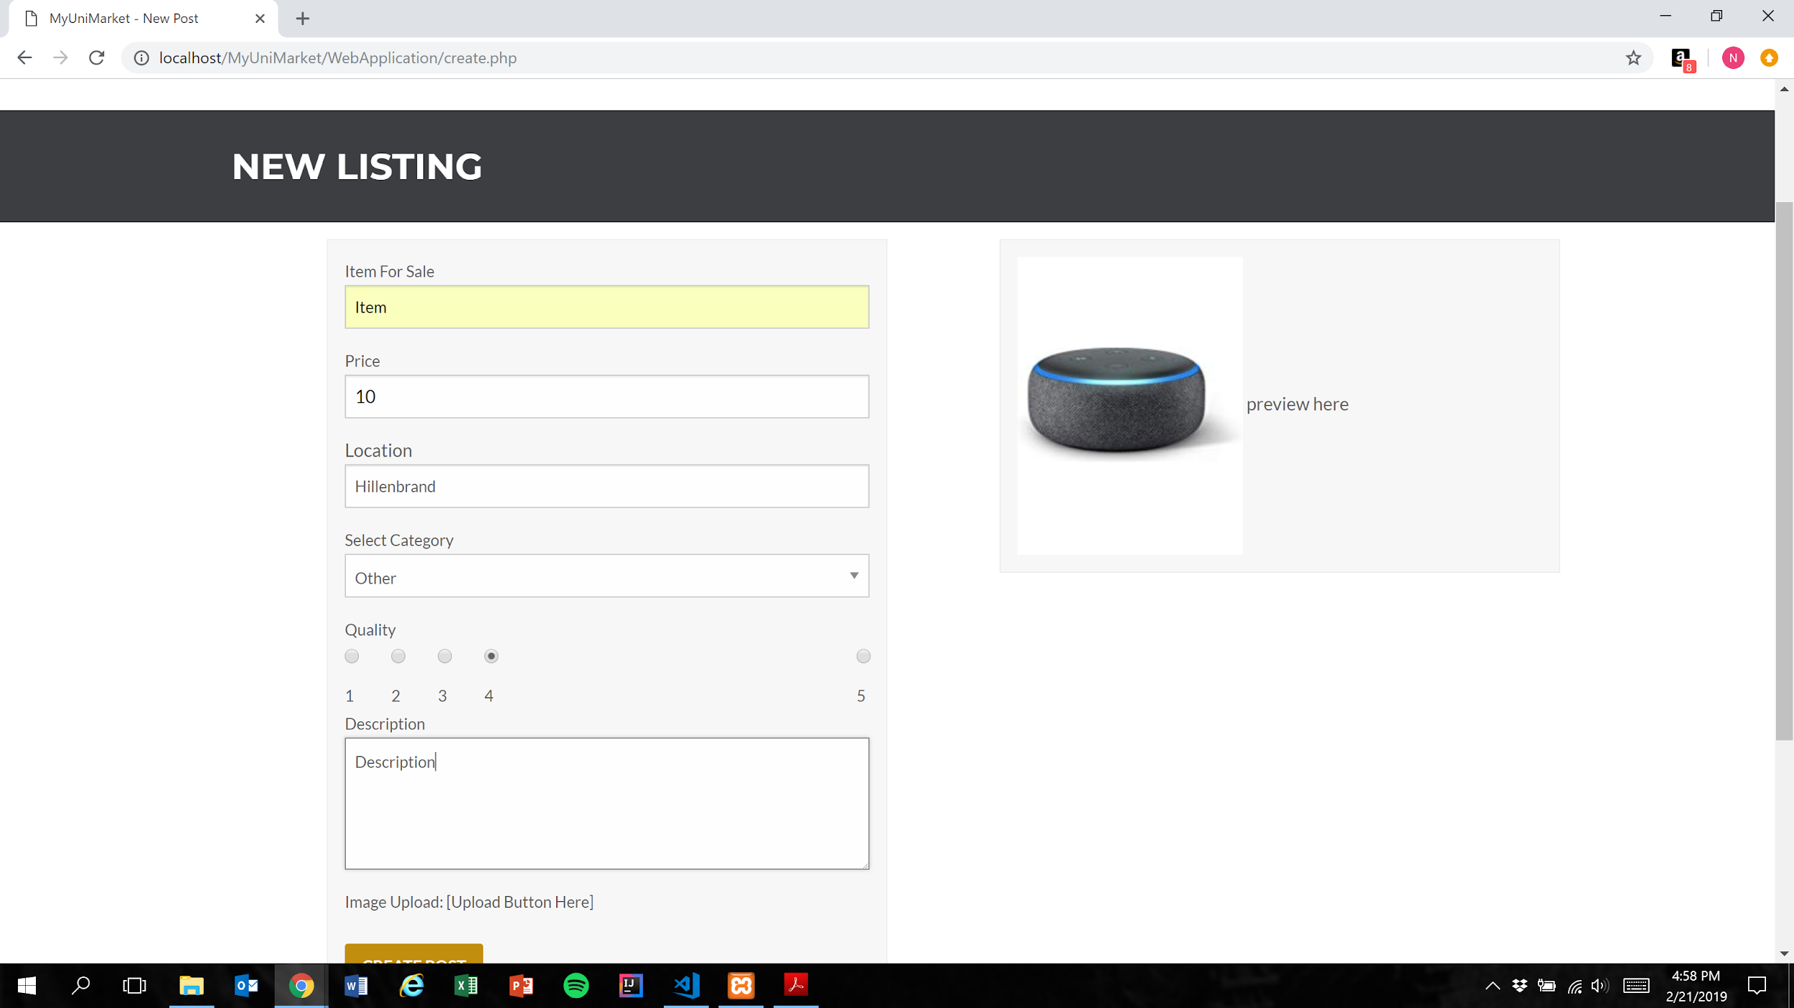

1. User presses the create post button (Figure 1)

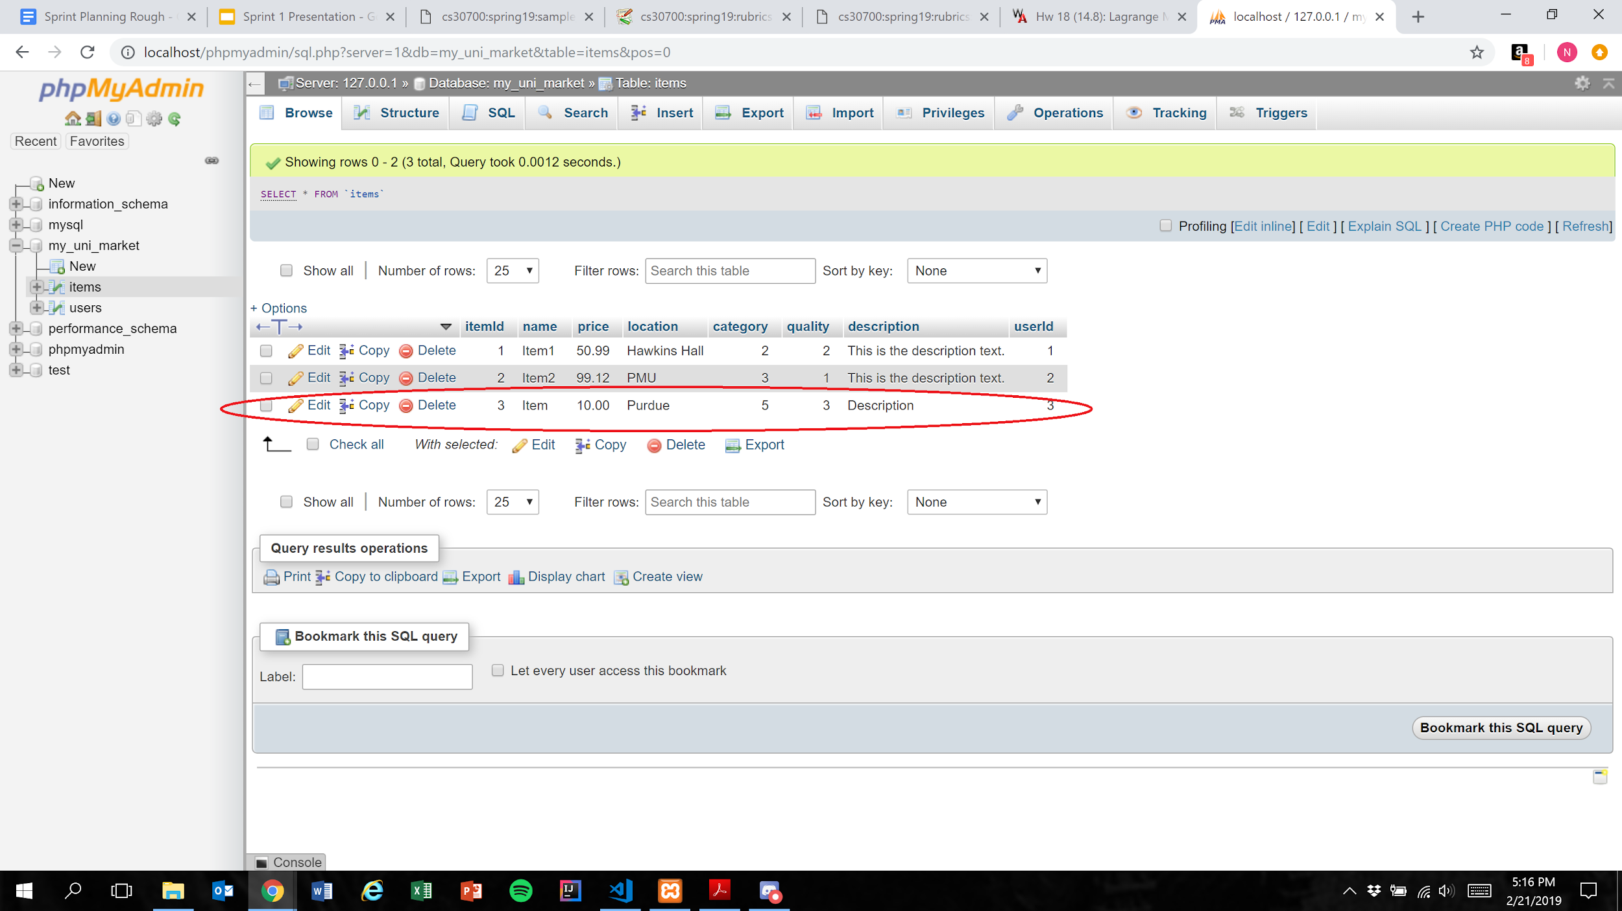

Expected Result: Listing is added to the database

**NOTE:** Marketplace functionality was not implemented as part of this sprint, so the user is not notified when they successfully post a listing. Additionally, the quality integer in the database is 1 less than the quality selected by the user. This is expected behavior.

Test Result: **PASSED**

# User Story #07

**Test 1:** **Given that the user has filled all required fields of a listing, if the user selects “1” as the quality, then the database should accurately represent this value**

Purpose: To meet acceptance criteria that every quality ranking is functional

Step:

1. User properly inputs data in all required fields and selects “1” for the “Quality” field

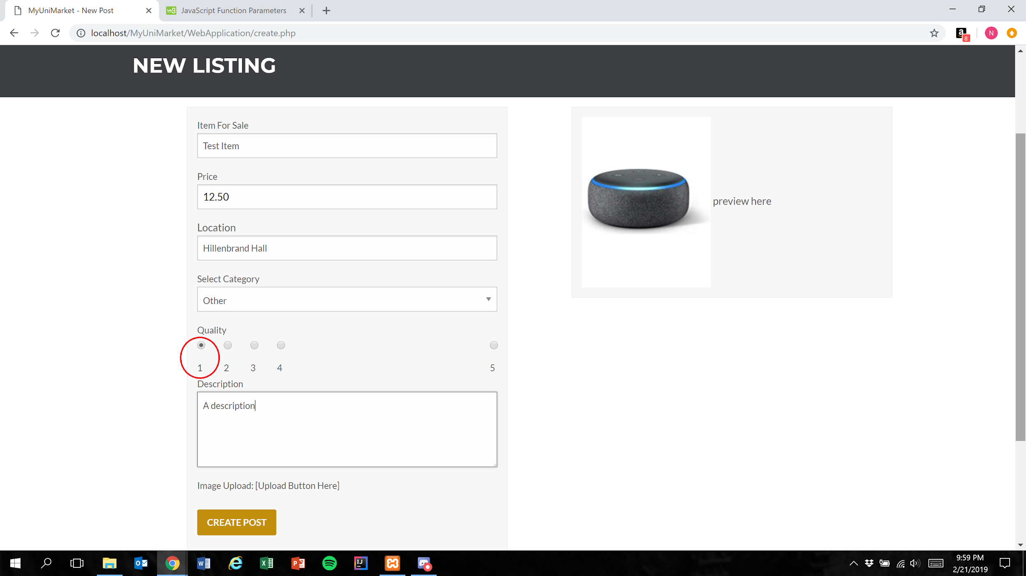

1. User presses the create post button

Figure 1



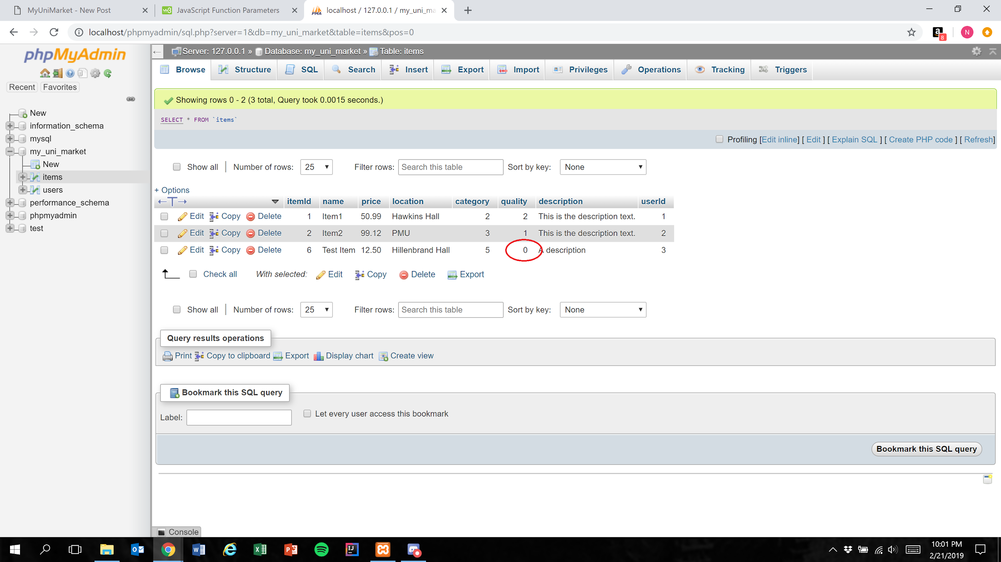

Expected Result: Quality field is represented in the database as 1 less than the user’s selection

Test Result: **PASSED**

**Test 2:** **Given that the user has correctly has filled all required fields of a listing, if the user selects “2” as the quality, then the database should accurately represent this value**

Purpose: To meet acceptance criteria that every quality ranking is functional

Step:

1. User properly inputs data in all required fields and selects “2” for the “Quality” field

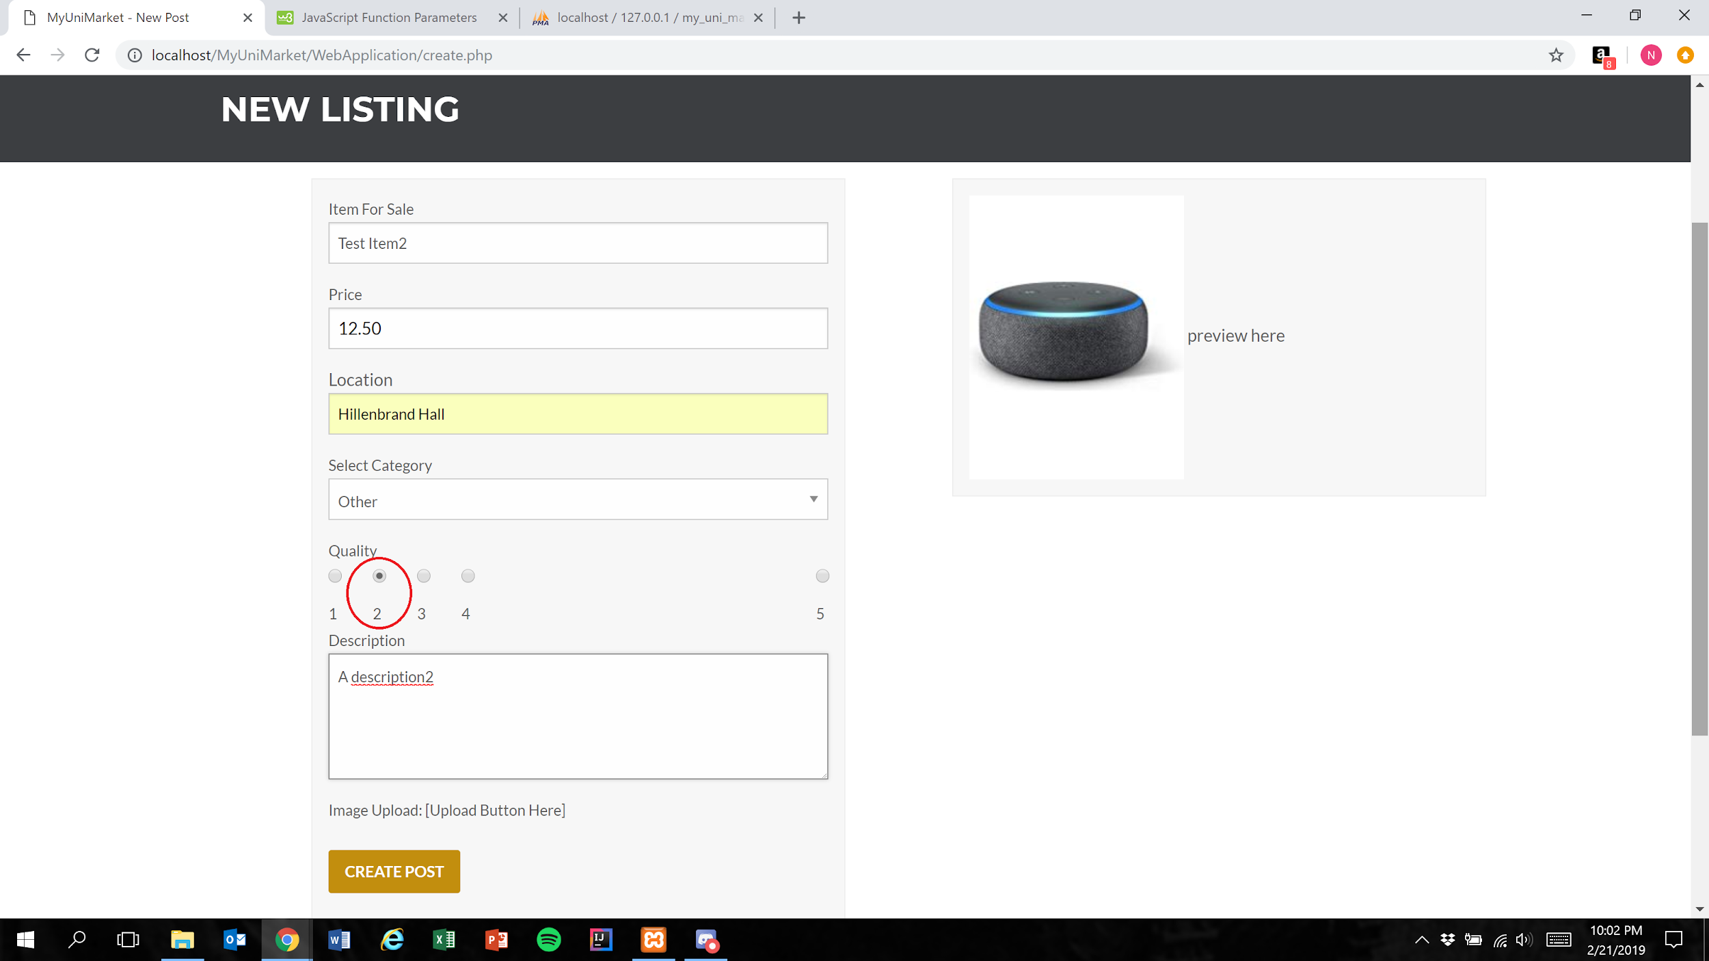

1. User presses the create post button (Figure 1)

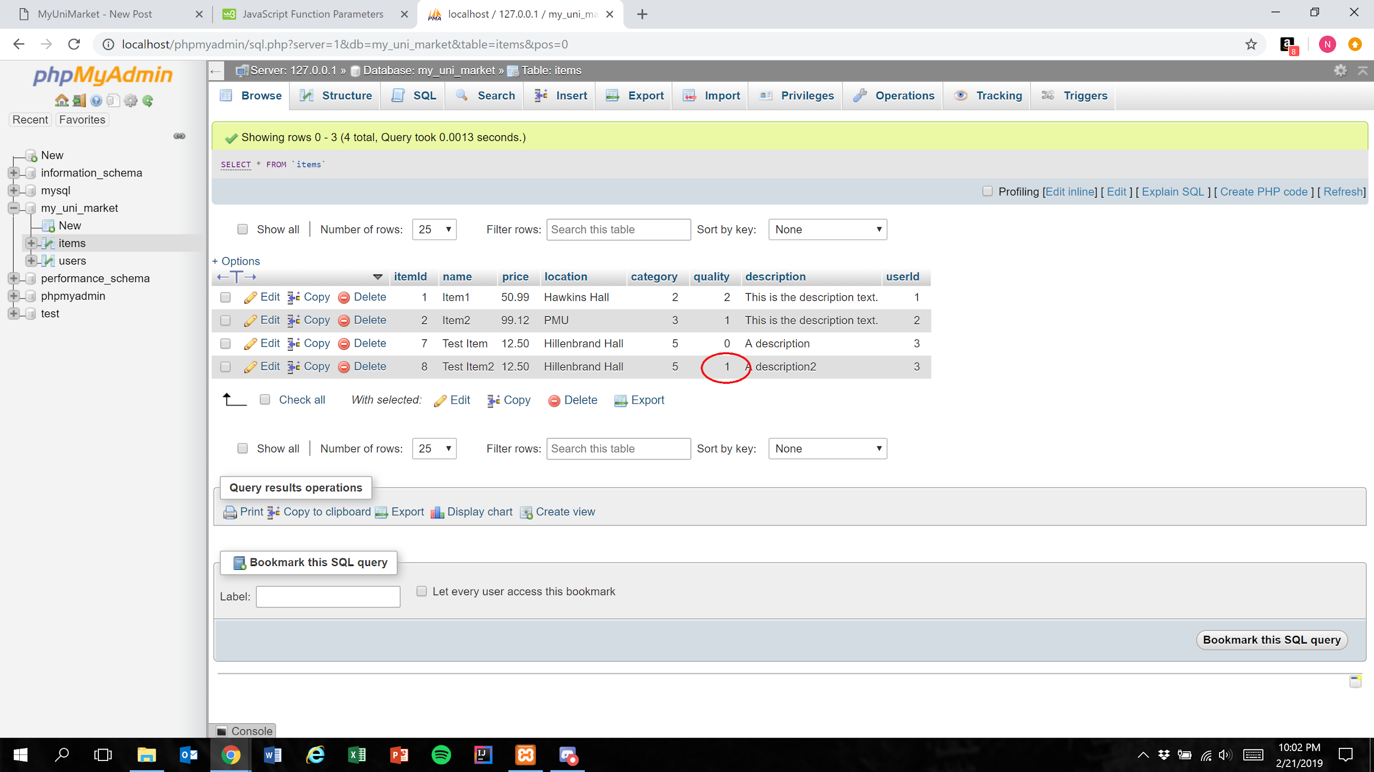

Expected Result: Quality field is represented in the database as 1 less than the user’s selection

Test Result: **PASSED**

**Test 3:** **Given that the user has correctly has filled all required fields of a listing, if the user selects “3” as the quality, then the database should accurately represent this value**

Purpose: To meet acceptance criteria that every quality ranking is functional

Step:

1. User properly inputs data in all required fields and selects “3” for the “Quality” field

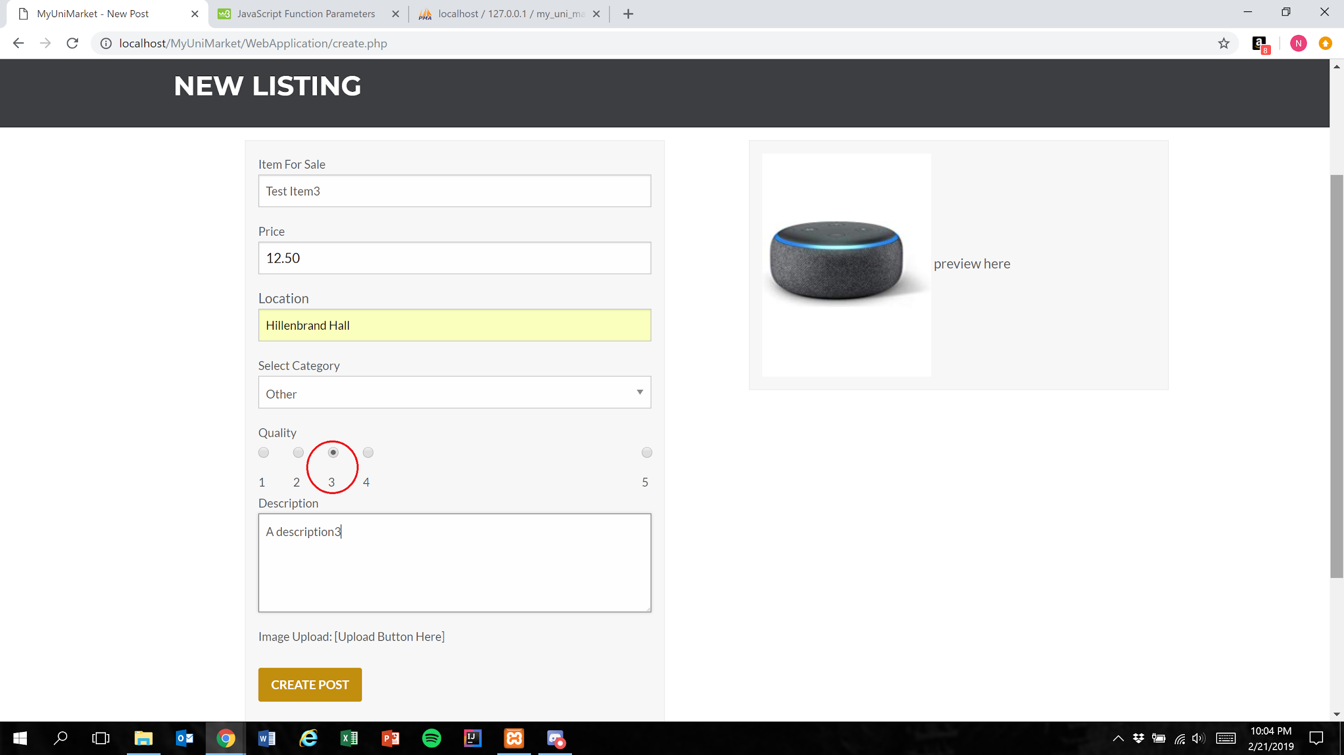

1. User presses the create post button (Figure 1)

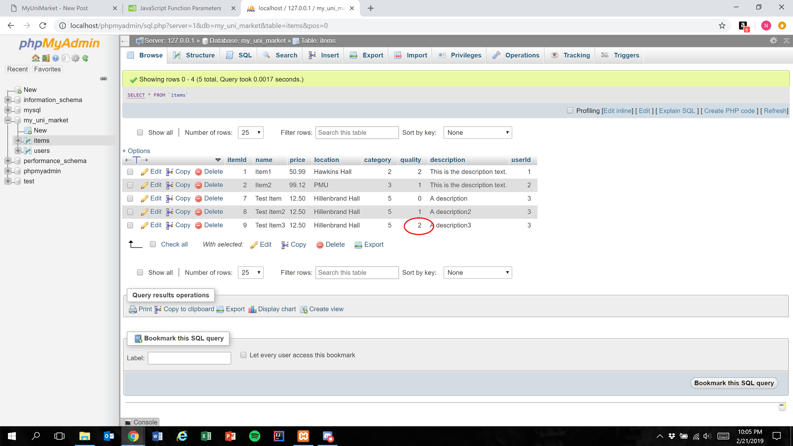

Expected Result: Quality field is represented in the database as 1 less than the user’s selection

Test Result: **PASSED**

**Test 4:** **Given that the user has correctly has filled all required fields of a listing, if the user selects “4” as the quality, then the database should accurately represent this value**

Purpose: To meet acceptance criteria that every quality ranking is functional

Step:

1. User properly inputs data in all required fields and selects “4” for the “Quality” field

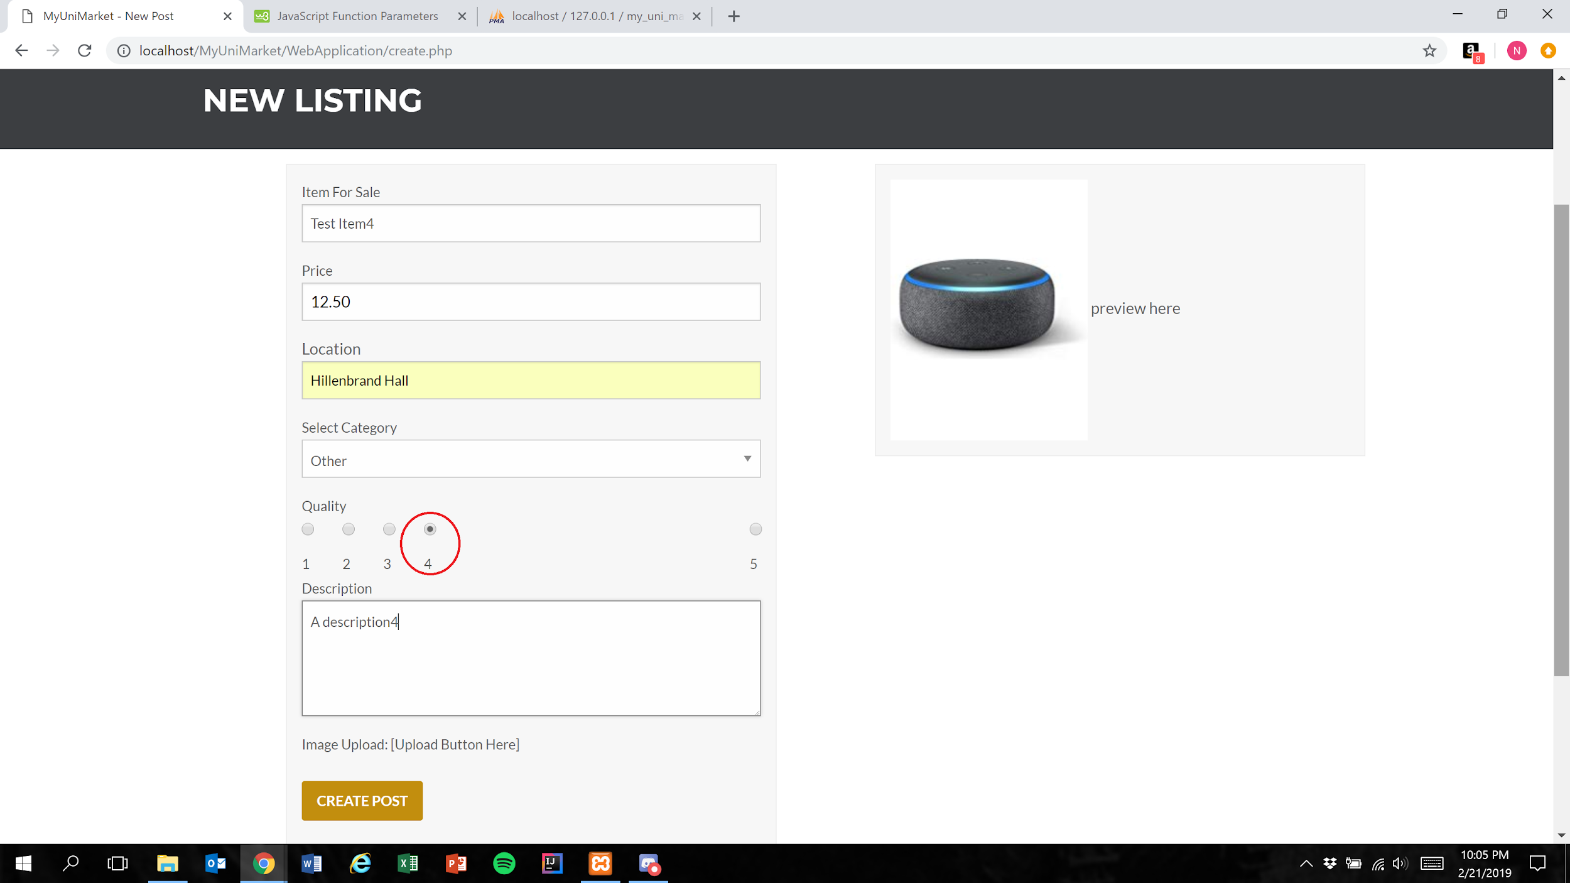

1. User presses the create post button (Figure 1)

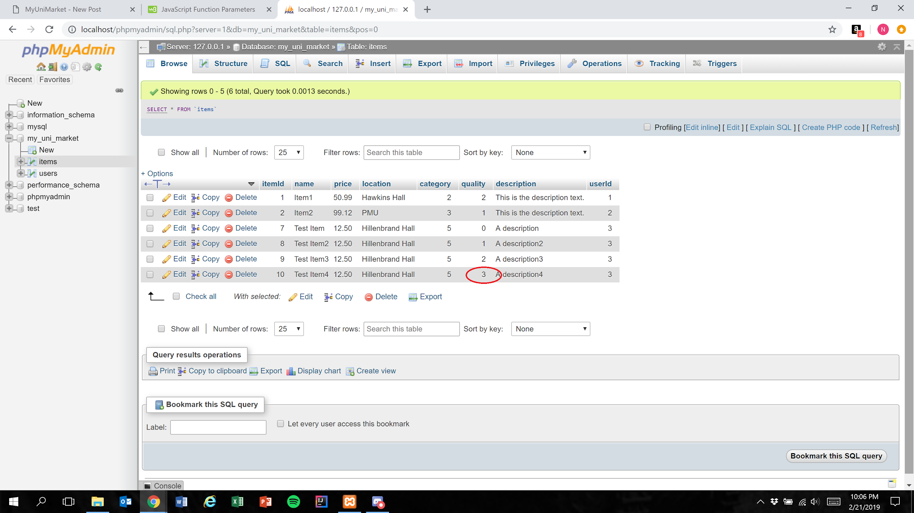

Expected Result: Quality field is represented in the database as 1 less than the user’s selection

Test Result: **PASSED**

**Test 5:** **Given that the user has correctly has filled all required fields of a listing, if the user selects “5” as the quality, then the database should accurately represent this value**

Purpose: To meet acceptance criteria that every quality ranking is functional

Step:

1. User properly inputs data in all required fields and selects “5” for the “Quality” field

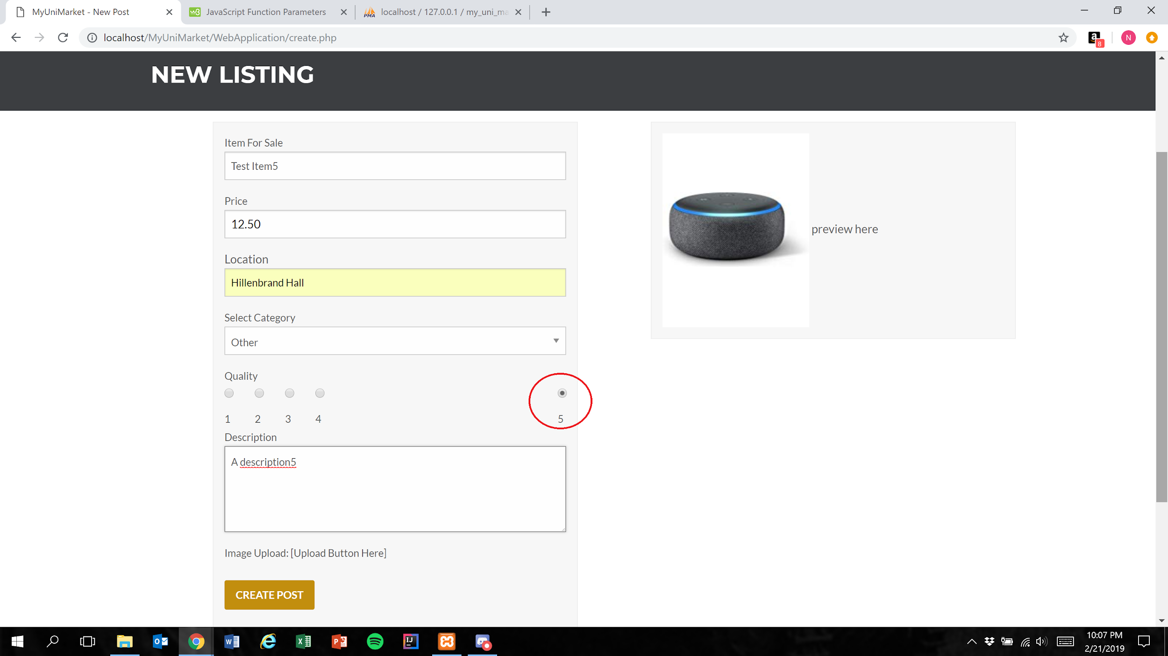

1. User presses the create post button (Figure 1)

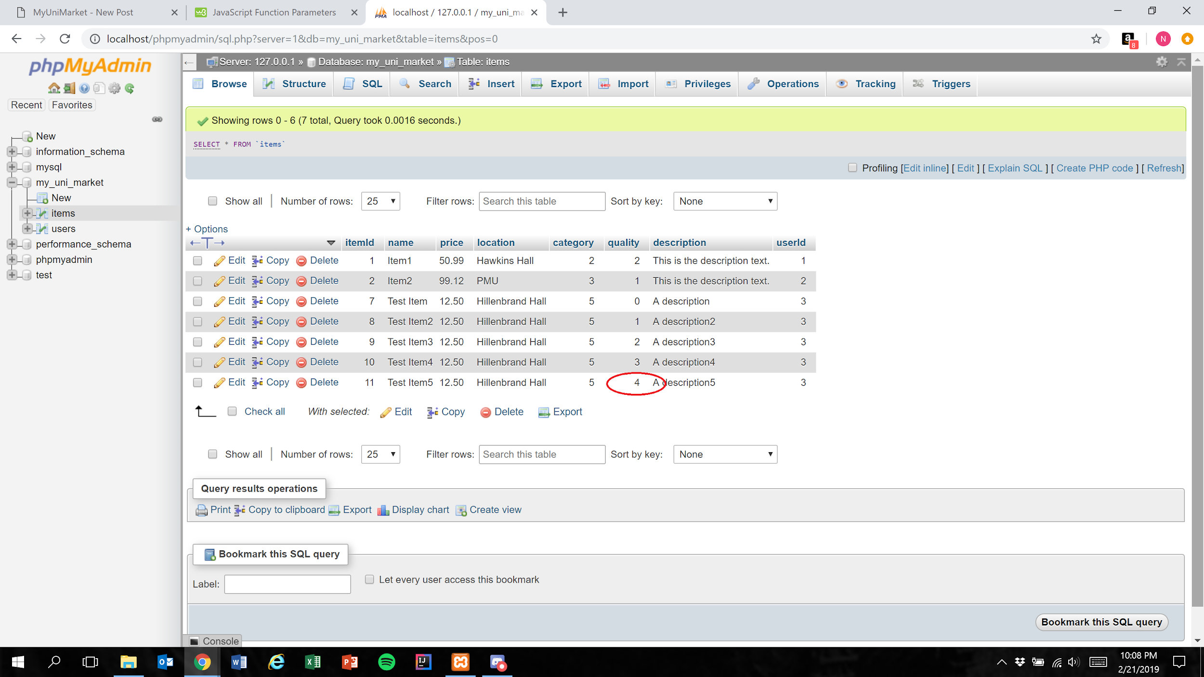

Expected Result: Quality field is represented in the database as 1 less than the user’s selection

Test Result: **PASSED**

# User Story #08

**Test 1: Given that the user has filled all required fields of a listing, if the user inputs a price, then the price is correctly stored in the database**

Purpose: To meet acceptance criteria that the price is correctly stored in the database

Steps:

1. User properly inputs data in all required fields and also inputs valid input into the “Price” field

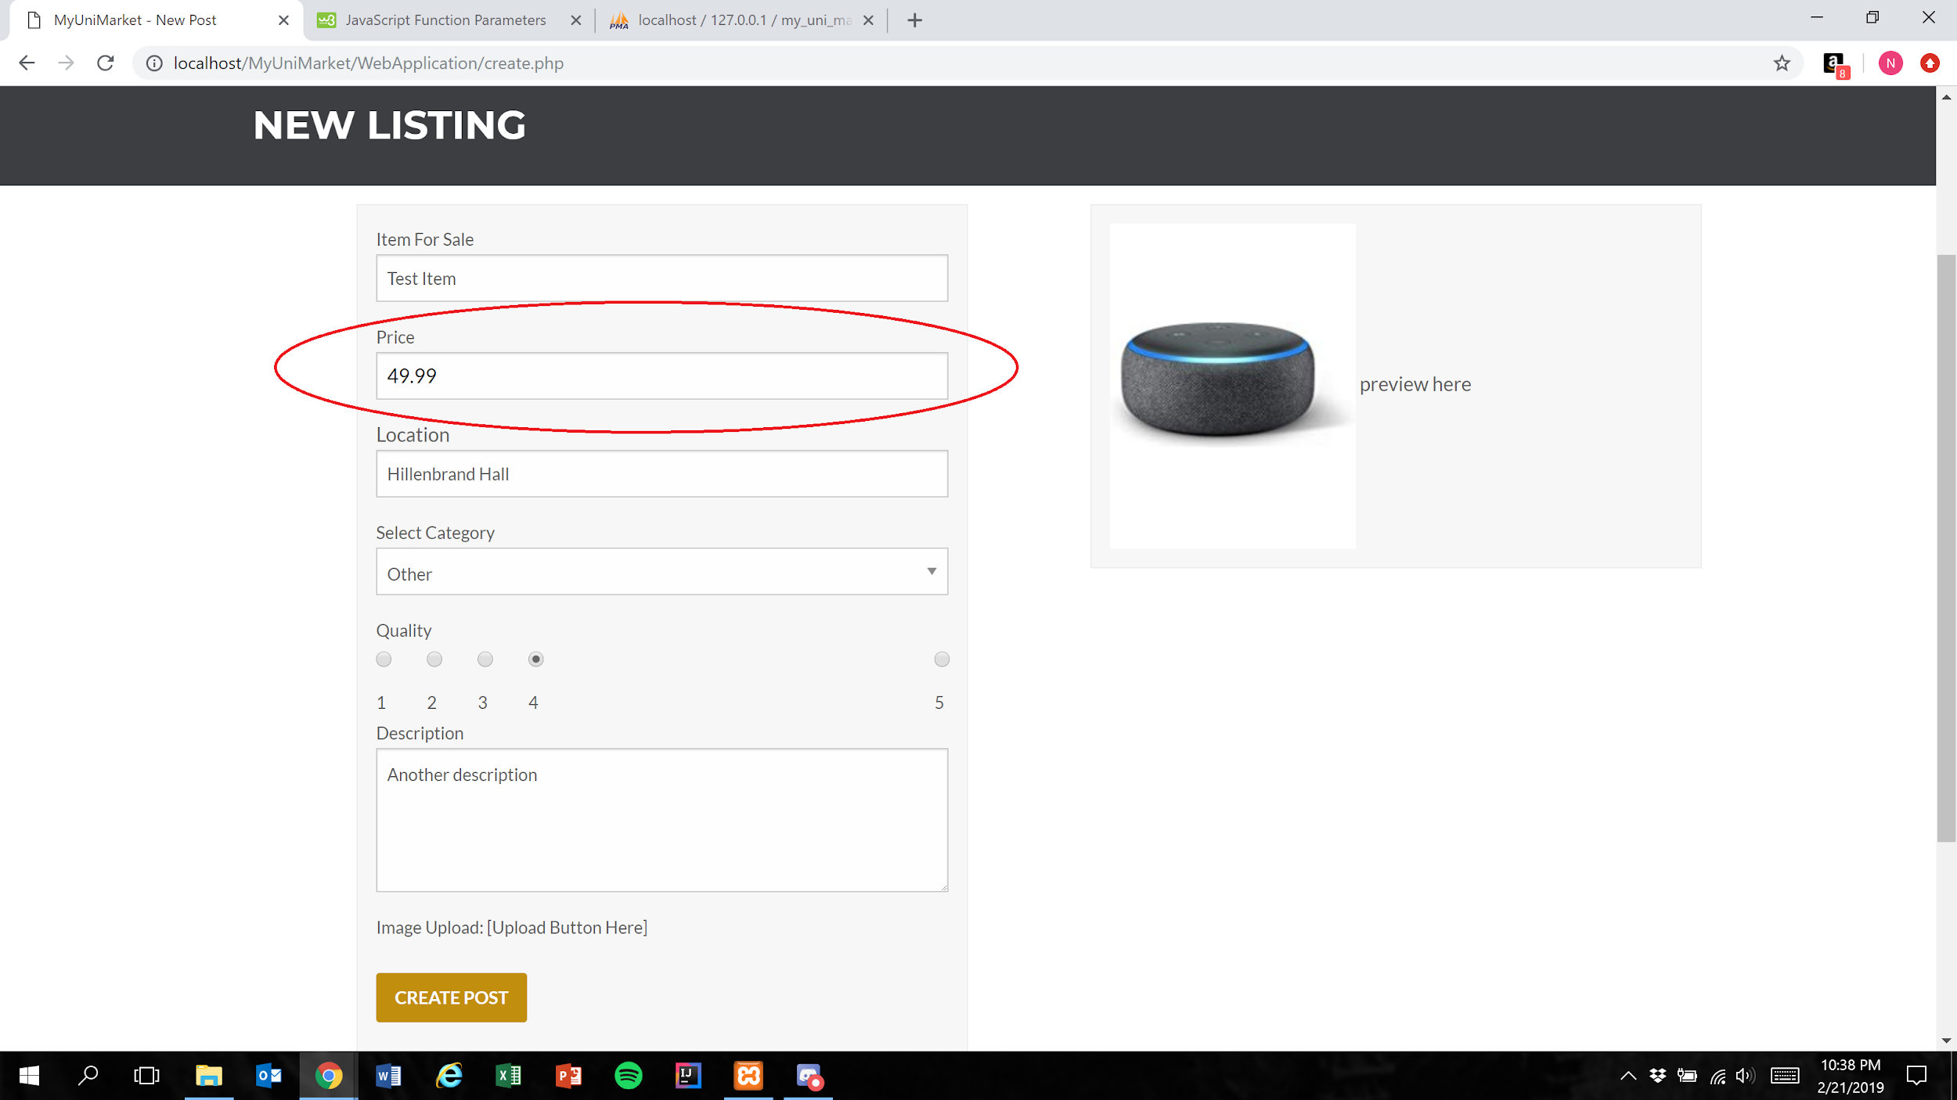

1. User presses the create post button



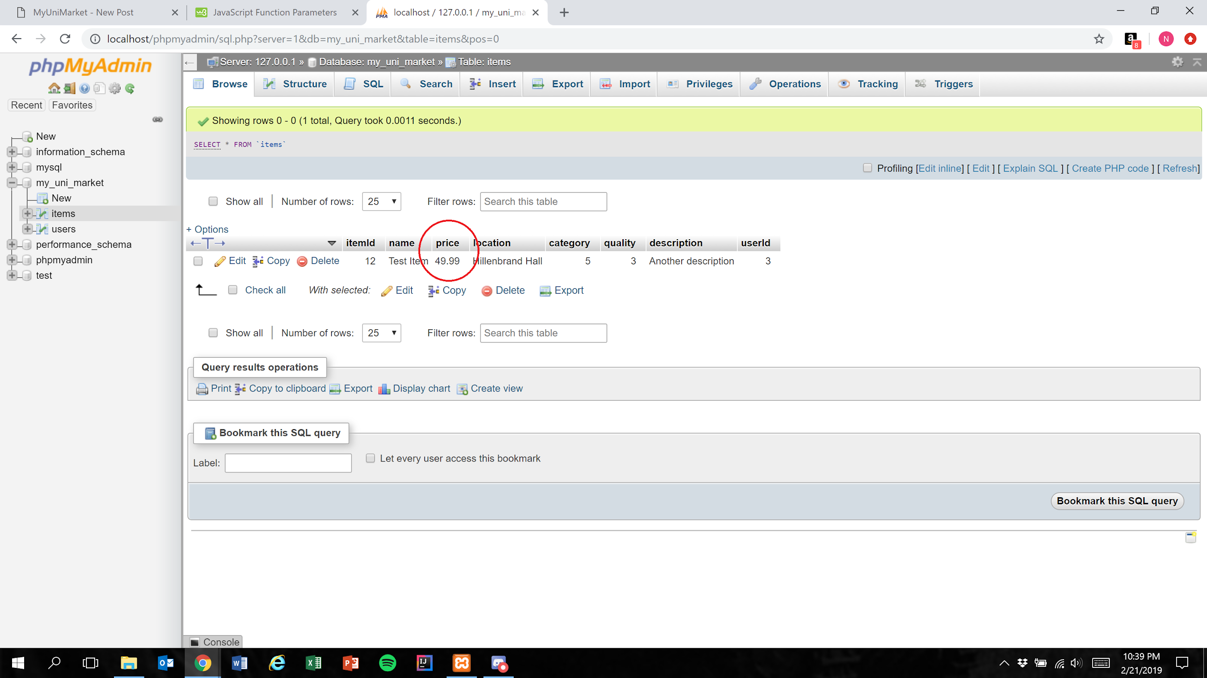

Expected Result: “Price” field is accurately represented in the database

Test Result: **PASSED**

**Test 2: Given that the user has filled all required fields of a listing, if the user attempts to input invalid characters into the “Price” field, then the input is not entered into the field**

Purpose: To meet the acceptance criteria that the user is unable to add invalid input to the “Price” field

Steps:

1. User properly inputs data in all required fields and attempts to include invalid input in the “Price” field
2. User is unable to type invalid input into the price field

Expected Result: The user is only able to type number characters and the “.” character

**NOTE:** Since the test involves characters *not* appearing in the “Price” field, screenshots will not be able to show the passing of this test

Test Result: **PASSED**

# User Story #09

**Test 1:** **Given that the user has filled all required fields of a listing, if the user inputs text into the “Description” field, then it is correctly stored in the database**

Purpose: To meet acceptance criteria that the description is correctly stored in the database

Steps:

1. User properly inputs data in all required fields and also inputs text into the “Description” field

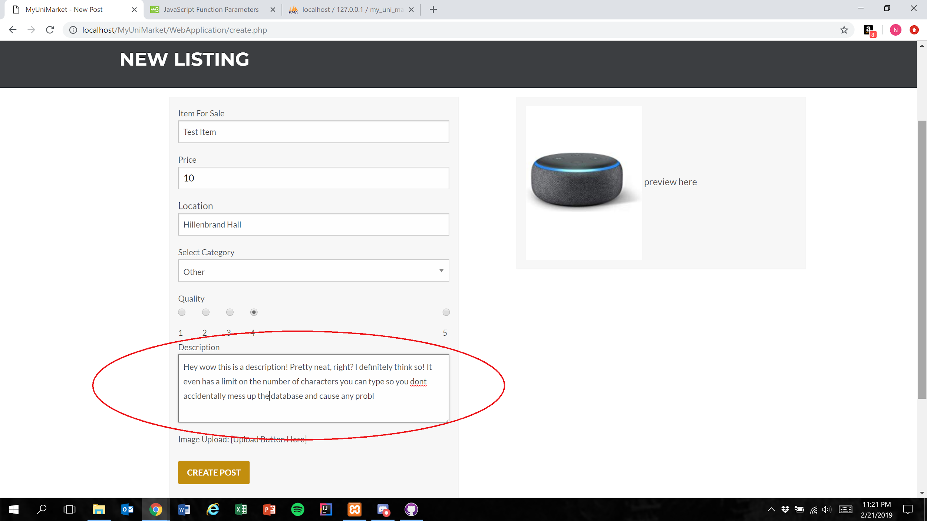

1. User presses the create post button



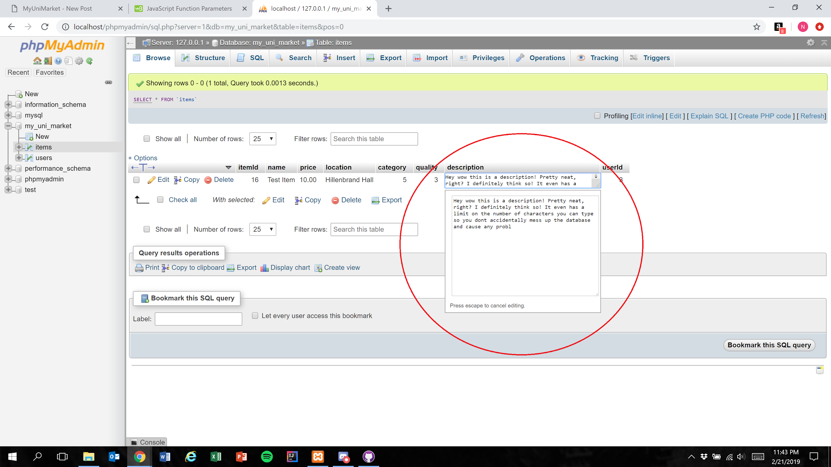

Expected Result: Text within the “Description” field is accurately represented in the database

**NOTE:** The “Description” field currently has a character limit of 200

Test Result: **PASSED**

# User Story #10

**Test 1: Given that the UI is correctly implemented, if the user clicks the “Select Category” field, then a dropdown menu appears to allow the user to make a selection**

Purpose: To meet the acceptance criteria that the UI is working as intended

Steps:

1. User clicks on the “Select Category” field

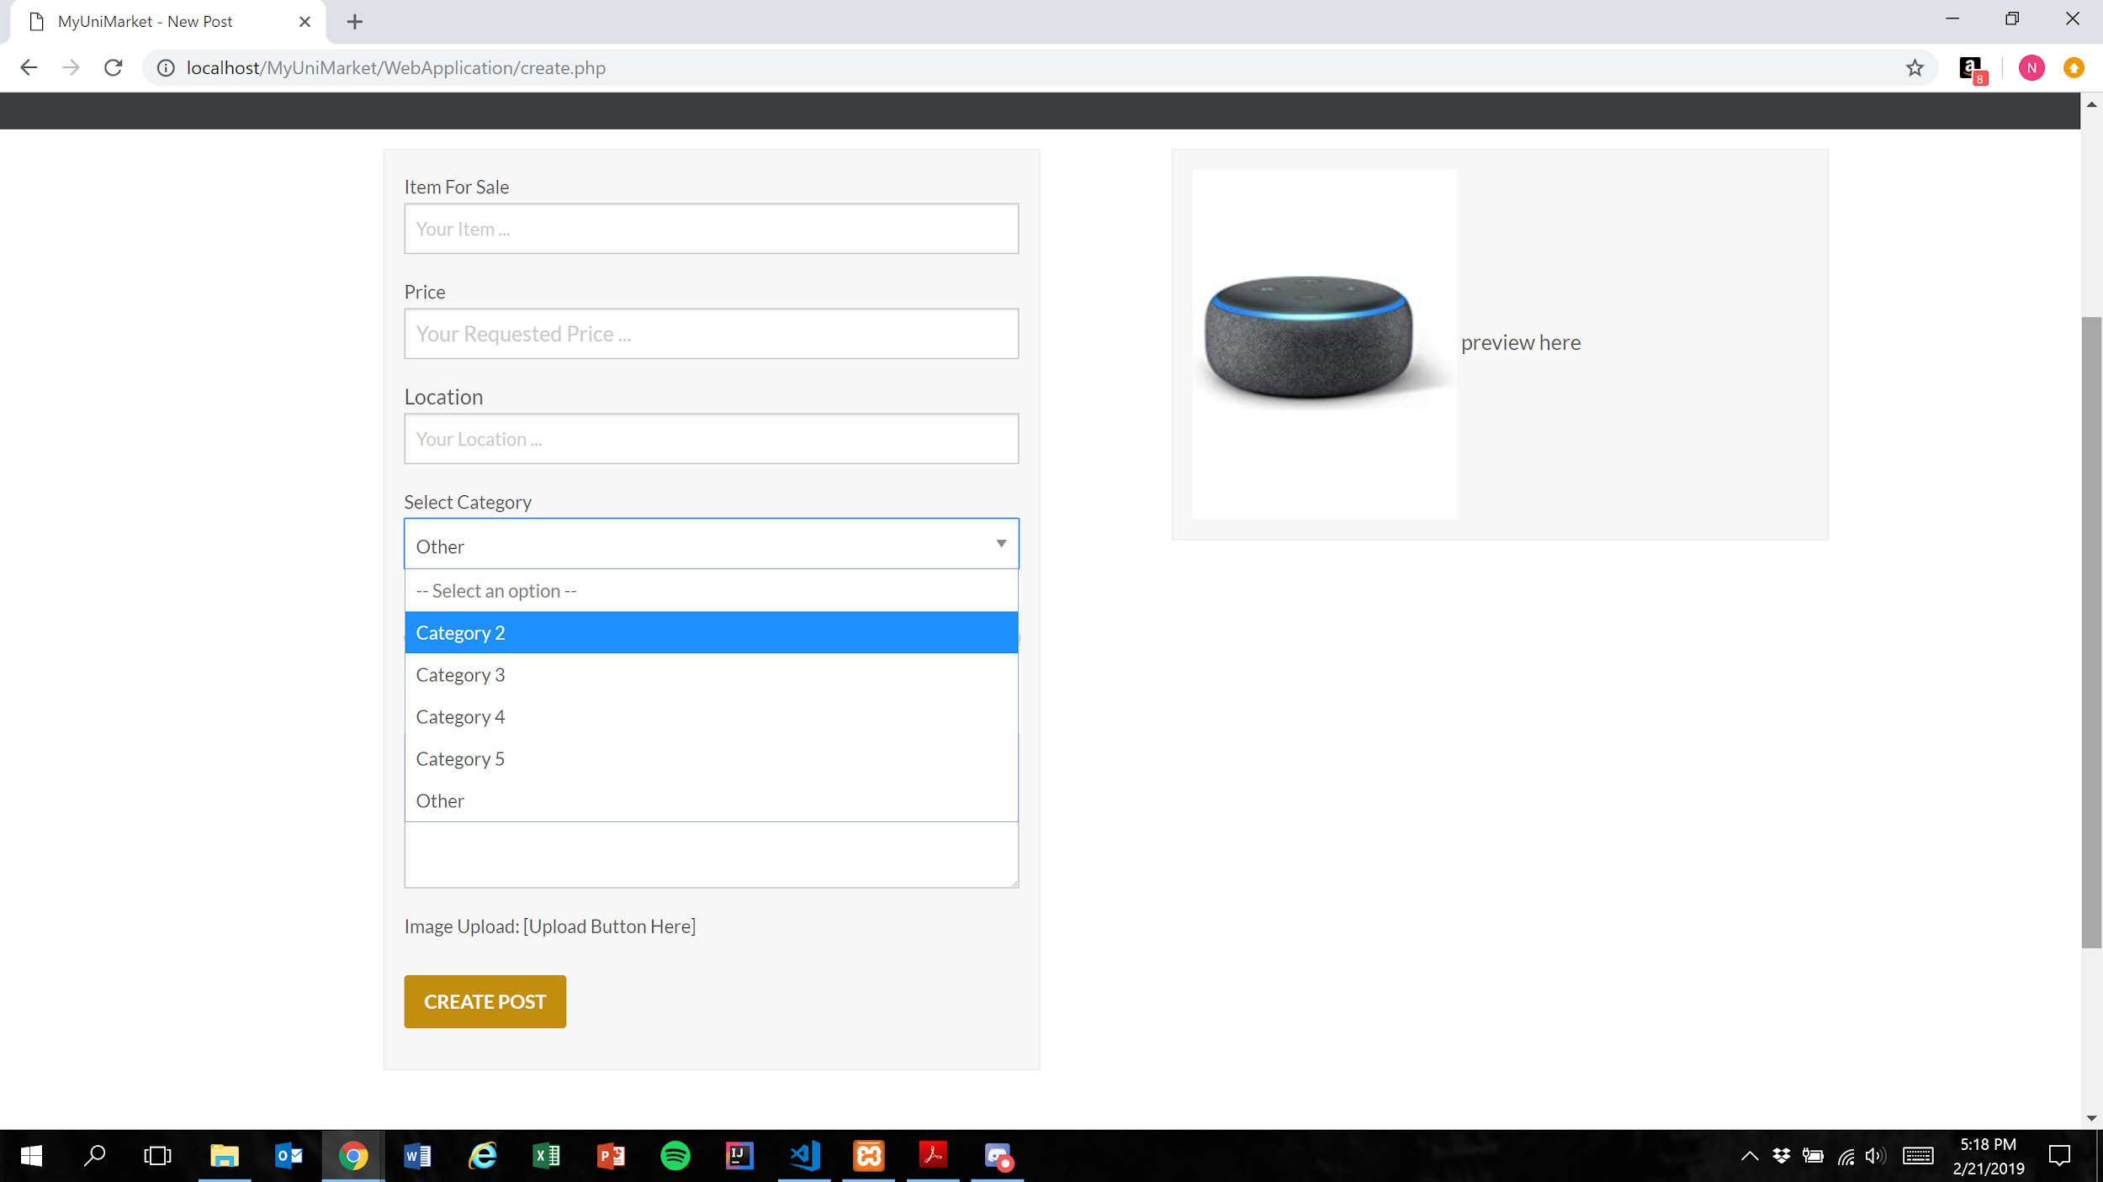

Expected Result: A dropdown menu in which the user can select one of multiple options is displayed

**NOTE:** Categories are currently placeholders as the marketplace was not implemented in Sprint 1

Test Result: **PASSED**

**Test 2: Given that the database has been implemented correctly, if the user submits a completed listing, then the database should correctly store the selected value**

Purpose: To meet the acceptance criteria that the database correctly stores the selected value for the “Select Category” field

Steps:

1. User properly inputs data in all required fields and clicks“Category 2” in the “Select Category” menu

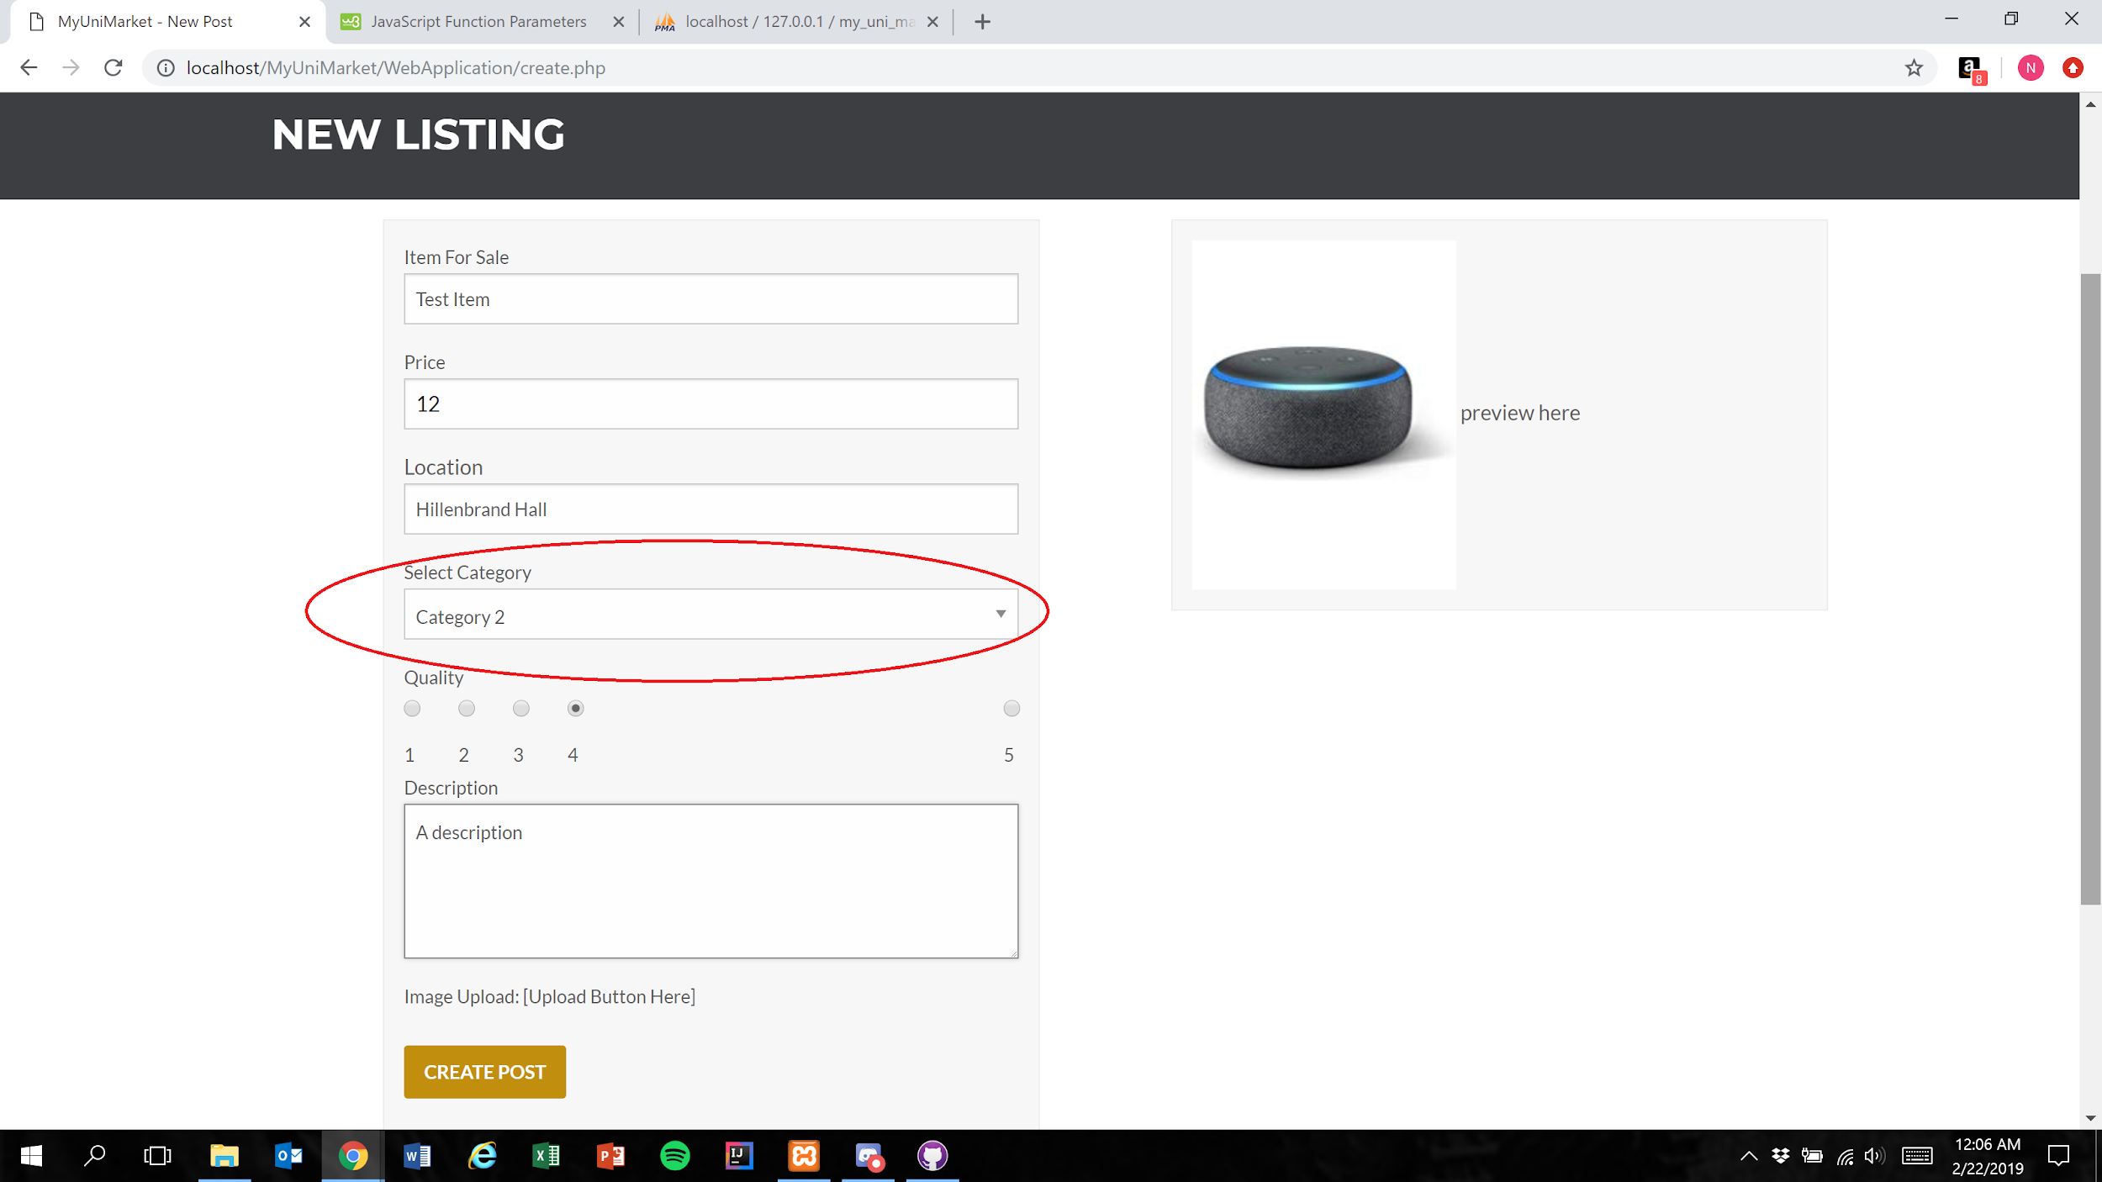

1. User presses the create post button

Figure 1



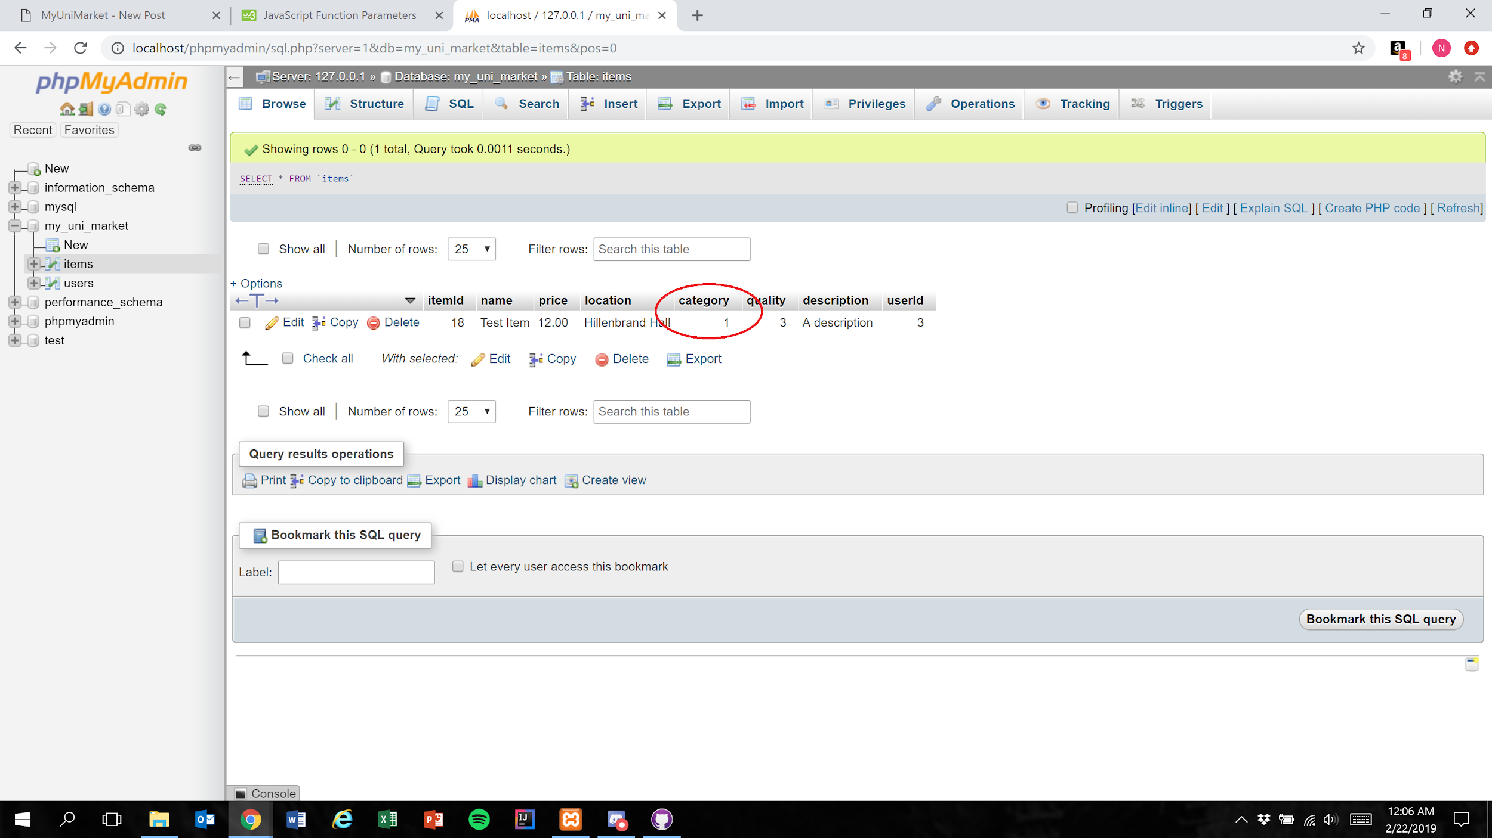

Expected Result: An integer 1 less than the category number the user selected is stored in the database

Test Result: **PASSED**

**Test 3: Given that the database has been implemented correctly, if the user submits a completed listing, then the database should correctly store the selected value**

Purpose: To meet the acceptance criteria that the database correctly stores the selected value for the “Select Category” field

Steps:

1. User properly inputs data in all required fields and clicks“Category 3” in the “Select Category” menu

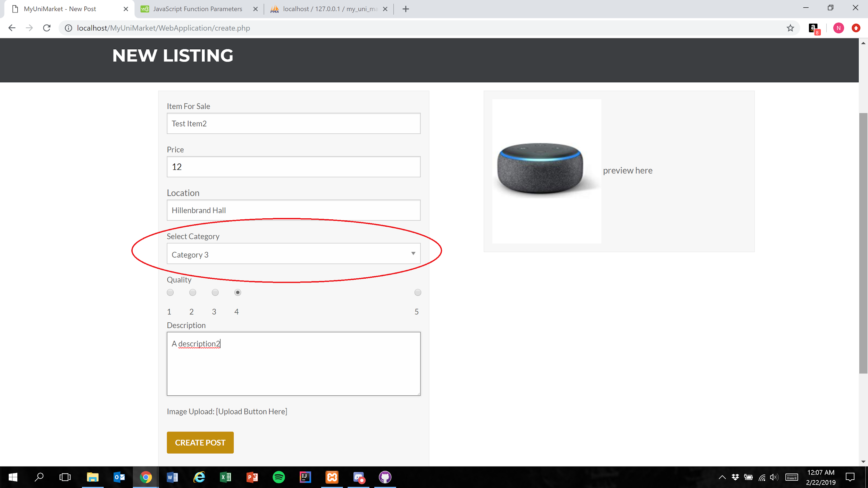

1. User presses the create post button (Figure 1)

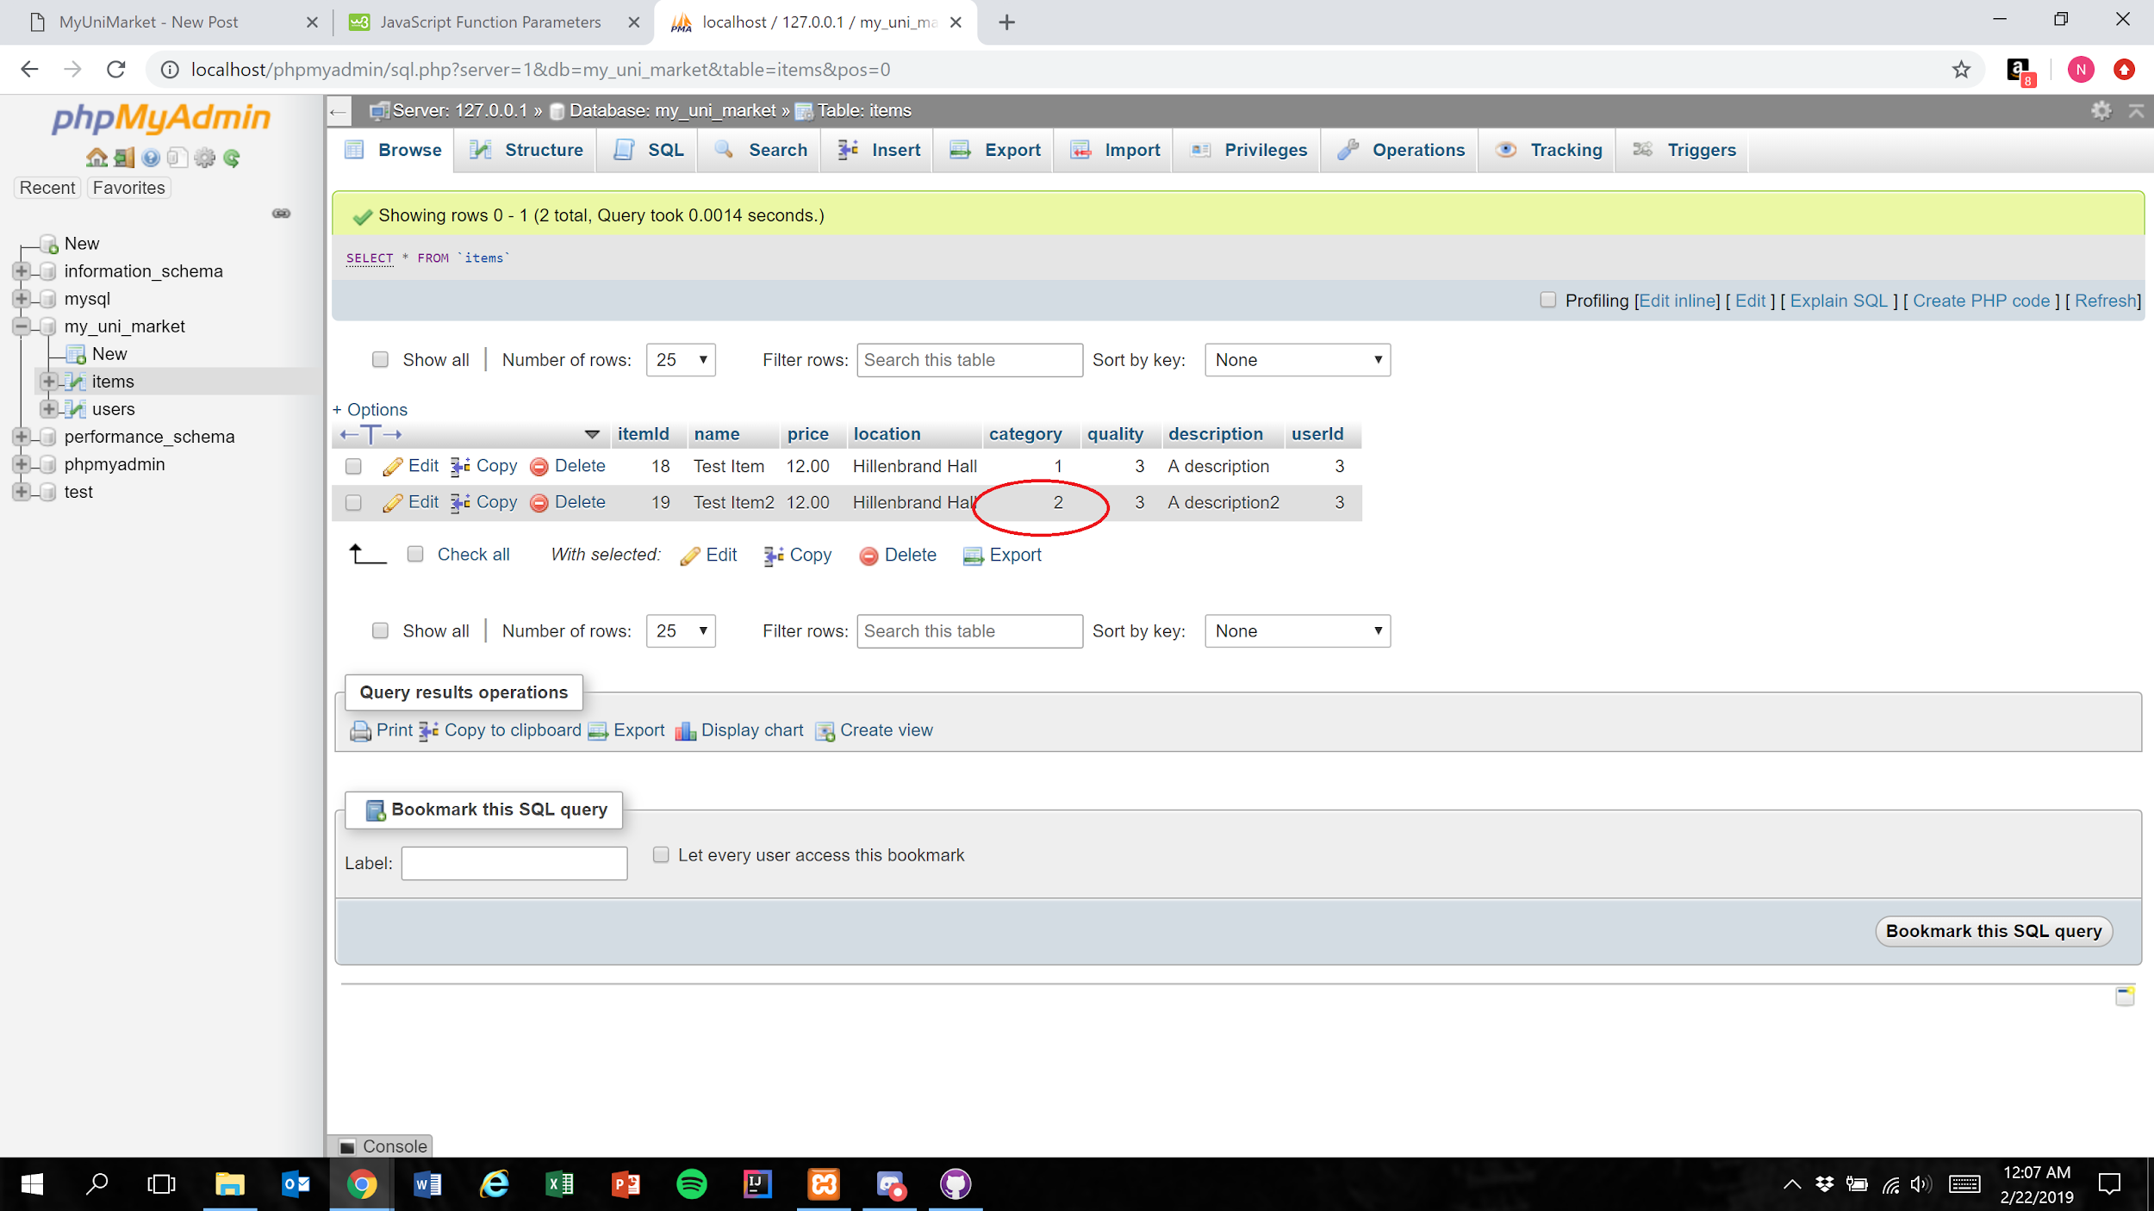

Expected Result: An integer 1 less than the category number the user selected is stored in the database

Test Result: **PASSED**

**Test 4: Given that the database has been implemented correctly, if the user submits a completed listing, then the database should correctly store the selected value**

Purpose: To meet the acceptance criteria that the database correctly stores the selected value for the “Select Category” field

Steps:

1. User properly inputs data in all required fields and clicks“Category 4” in the “Select Category” menu

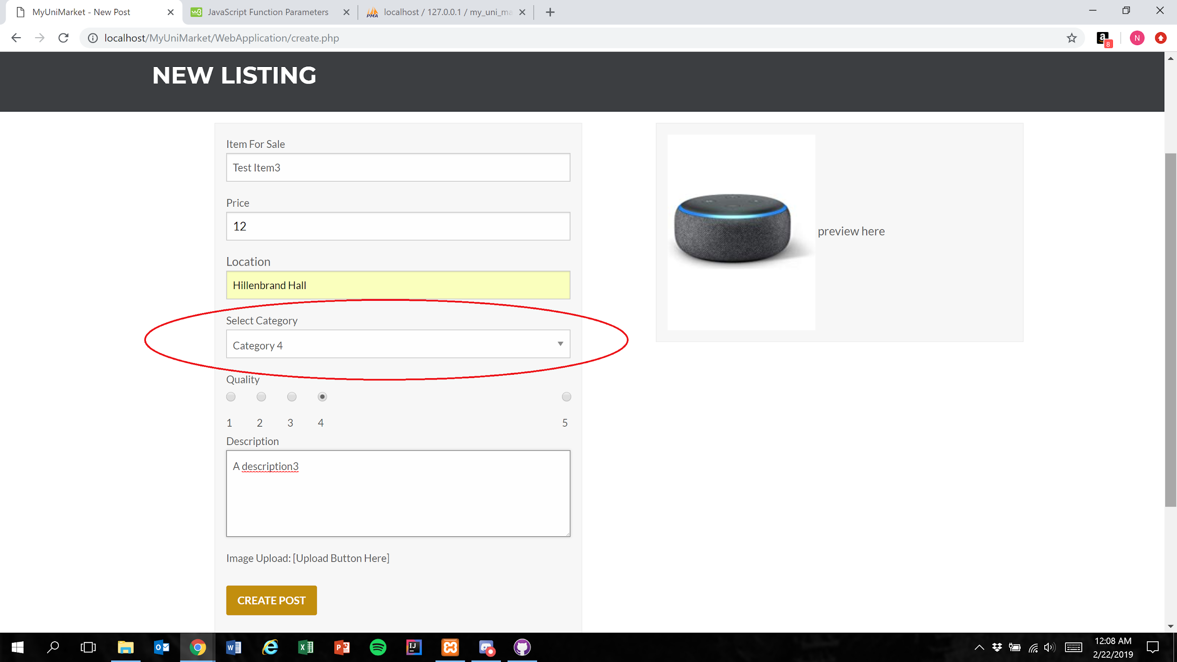

1. User presses the create post button (Figure 1)

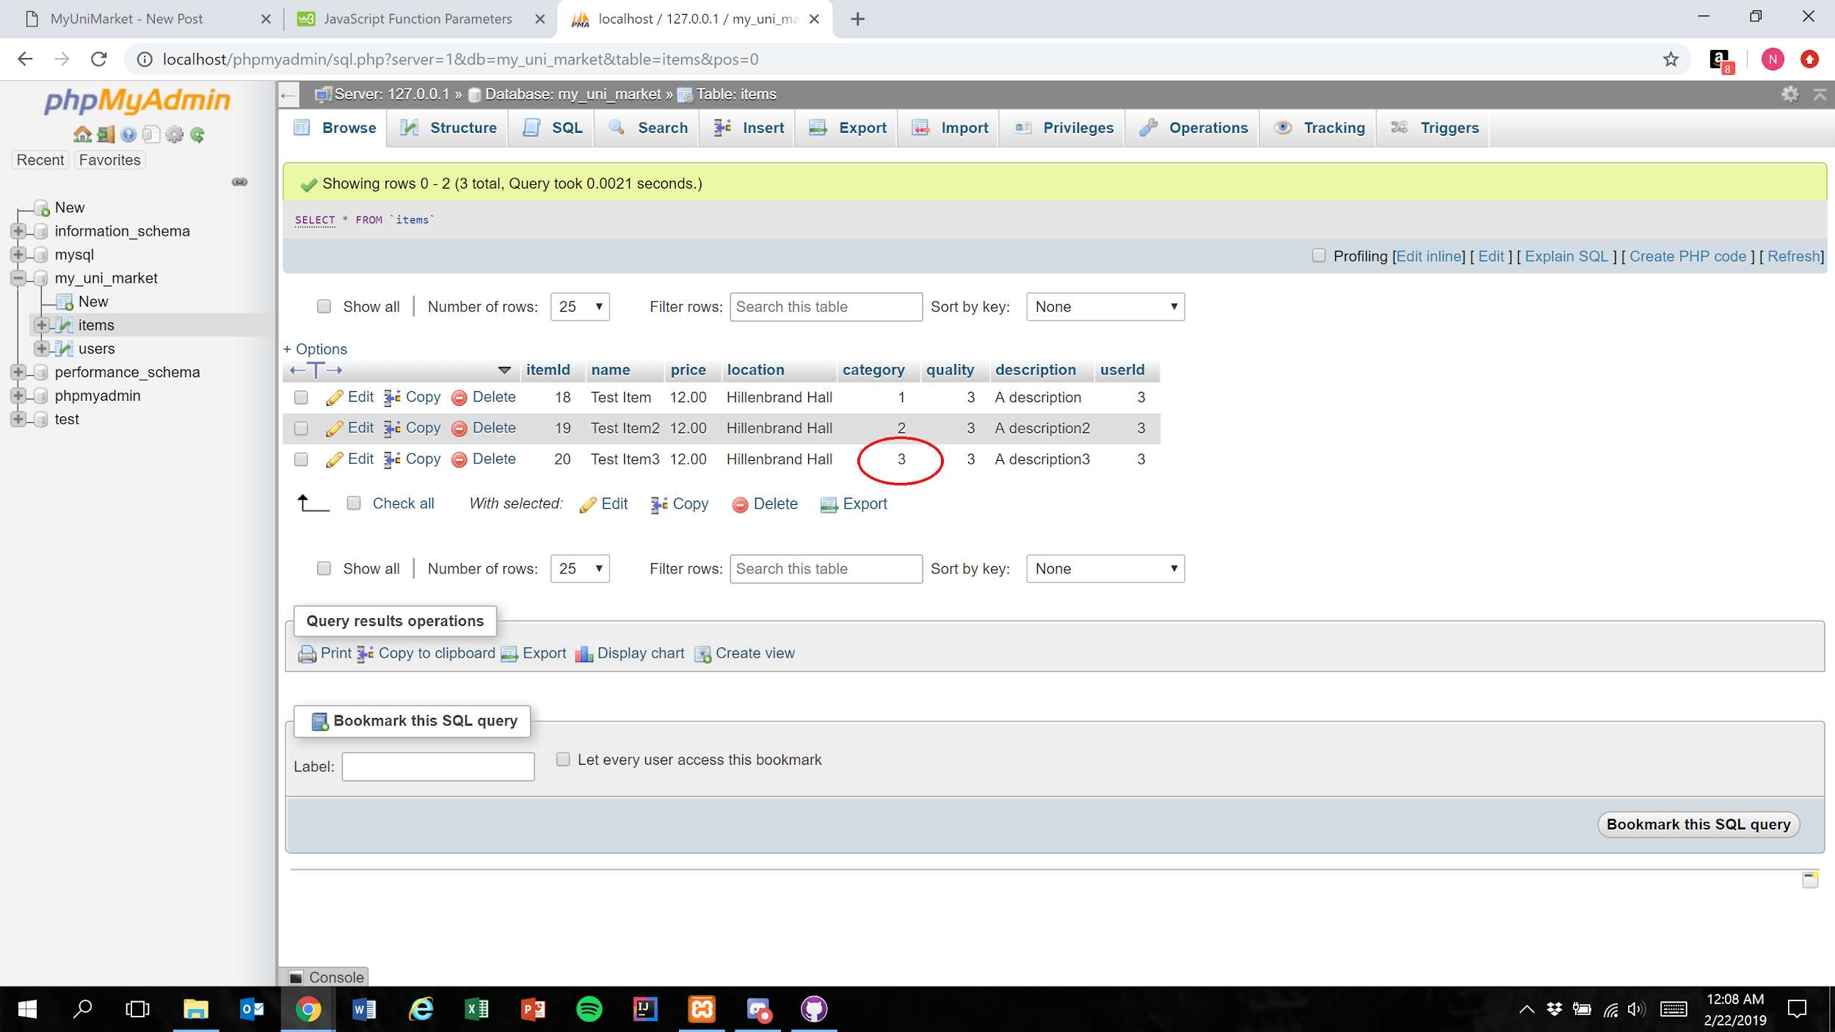

Expected Result: An integer 1 less than the category number the user selected is stored in the database

Test Result: **PASSED**

**Test 5: Given that the database has been implemented correctly, if the user submits a completed listing, then the database should correctly store the selected value**

Purpose: To meet the acceptance criteria that the database correctly stores the selected value for the “Select Category” field

Steps:

1. User properly inputs data in all required fields and clicks“Category 5” in the “Select Category” menu

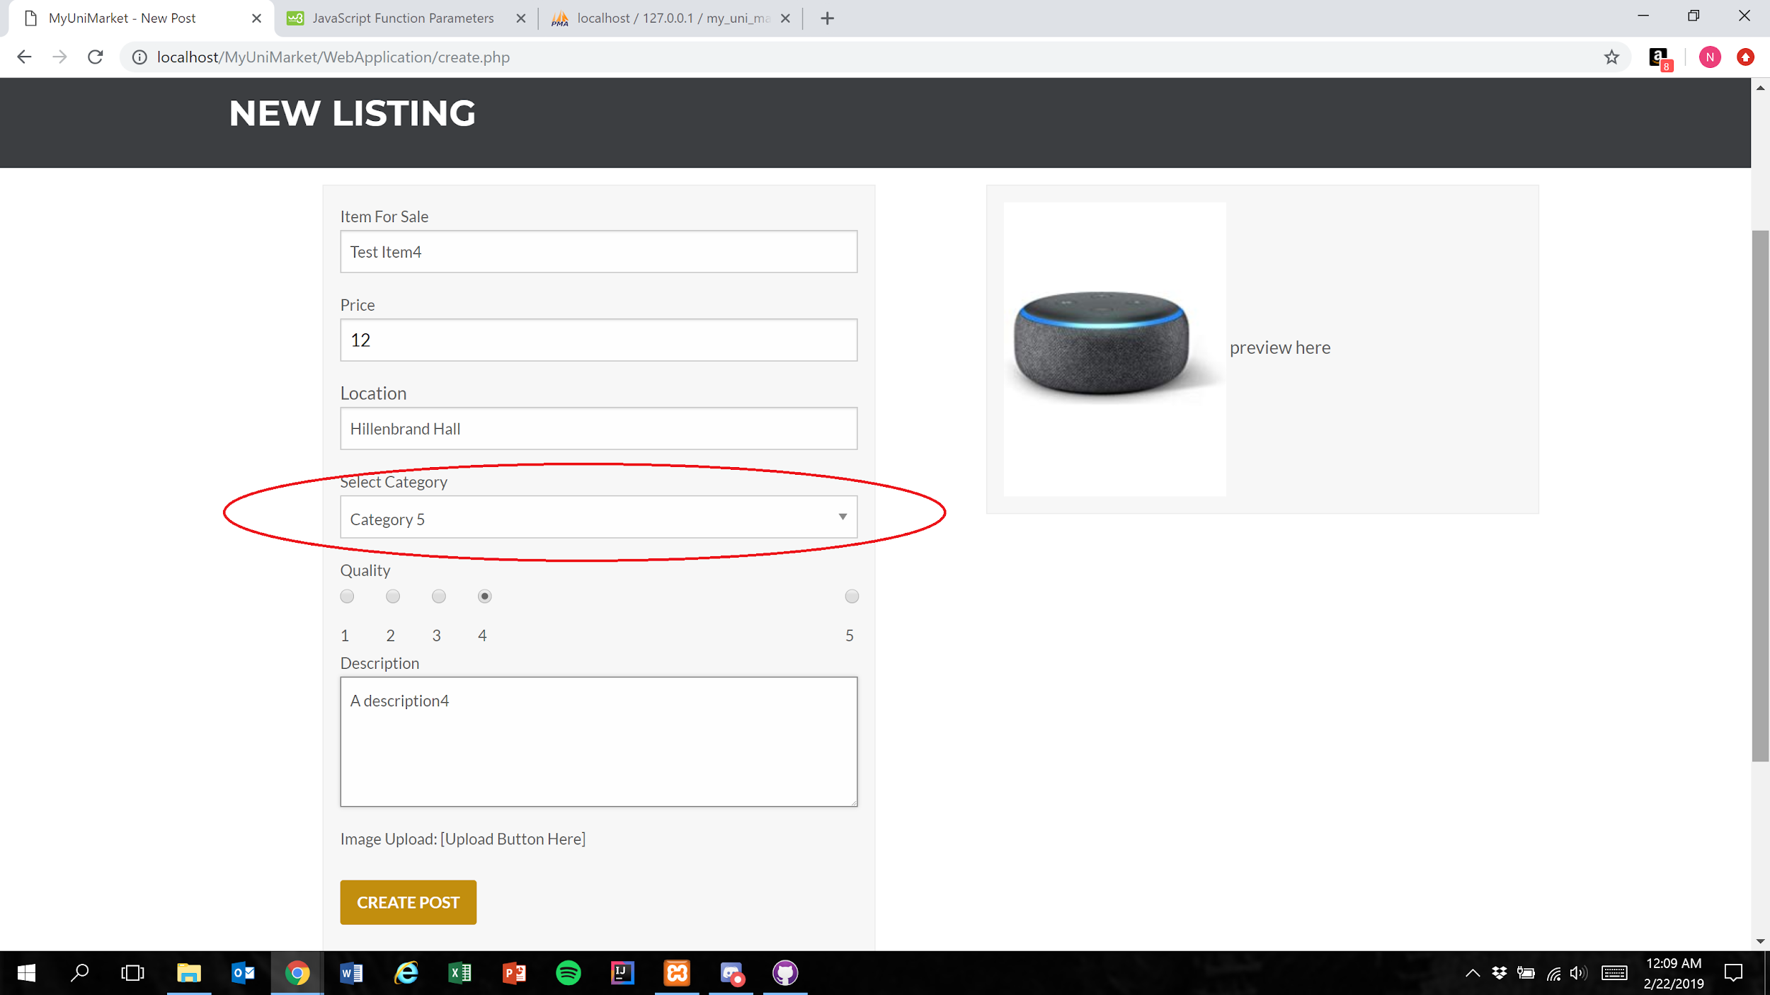

1. User presses the create post button (Figure 1)

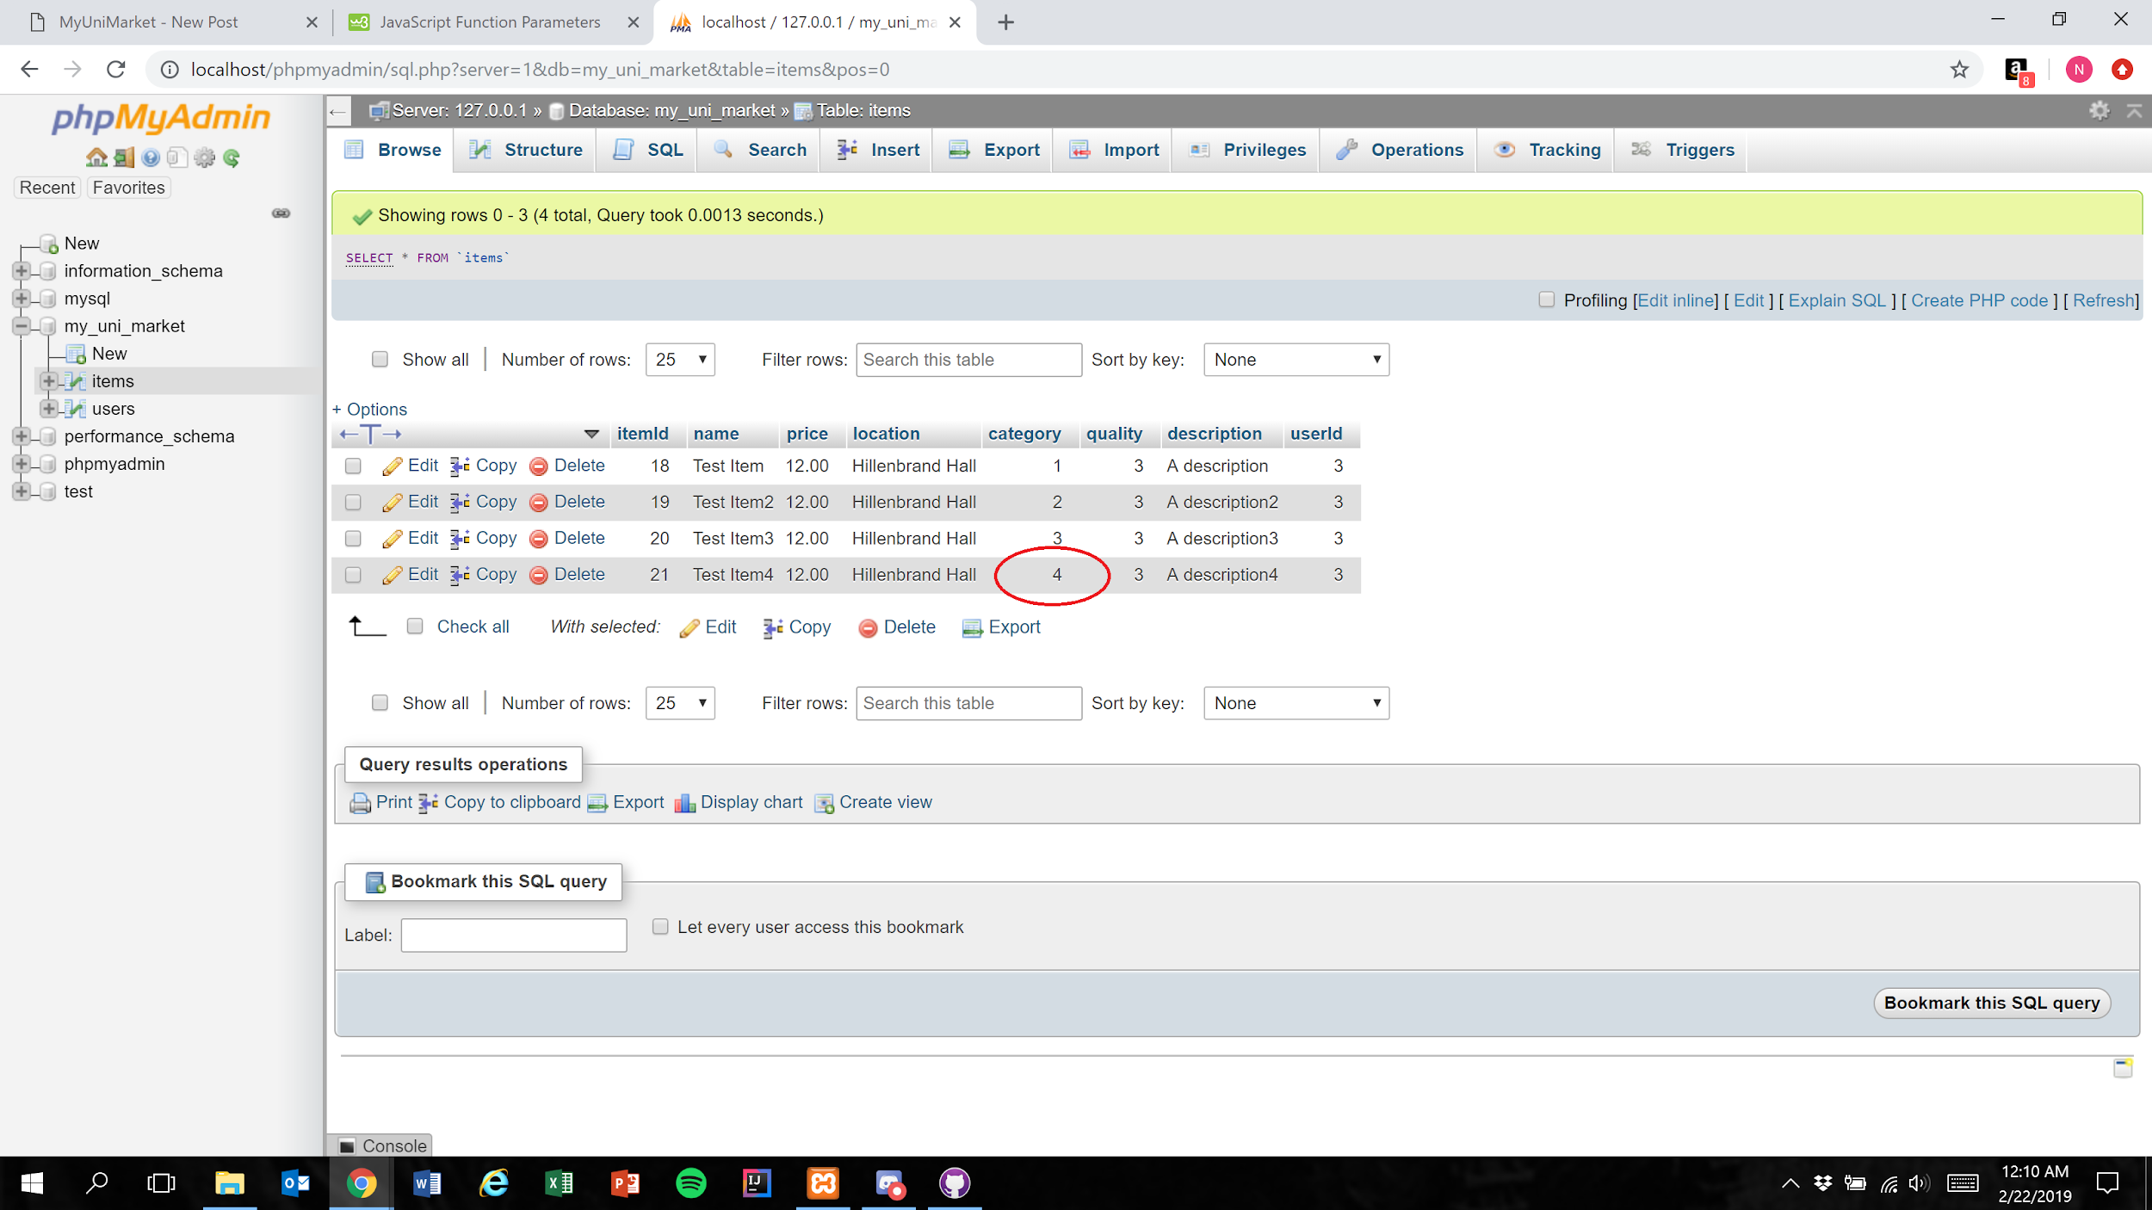

Expected Result: An integer 1 less than the category number the user selected is stored in the database

Test Result: **PASSED**

**Test 6: Given that the database has been implemented correctly, if the user submits a completed listing, then the database should correctly store the selected value**

Purpose: To meet the acceptance criteria that the database correctly stores the selected value for the “Select Category” field

Steps:

1. User properly inputs data in all required fields and clicks“Other” in the “Select Category” menu

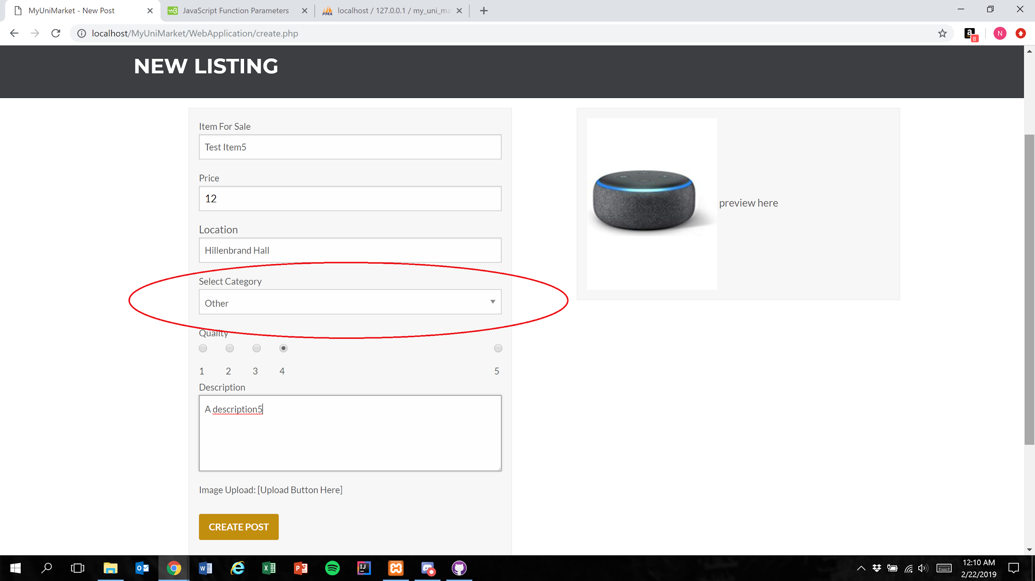

1. User presses the create post button (Figure 1)

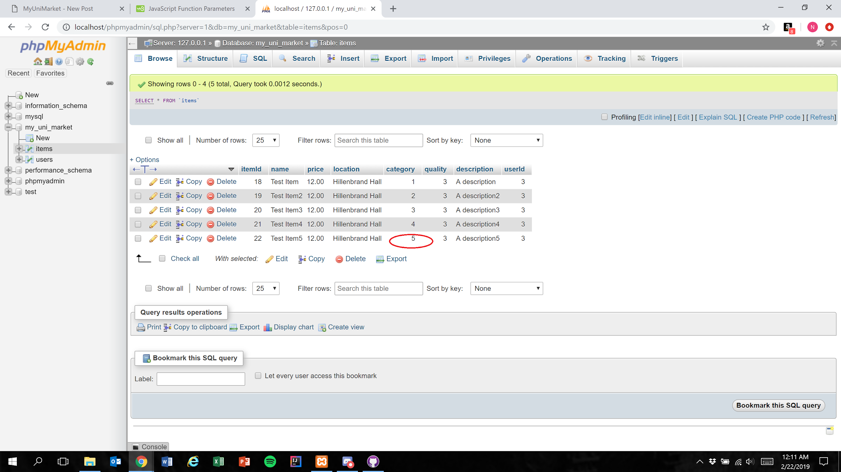

Expected Result: The integer 5 is stored in the database to represent the selection of “Other”

Test Result: **PASSED**

# User Story #11

**Test 1:** **Given that the user has filled all required fields of a listing, if the user inputs text into the “Location” field, then it is correctly stored in the database**

Purpose: To meet acceptance criteria that the location is correctly stored in the database

Steps:

1. User properly inputs data in all required fields and also inputs text into the “Location” field

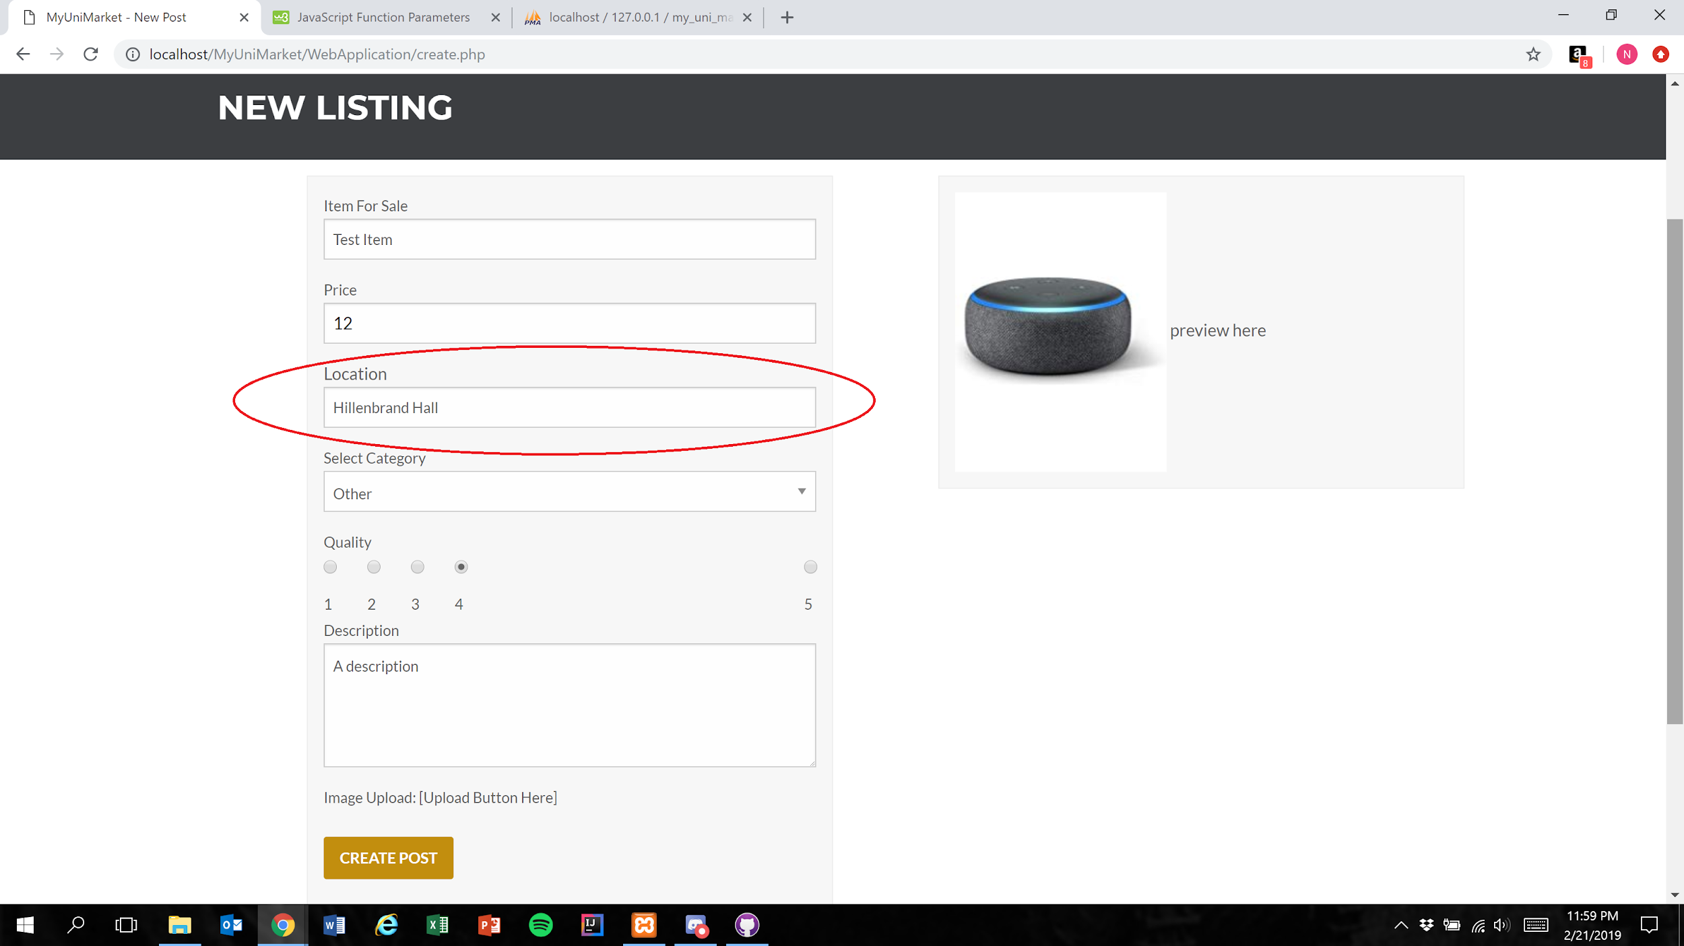

1. User presses the create post button



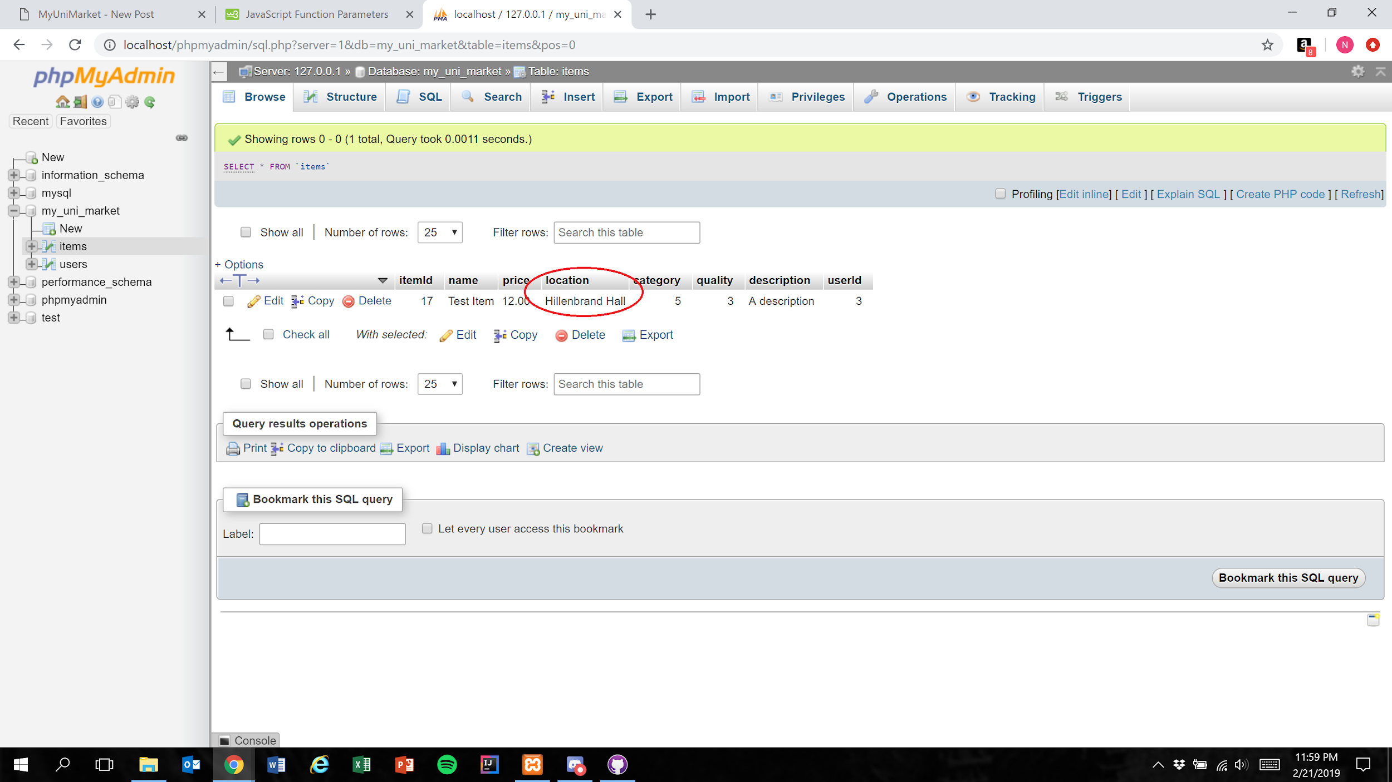

Expected Result: Text within the “Location” field is accurately represented in the database

**NOTE:** The “Location” field currently has a character limit of 100

Test Result: **PASSED**

# 

# User Story #12

**Test 1: Testing all created pages are responsive, and have correct redirection.**

Purpose: To meet the acceptance criteria, the user should be able to easily view and navigate our minimalistic page from any device they so please. Each test was tested on an iPhone X and a regular browser on computer.

Steps:

1. The user can view the signin.php page on all devices. 

**iPhone X Google Chrome Browser on Computer** 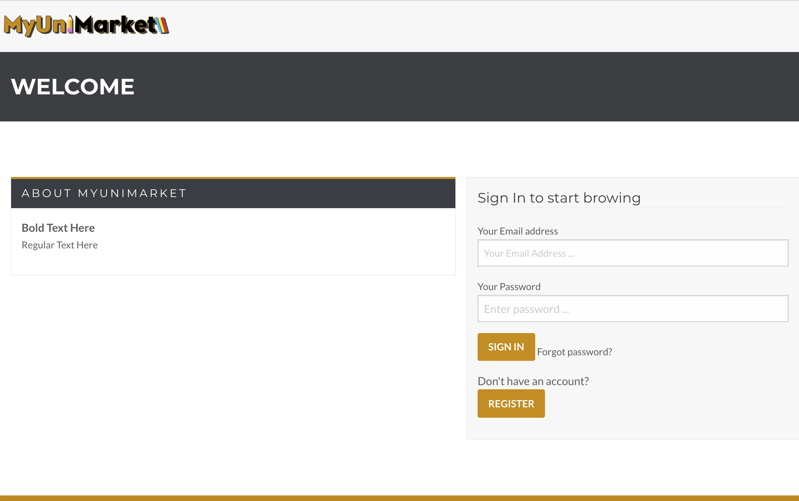

1. The user can view the signup.php page on all devices.

**iPhone X Google Chrome Browser on Computer** 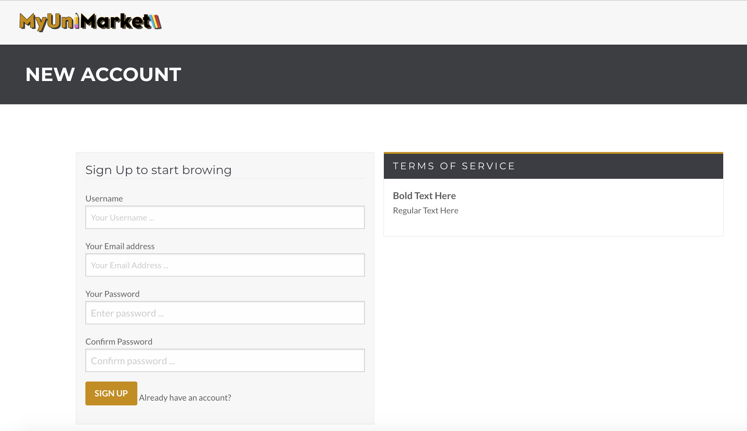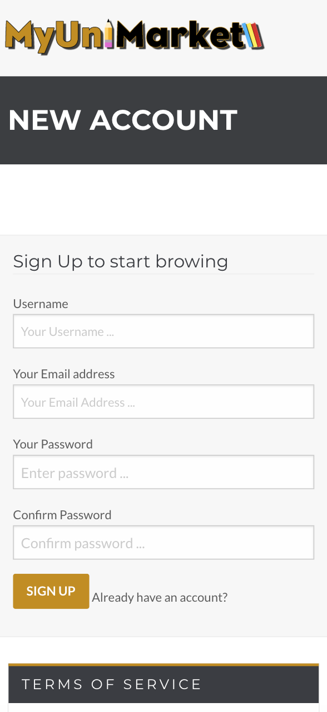

1. The user can view the create.php page on all devices.

**iPhone X Google Chrome Browser on Computer** 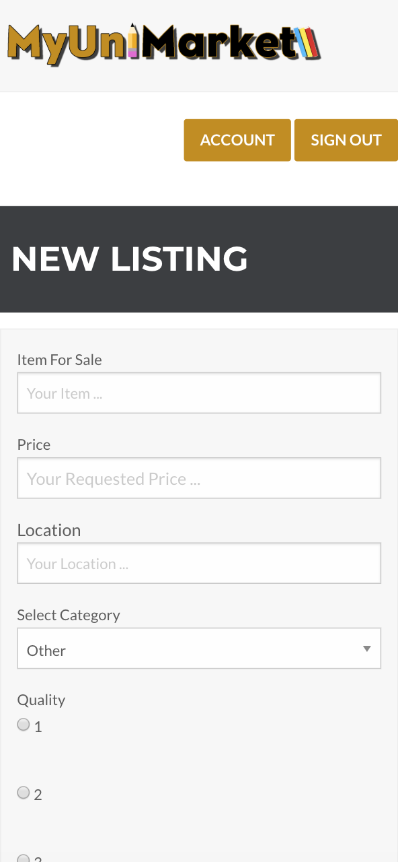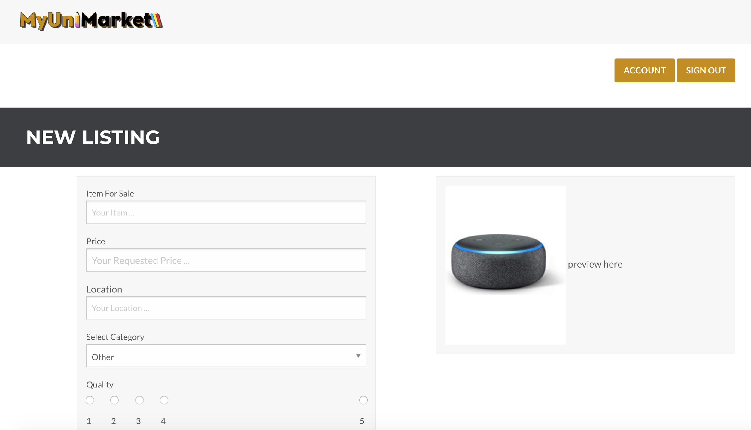

1. The user can view the account.php page on all devices.

**iPhone X Google Chrome Browser on Computer** 

1. The user can view the account2.php page on all devices.

**iPhone X Google Chrome Browser on Computer** 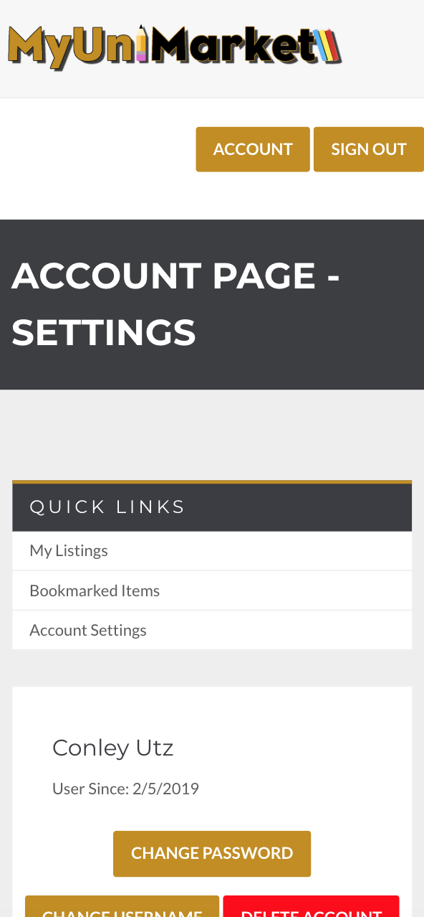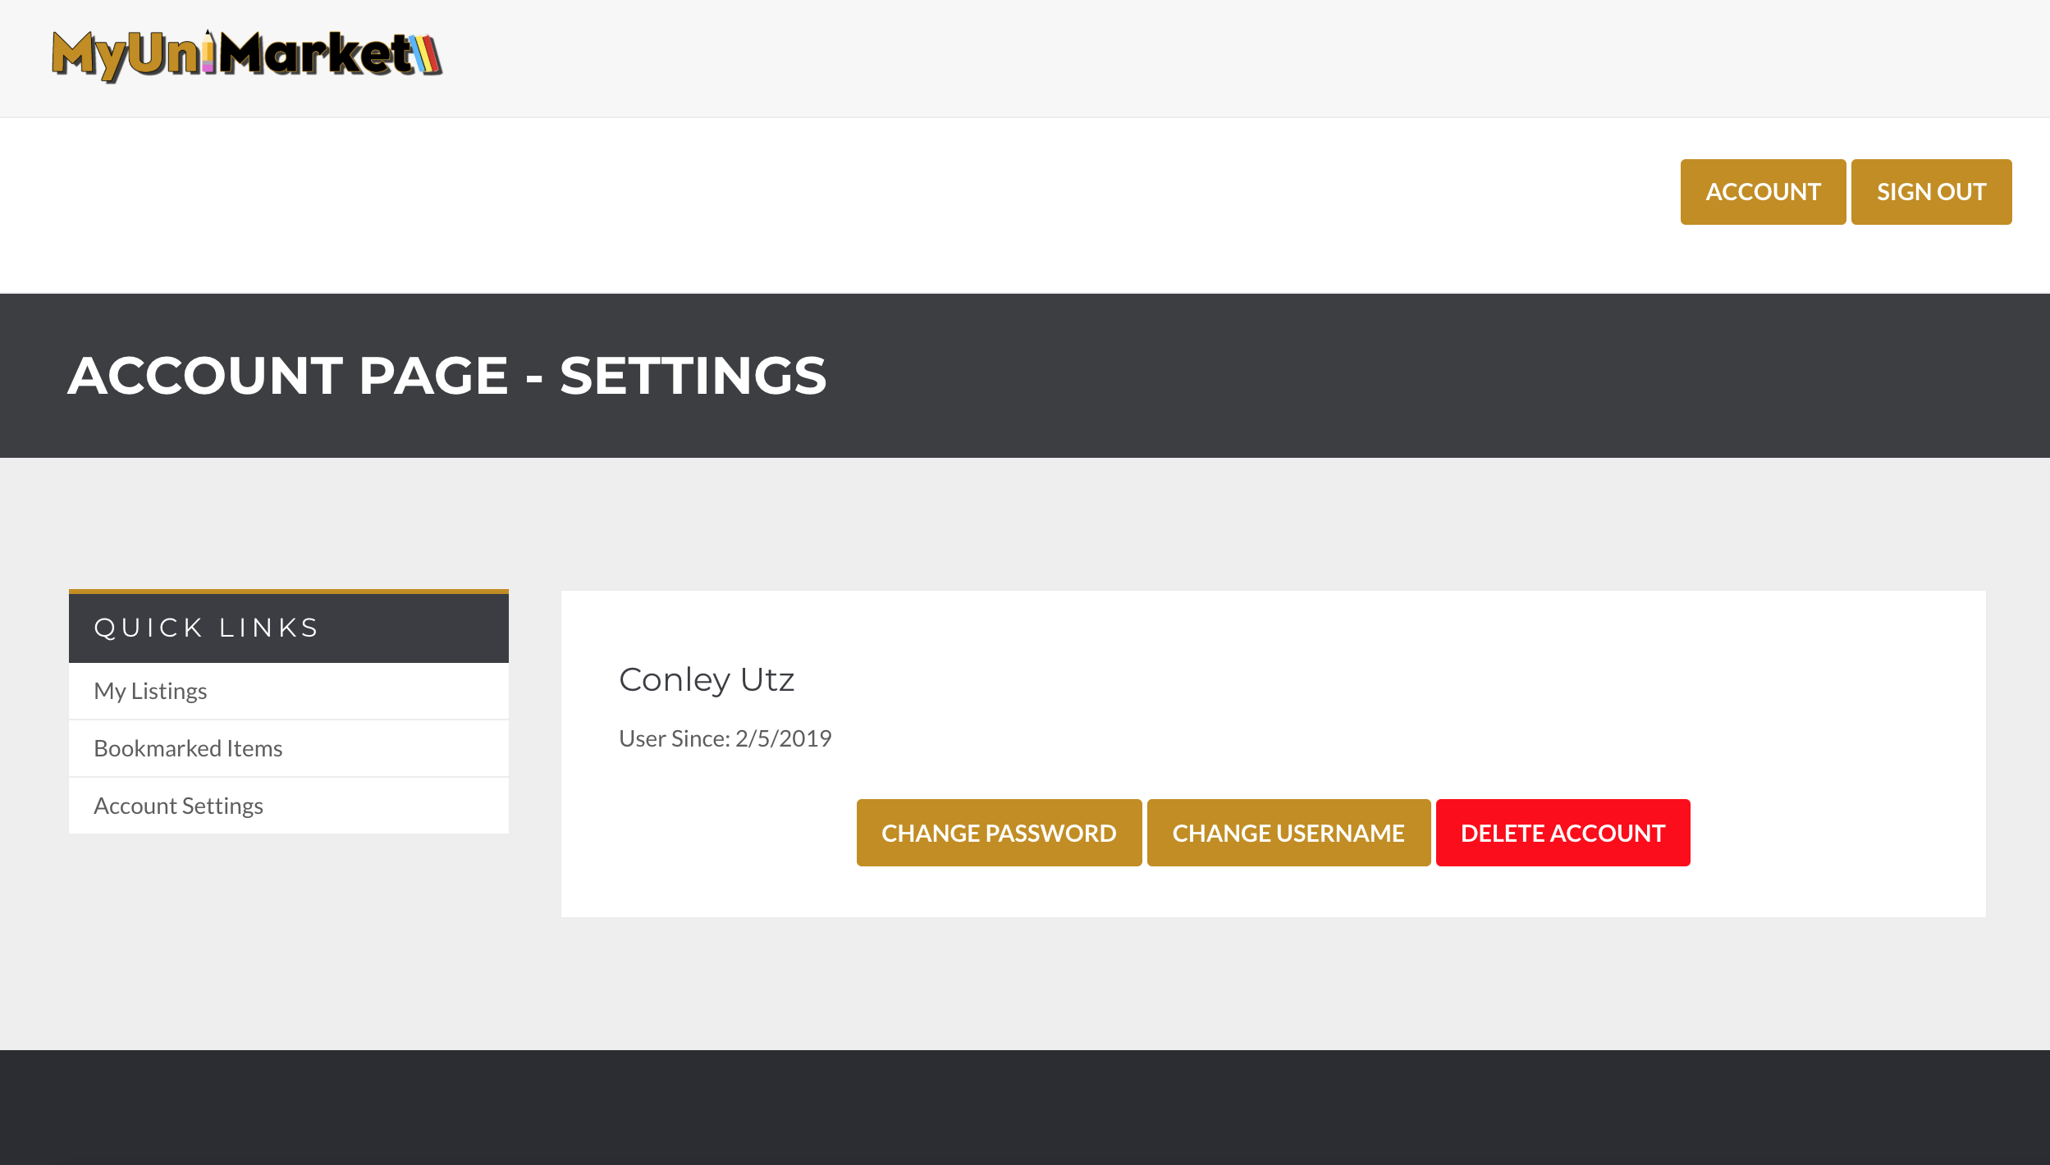

Expected Result: User is successfully able to view and navigate website across devices.

Test Result: **PASSED**

# User Story #13

**Test 1: Testing that user cannot use inappropriate words/phrase as a username.**

Purpose: To meet the acceptance criteria, user should not be able to register to MyUniMarket with an inappropriate username

Steps:

1. The user uses an inappropriate word as username to sign up. (No user is created)

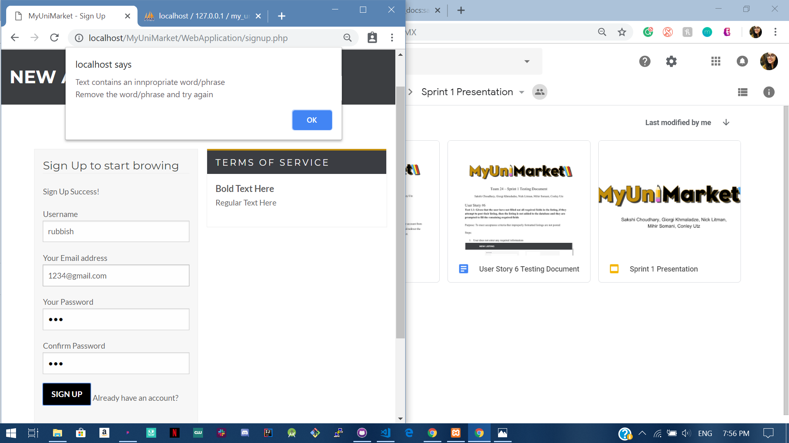

1. The user uses an appropriate word as username to sign up. (User is created)

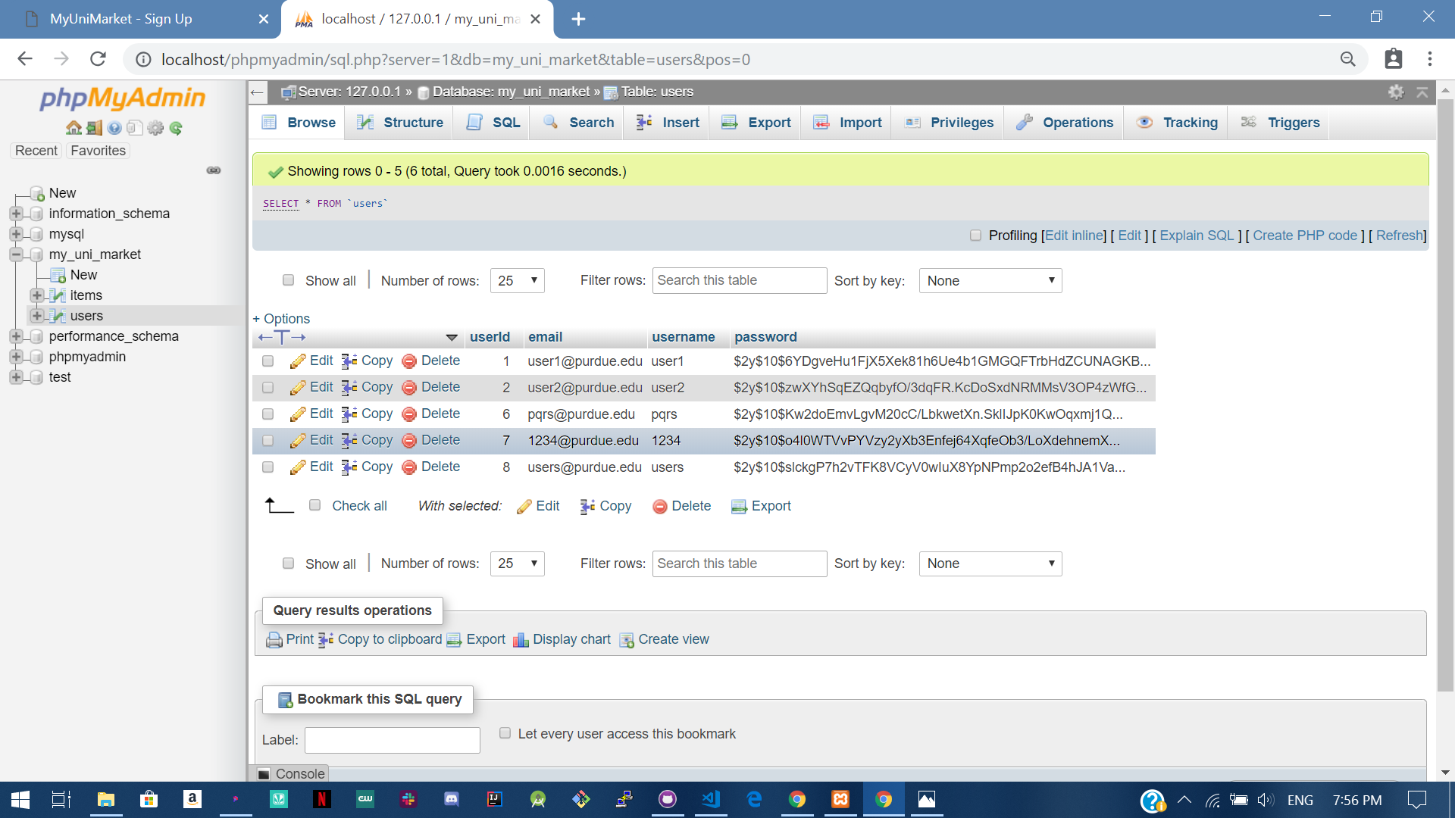

Expected Result: User cannot sign up if they use an inappropriate as username.

Test Result: **PASSED**

**Test 2: Testing that user cannot use inappropriate words/phrases as item details.**

1. The user uses an inappropriate word as name of the item for sale. (No item is listed)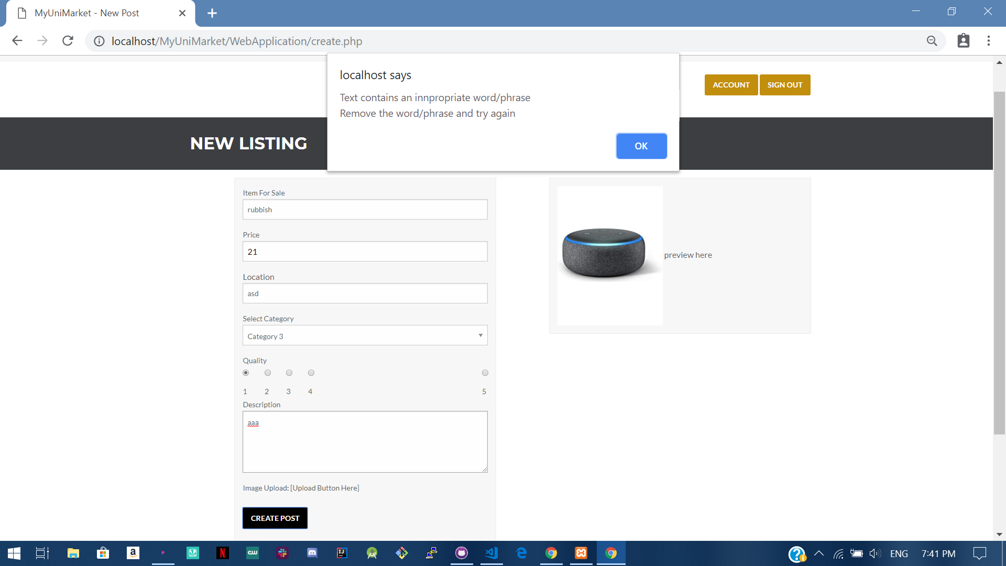
2. The user uses an inappropriate word as location for the item for sale. (No item is listed) 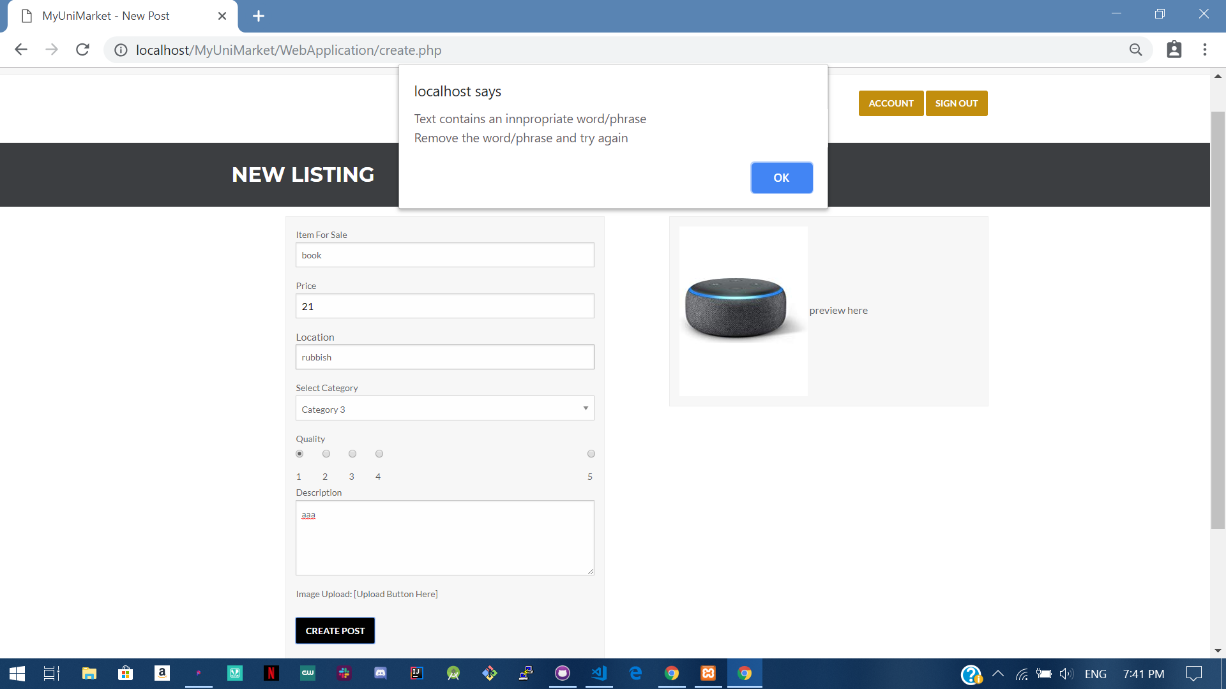
3. The user uses an inappropriate word as description for the item for sale. (No item is listed) 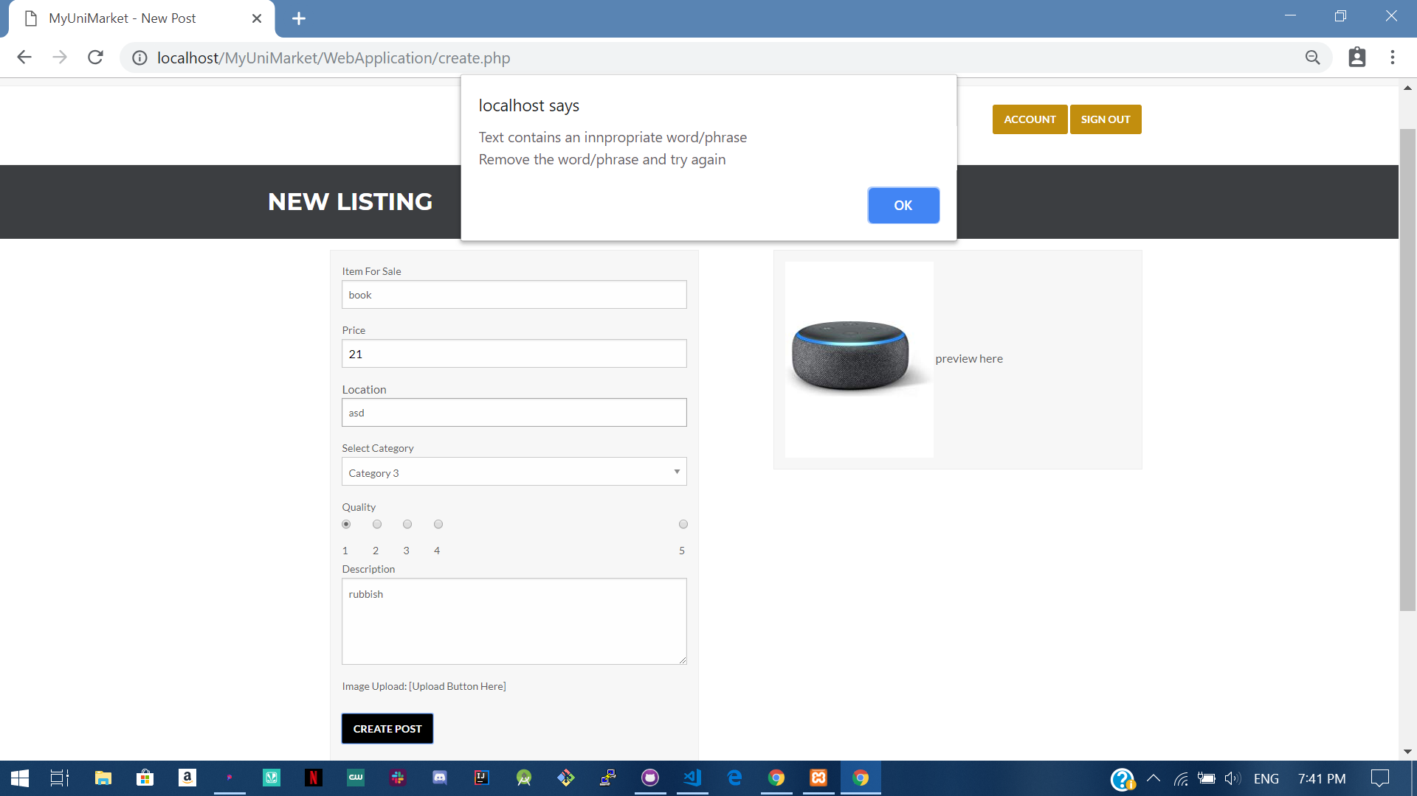

Expected Result: Item is not added to the database and user is asked to change the inappropriate word

Test Result: **PASSED**

**Test 3: Testing that if user does not use any inappropriate words/phrases the item is listed.**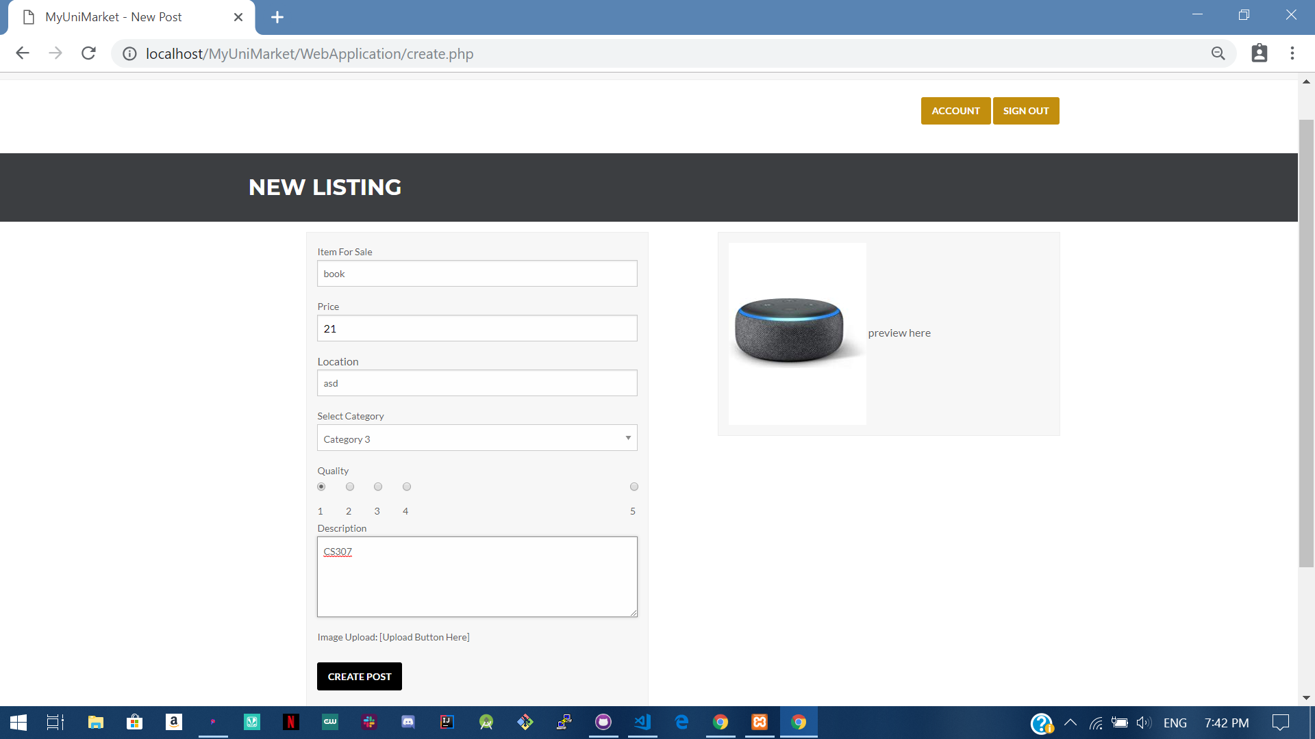

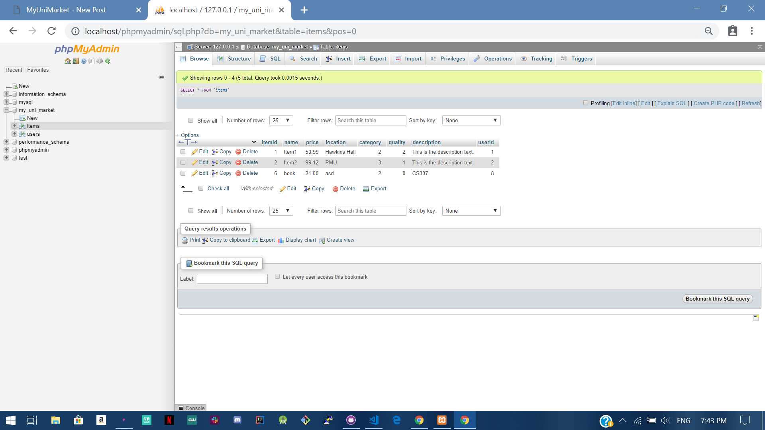

Expected Result: Item is added to the database

Test Result: **PASSED**

# User Story #14

**Test 1: Testing if the password is hashed when a new user is registering.**

Purpose: To meet the acceptance criteria the password that a user chooses must be stored as a hash.

Steps:

1. The user navigates to the sign-up page. 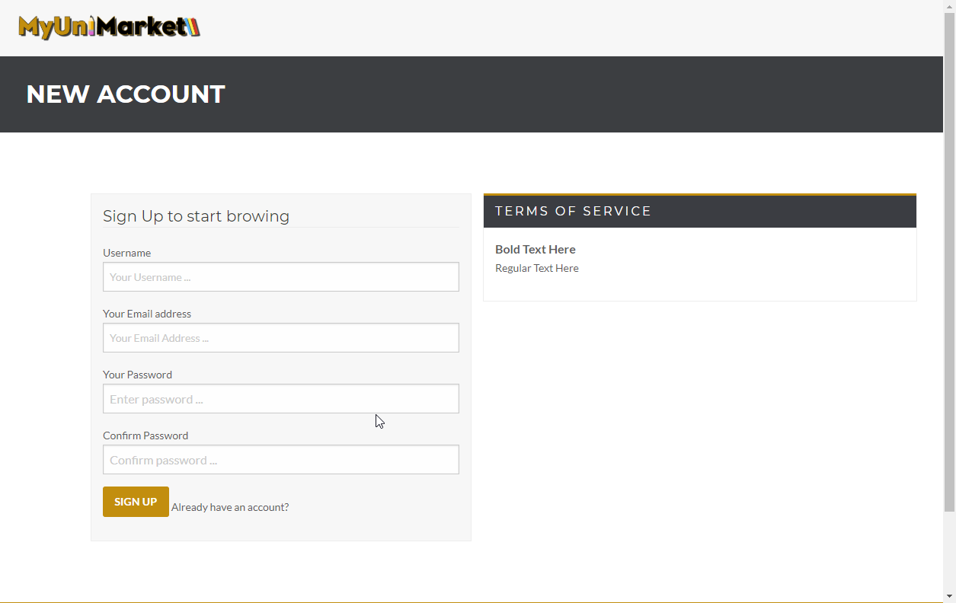
2. The user enters their details in the given fields. (Testing password is 123)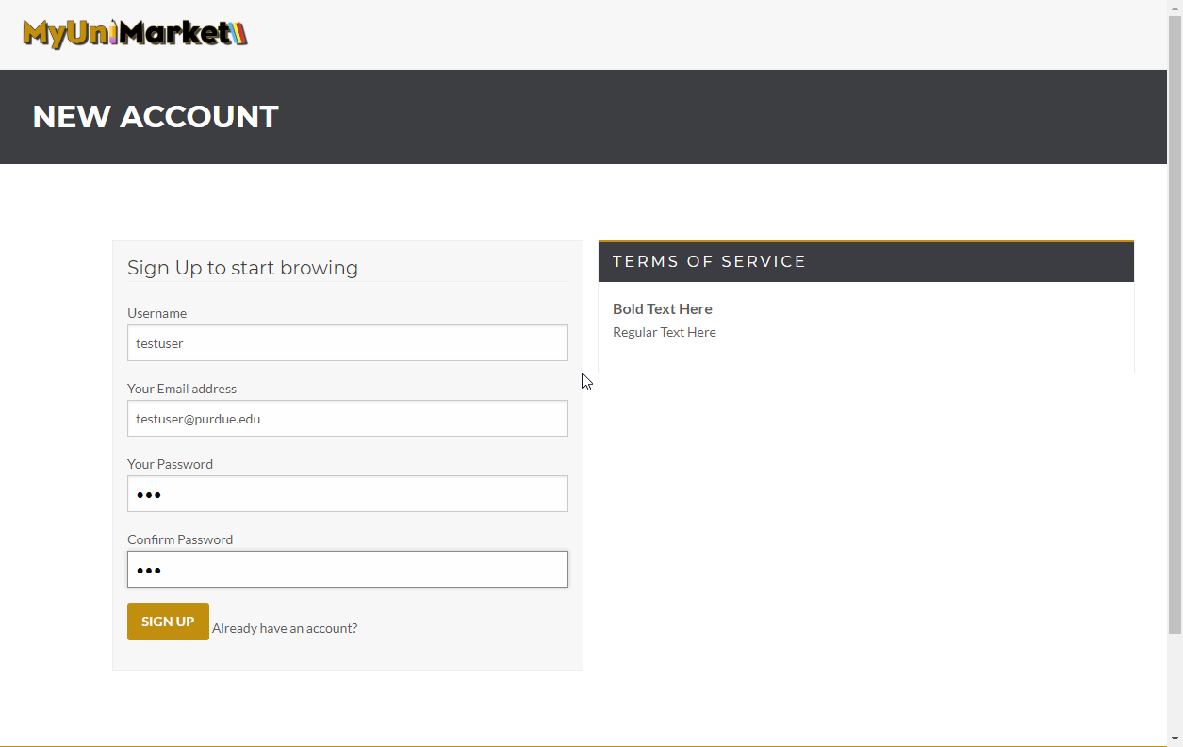
3. Looking at the database, a user with the email and username given above does not exist. 
4. The user clicks “SIGN UP” 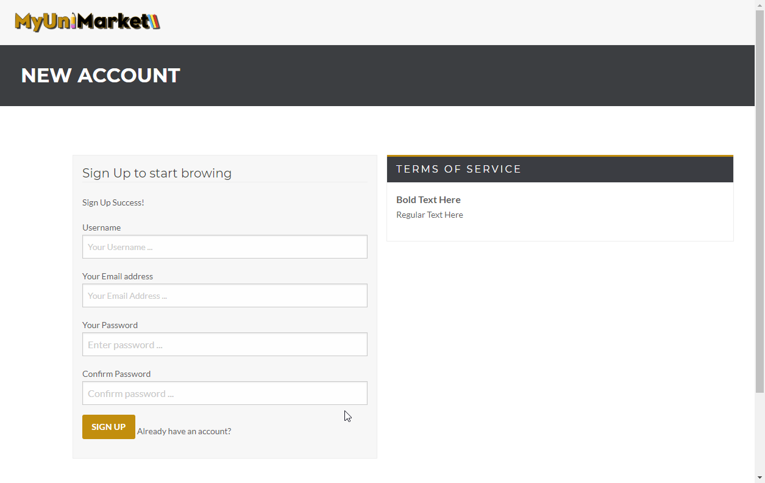
5. The user is added to the database with a hashed password. 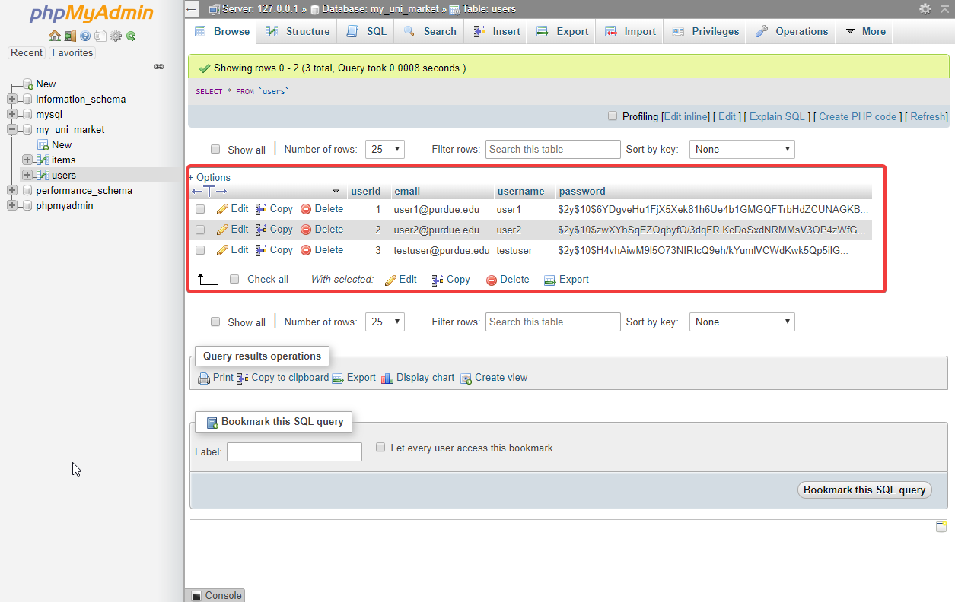

Expected Result: Any password a user decides to choose must be hashed and stored in a hash form for security.

Test Result: **PASSED**